Gandhinagar Institute of Technology
A Report on
“Startup Introduction”
(1st July 2019)

Seminar Overview:
The SSIP team of GIT has organized seminar on “Startup Introduction” on 01/07/2019 at 2:30 pm in C101. SSIP coordinator Prof Mrugesh B Khatri & co-coordinator Prof Jyotin A Kateshia mentored the seminar. The students of 5th semester Computer Engineering Division C attended the seminar. There were 39 participants.

Objective:
The objective of the seminar was to introduce the term Startup to the participants. The hidden objective was also to share the information about SSIP and IPR policy launched by Government of Gujarat.

Seminar Detail:
The session started at 2:30 pm in C101. Prof Mrugesh B Khatri started sharing information about Startup to energize the atmosphere. He informed participants about were elements of successful Startup like idea, team, business model, funding, timing etc. He added that there is necessity of unique idea to create your own idea. He added that involvement of innovation is the essential for any Startup.

The market survey plays a serious role in measuring the chances of success. He added that Government is also supporting the students’ innovation by familiarizing various supporting policies. The case studies of successful startup like flipkart, amazon, paytm etc was debated to motivate the students for innovation at their early age. They were also educated that the passion of person plays a vibrant role for future path selection to succeed.

He added that the ownership of the idea can be acquired by applying for patent. The other different forms of Intellectual Property Rights were deliberated by him. He added that the prior art search is mandatory before patent filling. He added that one can apply for provisional patent also if the prototype is under development.

Prof Jyotin A Kateshia educated participants about the quiring ownership on Intellectual Property Right. He informed participants that the provisional patent will help innovator to reserve the rights on their idea before commencement of a physical patent. He added that for medical, surgical, agriculture and horticulture there is no provision of patent filling. The prior art search in a proper way increases the chances of patent approval.

The event was a grand success under the enlightenment of Dr H N Shah, Principal of the institute and the participants.

Seminar Memories:
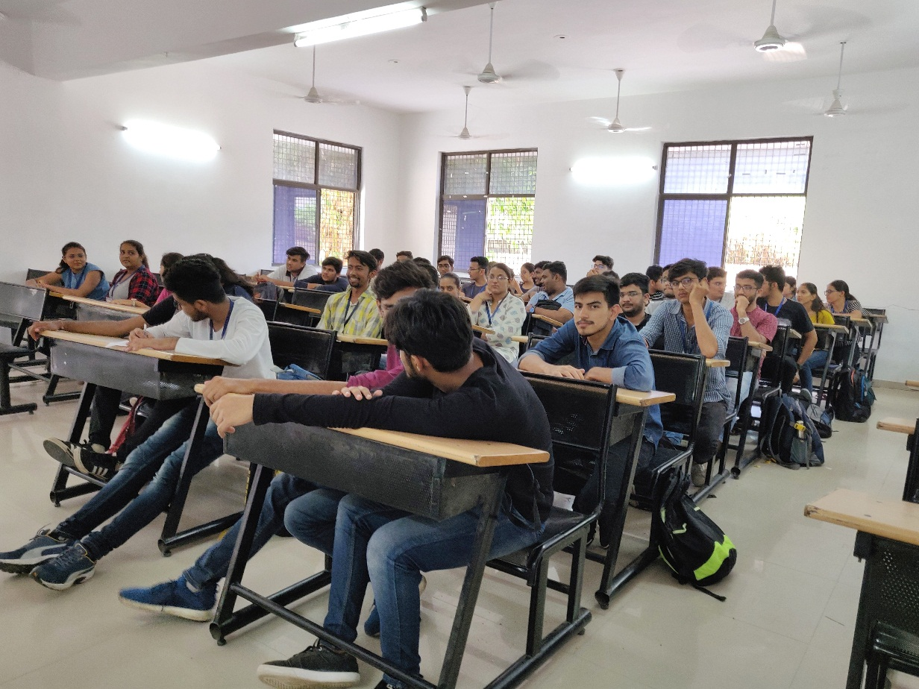Participants Listening to Coordinator

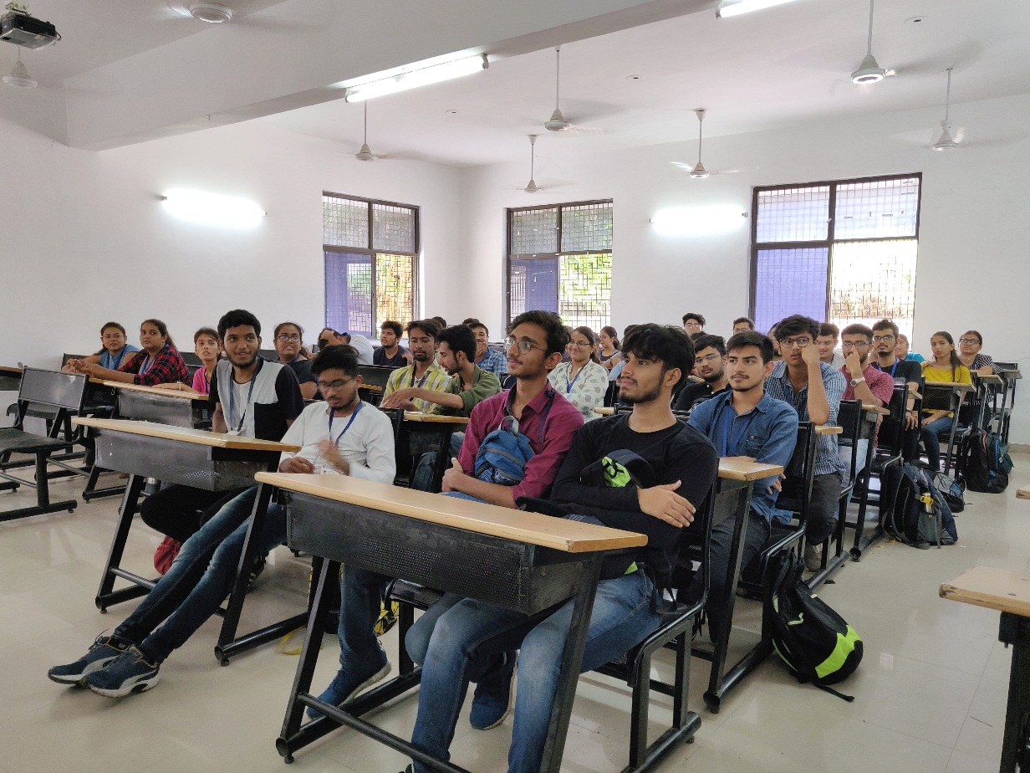
Participants Interacting with Coordinator

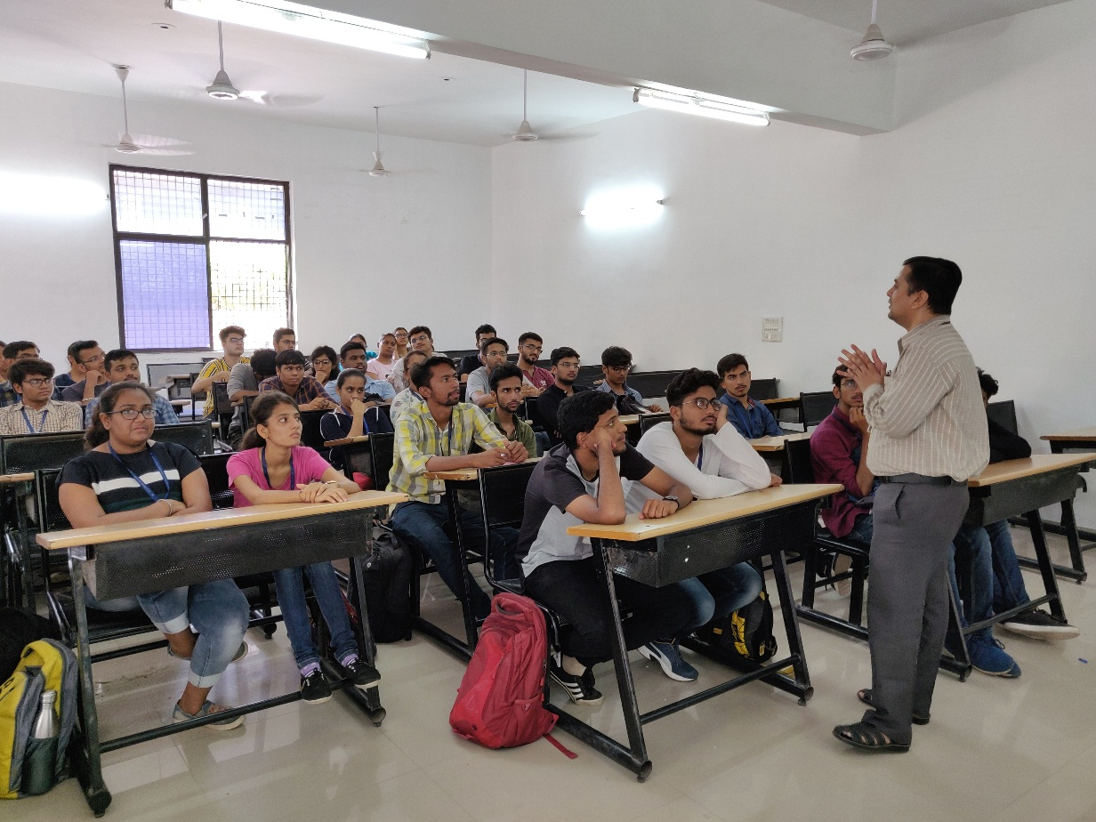
Coordinator Delivering the information

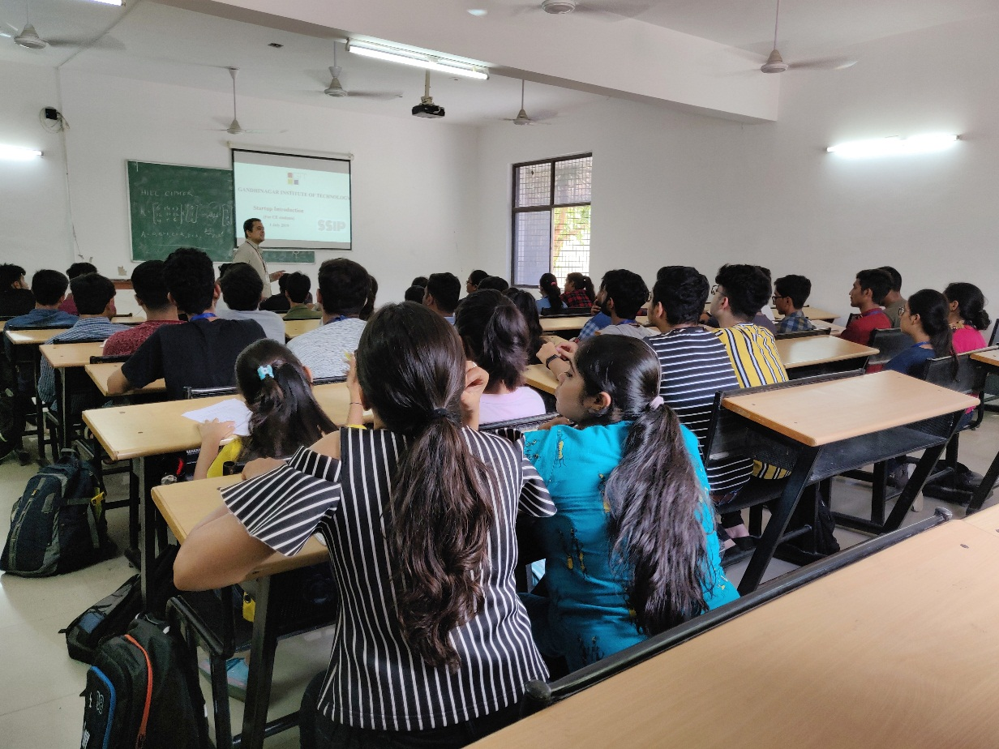
Question Answer Session

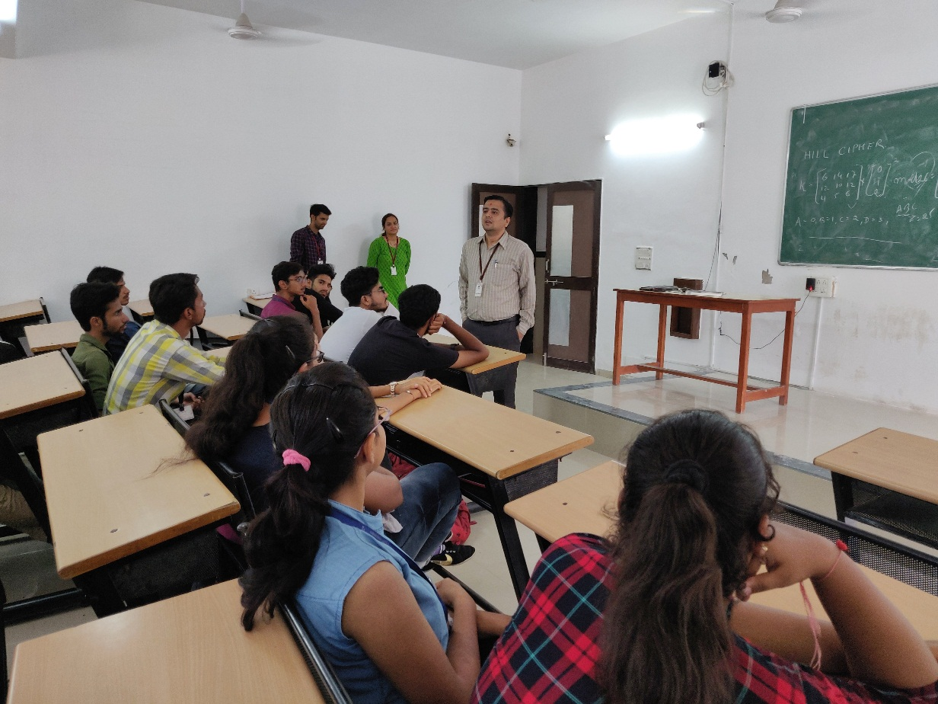
Coordinator Solving Queries

