Gandhinagar Institute of Technology
A Report on
“Details of SSIP Policy”
(2nd July 2019)

Seminar Overview:
The SSIP team of GIT has organized seminar on “Details of SSIP Policy” on 02/07/2019 at 12:15 am in C107. SSIP Prof Jyotin A Kateshia mentored the seminar. The students of Computer Engineering, 5th Semester Division A attended the seminar. There were 37 participants.

Objective:
The objective of the seminar was to educate the participants about Startup. The silent objective was to motivate them to adopt problem solving approach for innovation. The hidden objective was also to share the information about SSIP and IPR policy launched by Government of Gujarat.

Seminar Detail:
The session started at 11:15 am in C107. Prof Jyotin started session by defining the term Startup. He informed that the financial gain is the primary goal of an Entrepreneur whereas it is not for a Startup. The Startup is involves use of technology for problem solution. He added that the treatment of real pain of customer helps the most in discovering innovative problem solutions.

He educated participants to about team forming practive. He added that the team must be comprising of various field experts rather than friends. The mixture of various field expert in team will decrease the effort of your team to resolve any problem at any stage. He also informed participants to make the business model comprising of planning each stage from starting towards the execution. He educated participants about procedure to avail financial benefit through SSIP.

In the last phase of seminar, the participants were educated about SSIP & IPR policy launched by Government of Gujarat to develop ecosystem for Startup. The benefits of SSIP policies were informed to the participants. They were also informed to opt ownership on their idea in form of patent. The participants were given information about Student Open Innovation Challenge. The provision of support for patent filling was also shared with them. The efforts made by GIT to develop the culture of Startup at GIT were also shared with them.

The event was a grand success under the enlightenment of Dr H N Shah, Principal of the institute and the participants.

Seminar Memories:
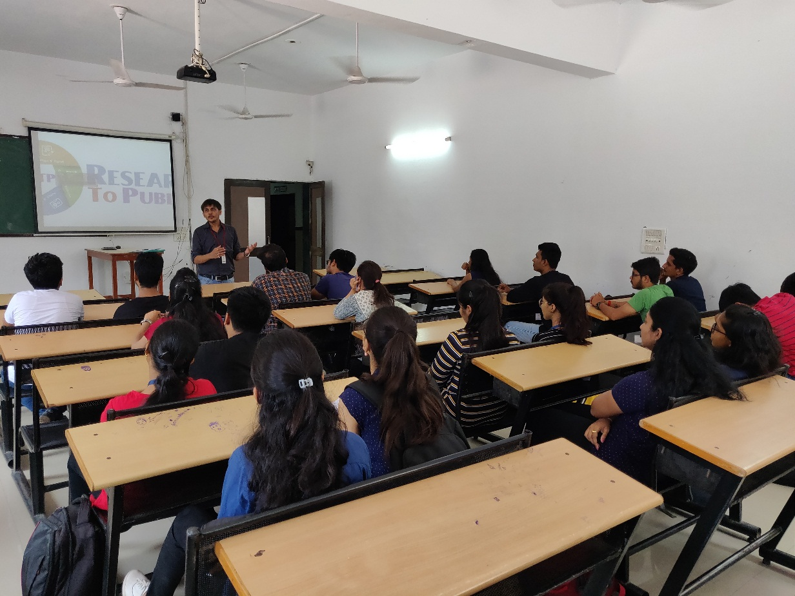
Coordinator Delivering the session

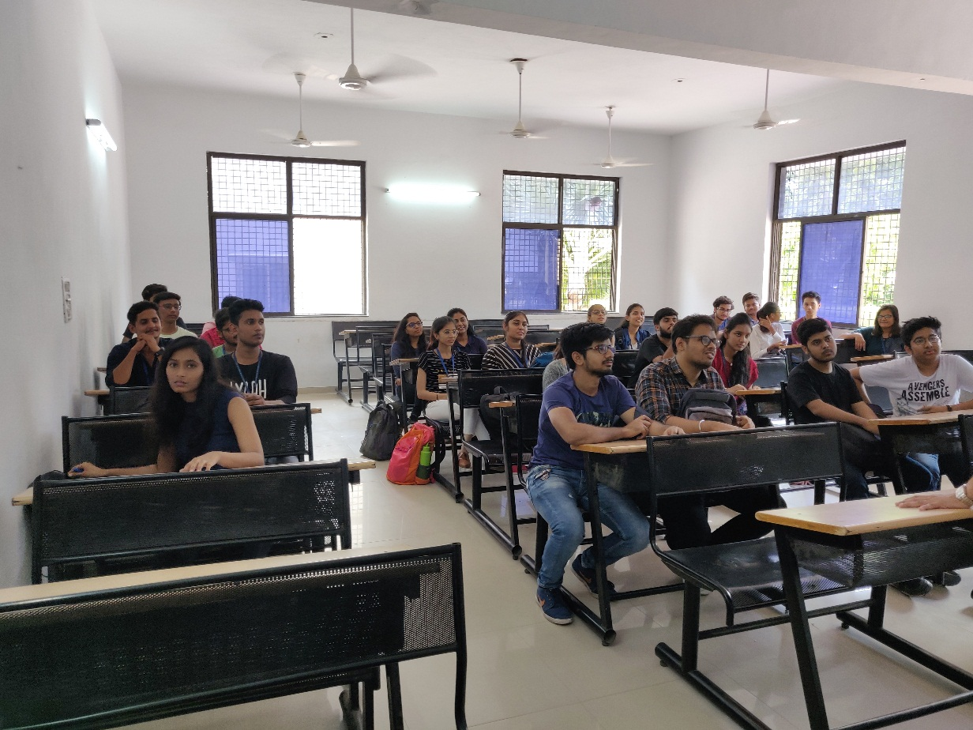
Participants Listening to Coordinator
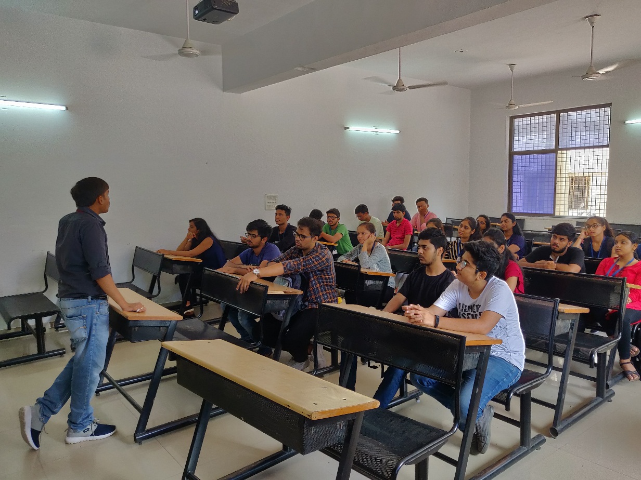
Interaction between Coordinator & Participants

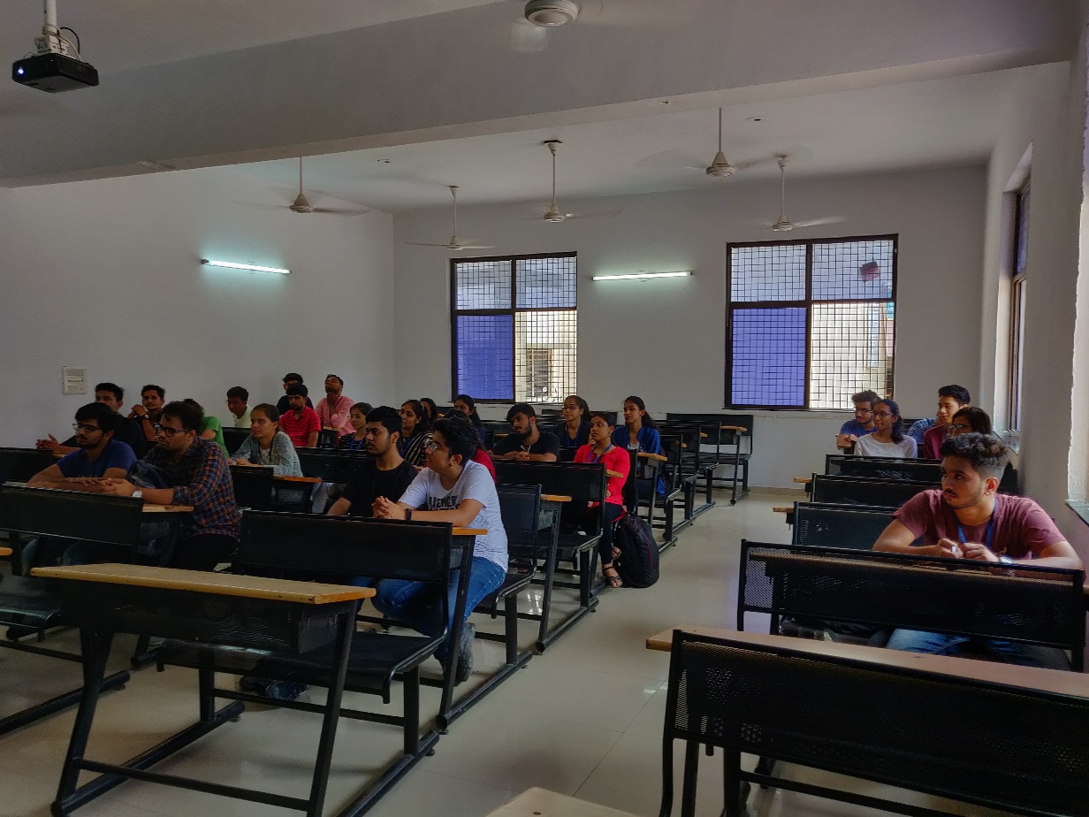
Question Answer Session

