Gandhinagar Institute of Technology
A Report on
“Ideation”
(5th July 2019)

Workshop Overview:
The SSIP team of GIT has organized workshop on “Ideation” on 05/07/2019 at 1:30 pm in A214. The workshop was mentored by SSIP Co-ordinator Prof Mrugesh Khatri & Co-coordinator Prof Jyotin Kateshia. The workshop includes brainstorming activity and making of proof of concept. The students of Mechanical Engineering attended the seminar. There were 50 participants.

Objective:
The objective of the workshop was to educate the participants about problem identification and design methodology. The hidden objective was to teach them the process of making final product by considering various aspects like ergonomics, manufacturing, athletics etc.

Workshop Detail:
The workshop commenced at 1:30 pm in A214. Prof Mrugesh Khatri initiated with the introduction of terms innovation. He added any new technique or process or product which enhances the performance is called innovation. He gave information about the steps involved in problem identification like observe users, environment, interactions, object, mind mapping, brainstorming, ideation etc.

The students were informed that it is essential to have team members of different expertise. The students were asked to form their groups. They were informed to select the domains. They were asked to workout for AEIOU framework. The problems associated with the domain were brainstormed and noted in logbooks. They were asked to find feasible solutions of those problems. They were educated that one of the combinations leads to innovative problem statement.

They were educated about the importance of POC. The feedback of customer helps in improving the product features and characteristics. The participants were informed to take reviews of actual users and field experts to increase the chances of success for your idea. The case studies of various mechanical start-ups were discussed to explain design methodology to the participants. The students were delighted to conclude the session of workshop by finalizing their problem definitions.

The event was a grand success under the enlightenment of Dr H N Shah, Principal of the institute and the participants.

Workshop Memories:
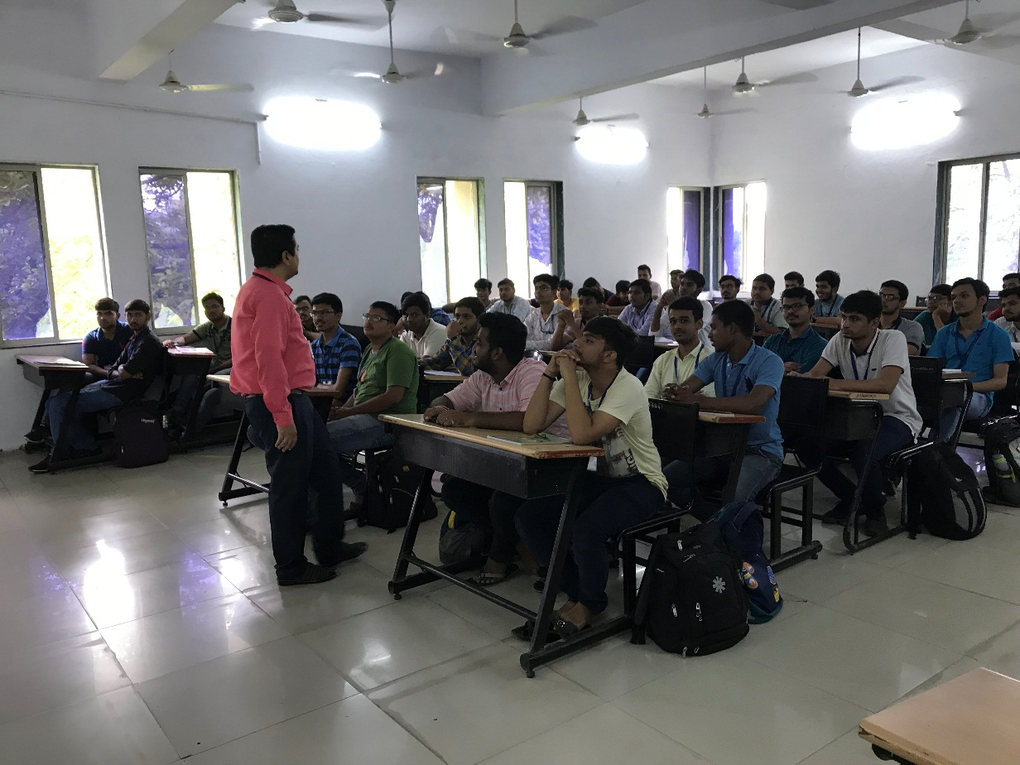
Participants Listening to Coordinator

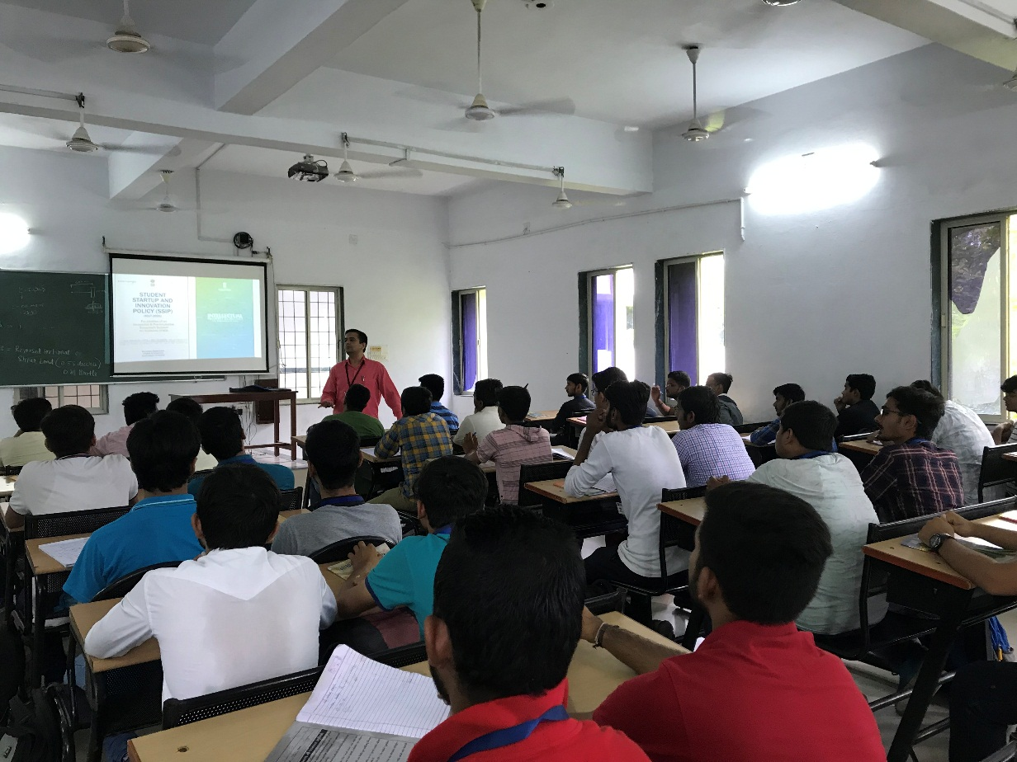
SSIP Policy Discussion
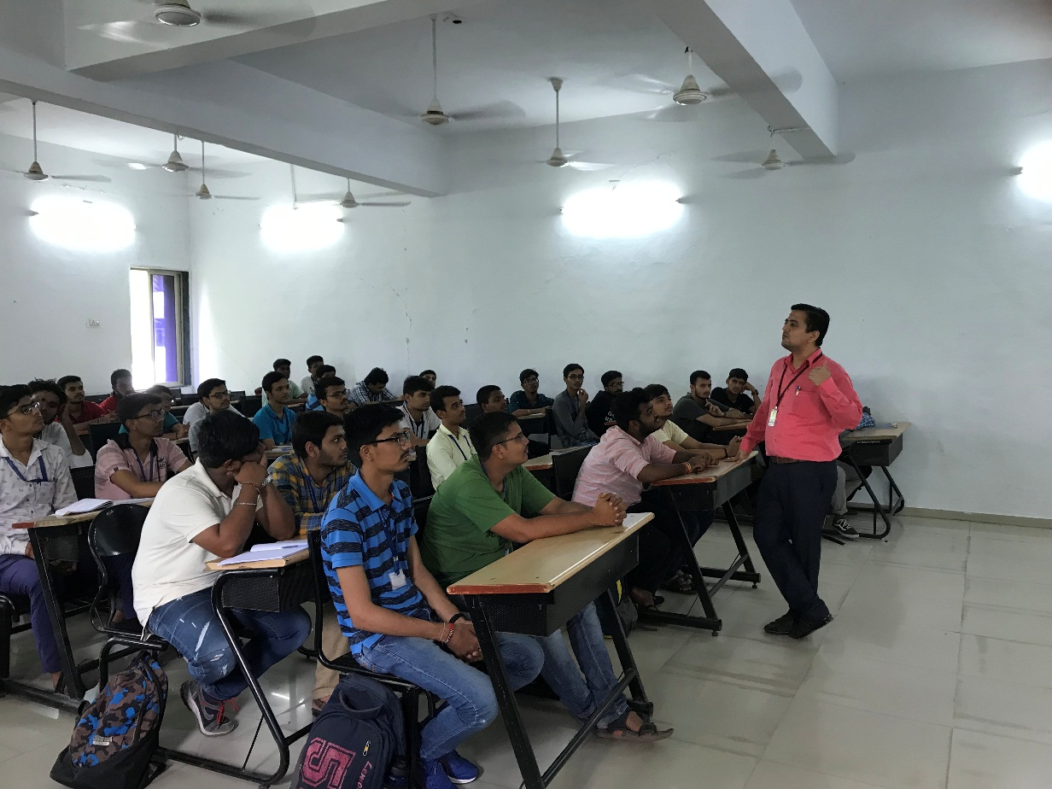
Interaction between coordinator & participants

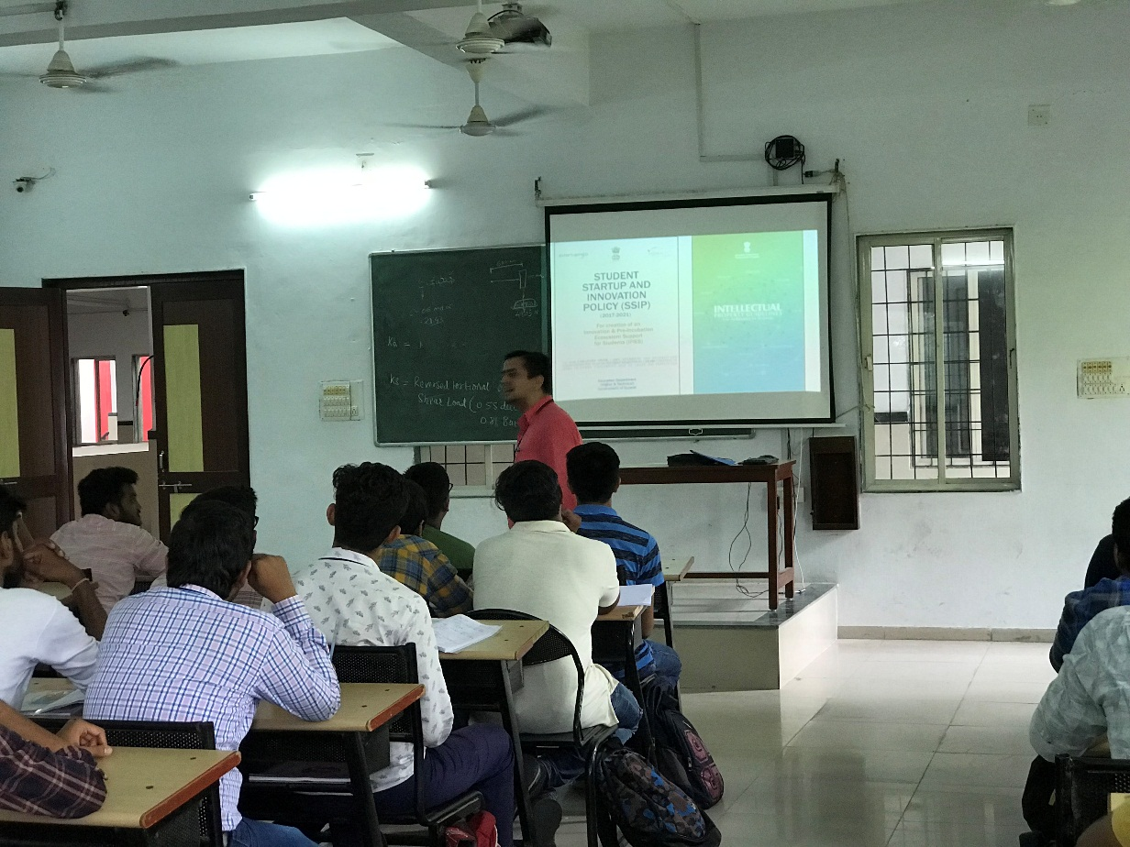
Question Answer Session

