Gandhinagar Institute of Technology
A Report on
“Pen Your Idea Down”
(8th July 2019)

Workshop Overview:
The SSIP team of GIT has organized workshop on “Pen Your Idea Down” on 08/07/2019 at 1:30 pm in A212. SSIP coordinator Prof Mrugesh B Khatri & co-coordinator Prof Jyotin A Kateshia mentored the workshop. The students of 5th Semester Mechanical Engineering Division A attended the workshop. There were 45 participants.

Objective:
The objective of the workshop was to educate the students about the Startup by sharing the information of successful startup stories of India. The hidden objective of workshop was also to educate them about SSIP and IPR policies launched by Government of Gujarat.

Workshop Detail:
The workshop commenced at 1:30 pm in A212. The participants were quarries to know the details of flow of workshop. Prof Mrugesh B Khatri initiated the workshop by explaining them the term “Startup”. He added that the Innovation is the essential element of the Startup. The necessity of innovation was clarified to the participants for startup. He also informed the participants that there is no shortcut for innovation.

He educated participants about a systematic approach towards concluding innovative idea. He added that mind mapping, empathy mapping, ideation and AEIOU technique will help them in finding out innovative solution of any problems. He also educated them how the number of combinations of problems solutions drives to innovation in brainstorming. He added that the observations play a critical role in finding problems. He also informed participants that any small change in the process of manufacturing product is innovation, use of product in a unique manner which no one have attempted before is innovation.

He asked students to divide themselves into groups and perform brainstorming exercise. He also informed them to note all their thoughts into logbook. The participants started following the design methodology explained by the mentor. They started interacting within groups and coming up with innovation ideas. Prof Mrugesh Khatri and Prof Jyotin Kateshia were guiding the students in following steps of ideation. The participants have finalized their domains. The mentor informed them to start literature survey for finding out innovative solutions for the problems which they will find in their respective domains.

The event was a grand success under the enlightenment of Dr H N Shah, Principal of the institute and the participants.

Workshop Memories:
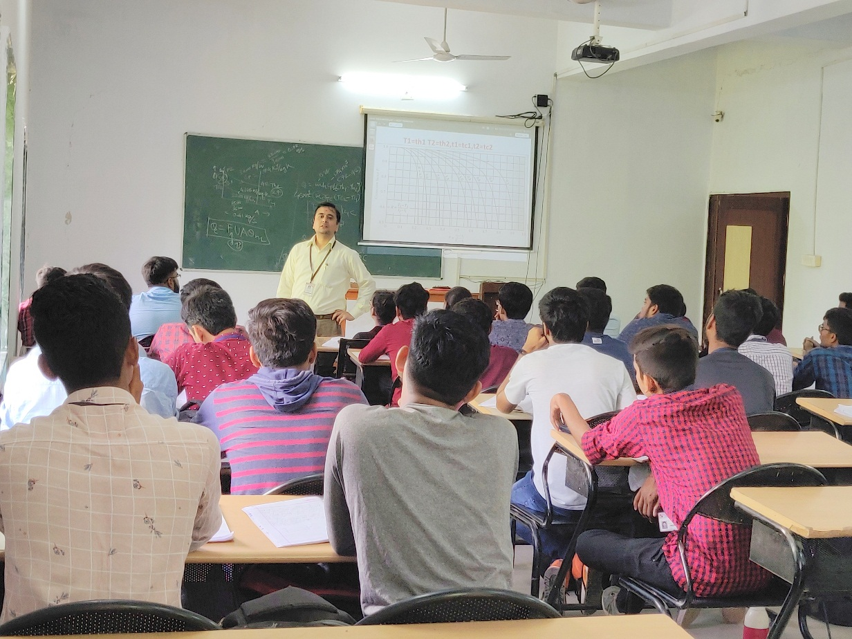
Mentor delivering session

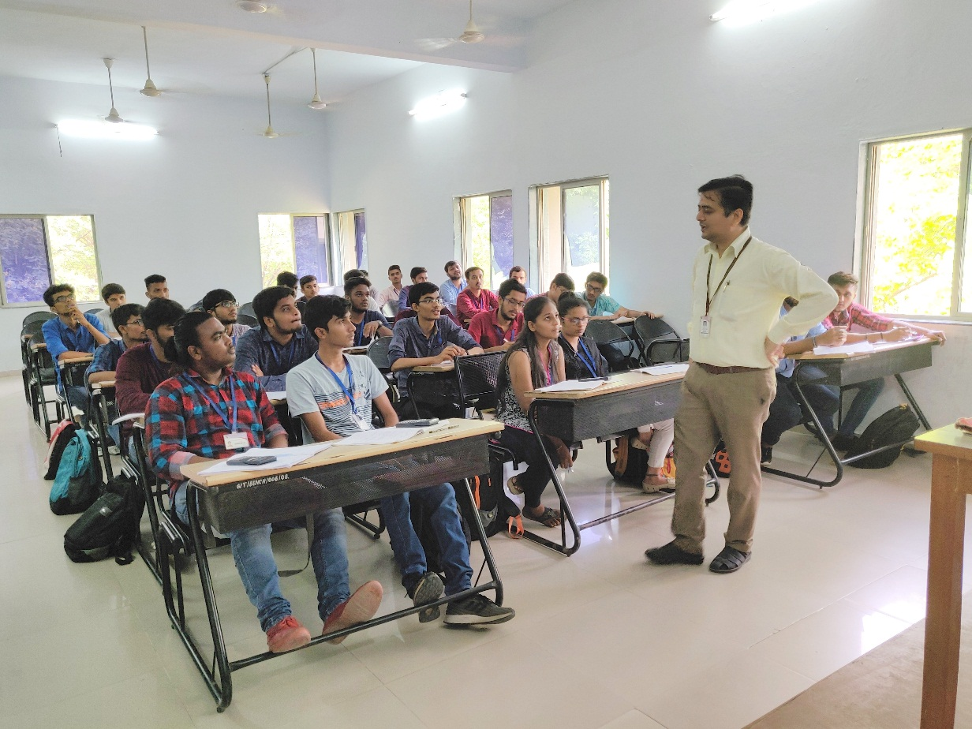
Participants listening to mentor
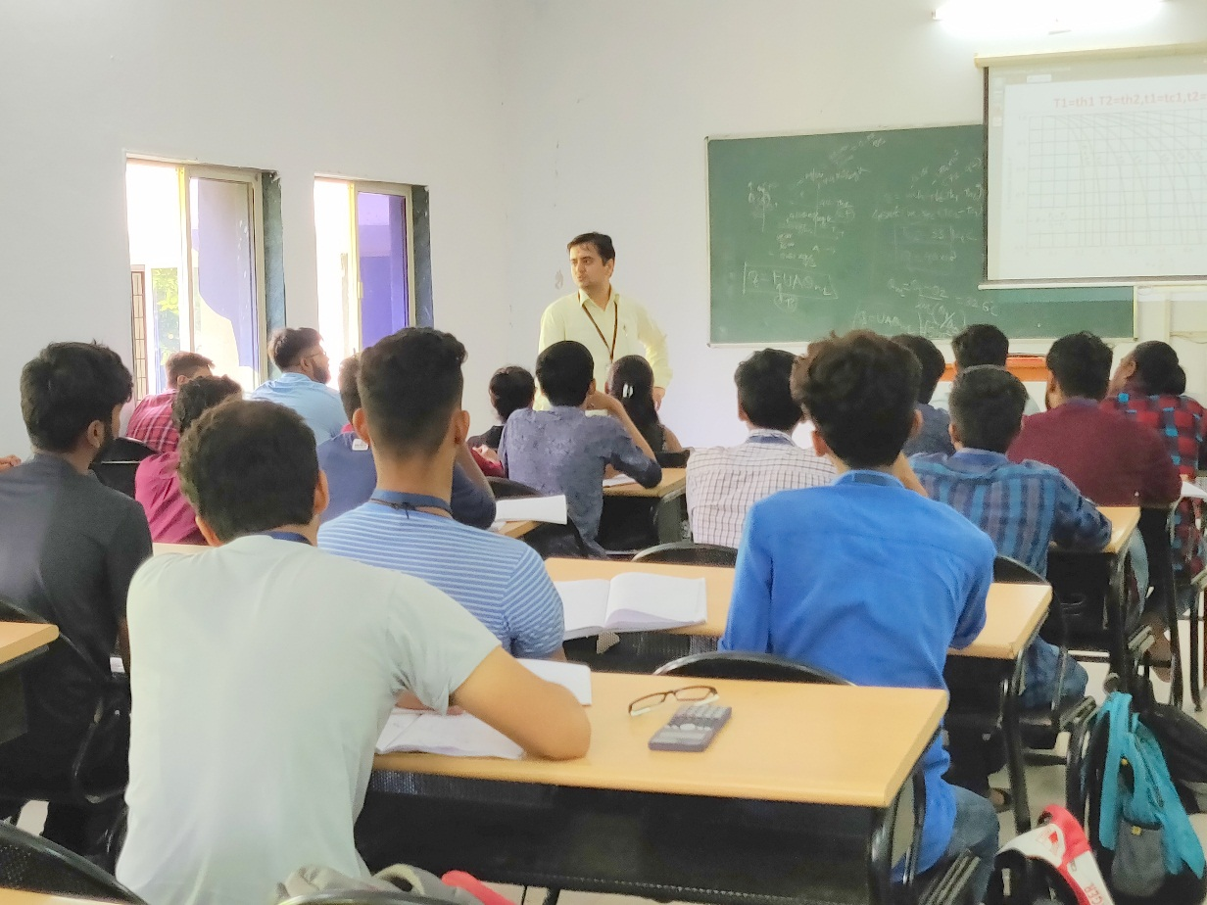
Mentor Listening to Participant's query

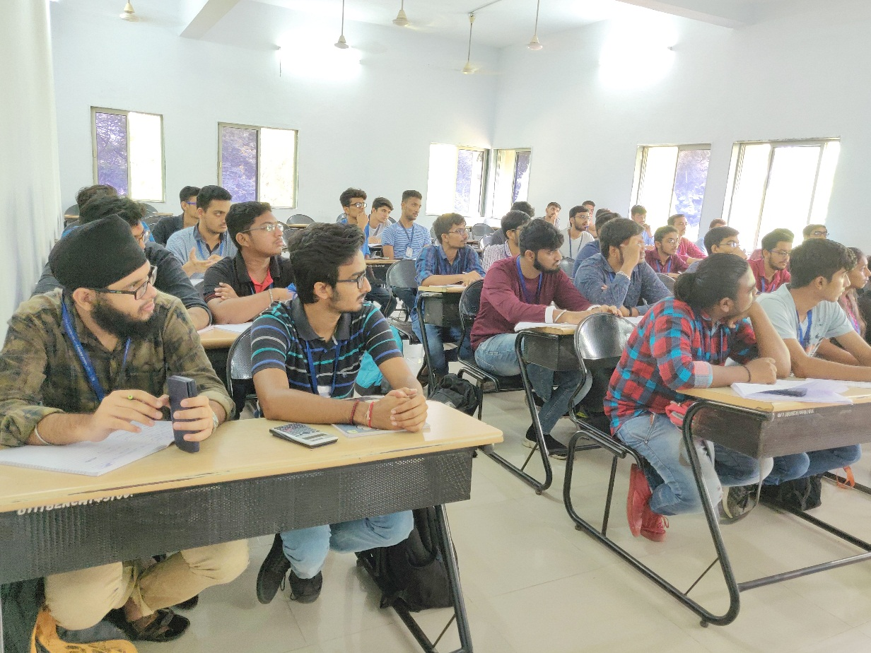
Question Answer Session

