Gandhinagar Institute of Technology
A Report on
“Problem Definition Guidelines”
(9th July 2019)

Workshop Overview:
The SSIP team of GIT has organized workshop on “Problem Definition Guidelines” on 09/07/2019 at 12:15 pm in C107. Prof Mukesh Parmar mentored the workshop. The students of 5th semester Computer Engineering Division A attended the workshop. There were 38 participants.

Objective:
The objective of the workshop was to clarify the benefits of becoming Entrepreneur and founder of a Startup. The hidden objective of the workshop was also to educate them about design methodology and spread awareness about the SSIP and IPR policy launched by Government of Gujarat.

Workshop Detail:
The session started at 12:15 in C107. The participants were very energetic to know about the flow of workshop. Prof Mukesh Parmar commenced the session by briefing the term Startup to the participants. He informed the participants about the various elements of Startup. The importance of unique business idea was informed by him. He also added that the experience of failure will teach them.

He informed participants that to identify the real pain of customer one must interact with the actual users. The actual problems associated with product, scope of improvement for ease of use can be known only from actual users. The observation on the activities performed by them also helps in identifying problems. He informed participants to follows the iterative loop for concluding to innovation. He also educated them about various steps and tools involved in the iterative loop of innovation.

He asked participants to divide themselves into groups and start identifying problems definitions. During the exercise he helped students to complete one loop of problem identification. He also assisted them in ideation exercise wherever they fail. The participants were enjoying the methodology of innovation. The session concluded with the domain selection of all groups and problem selection by few groups. He also informed participants about the benefits of SSIP policy.

The event was a grand success under the enlightenment of Dr H N Shah, Principal of the institute and the participants.

Workshop Memories:
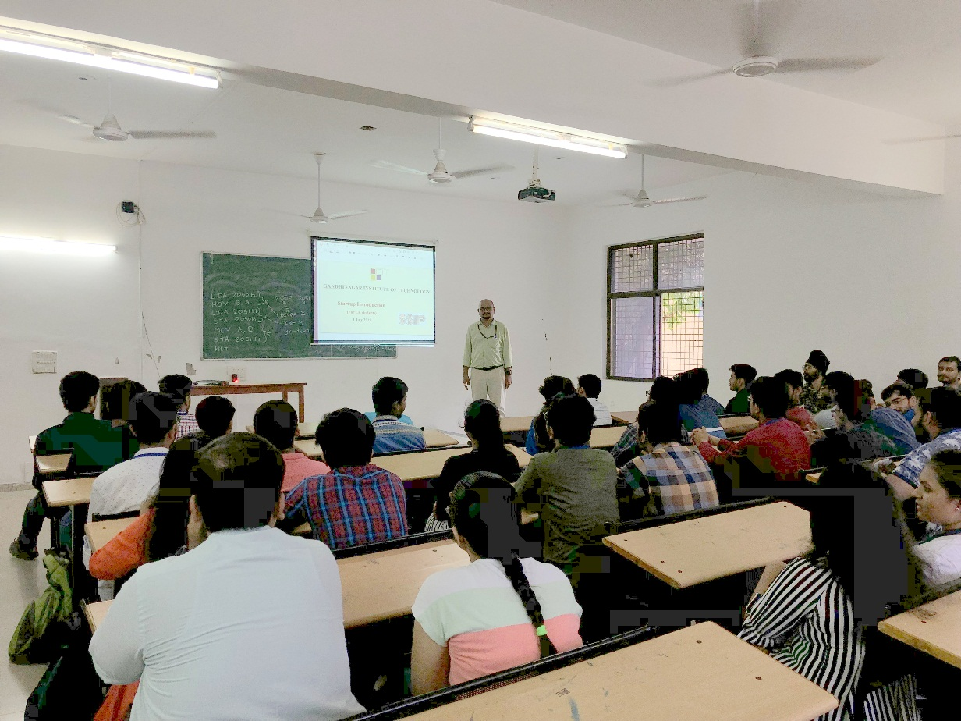
Mentor Initiating Session

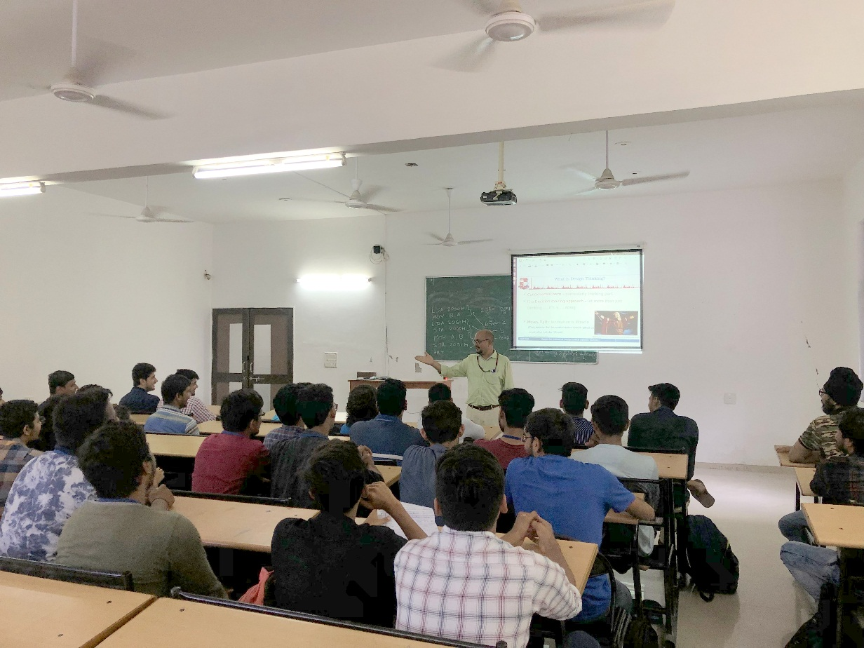
Mentor Addressing Participants
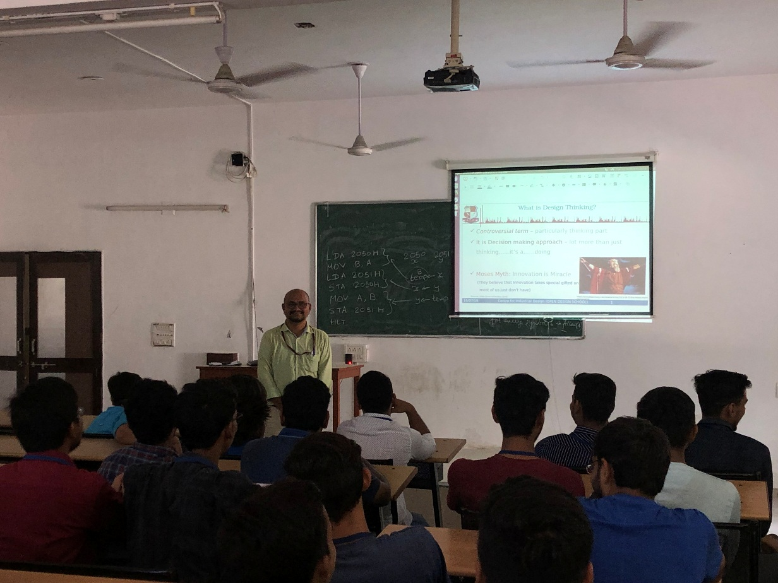
Question Answer Session

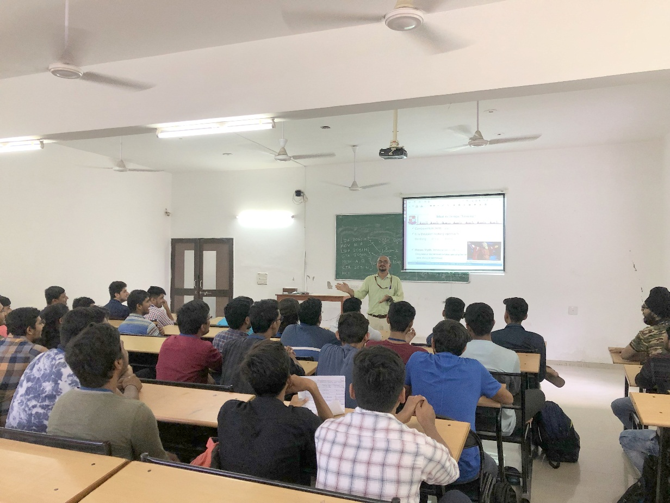
Mentor Responding to query

