Gandhinagar Institute of Technology
A Report on
“Opportunity Identification”
(10th July 2019)

Workshop Overview:

The SSIP team of GIT has organized workshop on “Opportunity Identification” on 10/07/2019 at 9:45 am in C107. The workshop was mentored by Prof Mukesh Parmar. The workshop includes brainstorming activity and making of proof of concept. The students of Computer Engineering Division C attended the workshop. There were 38 participants.

Objective:

The objective of the workshop was to educate the participants about problem identification and design methodology. The hidden objective was to teach them the process of making final product by considering various aspects like ergonomics, manufacturing, athletics etc.

Workshop Detail:

The workshop commenced at 9:45 am in C107. Prof Mukesh Parmar introduced the term “Startup” in the beginning of the workshop. He added that the Innovation is the essential portion of the Startup. The necessity of innovation was explained to the participants for startup. He also informed the participants that there is no shortcut for innovation. He motivated participants by debating successful startup stories like OYO room, Flipkart, Amazon, ULA, UBER etc. He added that there is requirement of out the box thinking not 10 or 20 years of experience.

The students learnt that it is essential to have team members of different expertise. The students were asked to form their groups. They were informed to select the domains. They were asked to exercise for AEIOU framework. The problems related with the domain were brainstormed and noted in logbooks. They were asked to find viable solutions of those problems. They were educated that one of the mixtures leads to innovative problem statement.

The participants started following the design methodology described by the mentor. They started interacting within groups and coming up with innovation ideas. Prof Mukesh Parmar guided the students for following steps of ideation. The participants have concluded their domains. The mentor informed them to start literature survey for finding out innovative solutions for the problems which they will find in their respective domains.

The event was a grand success under the enlightenment of Dr H N Shah, Principal of the institute and the participants.

Workshop Memories:
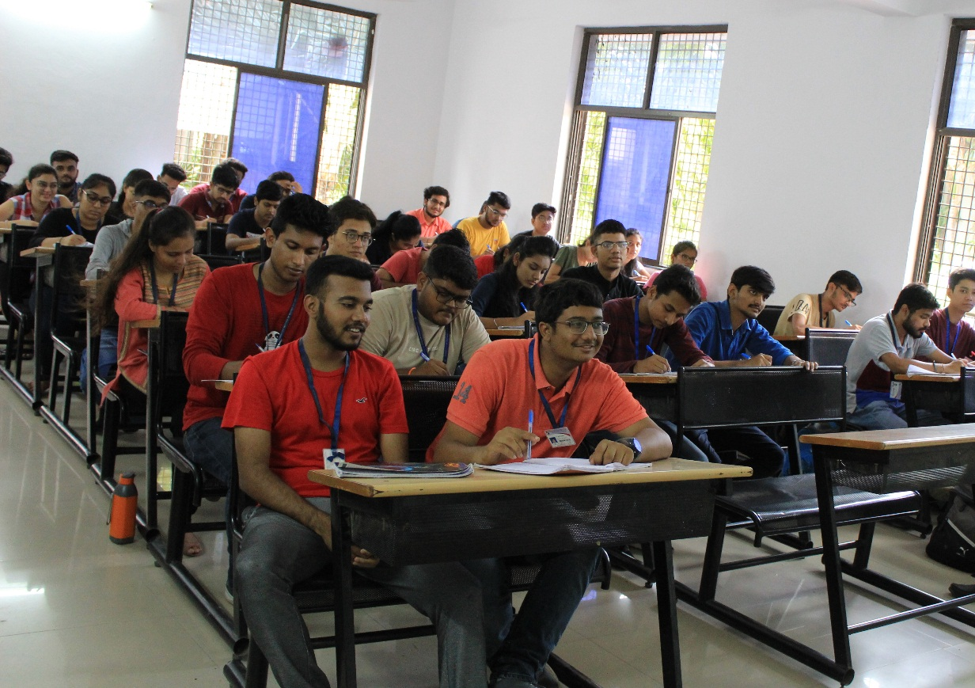
Students Listening to mentor

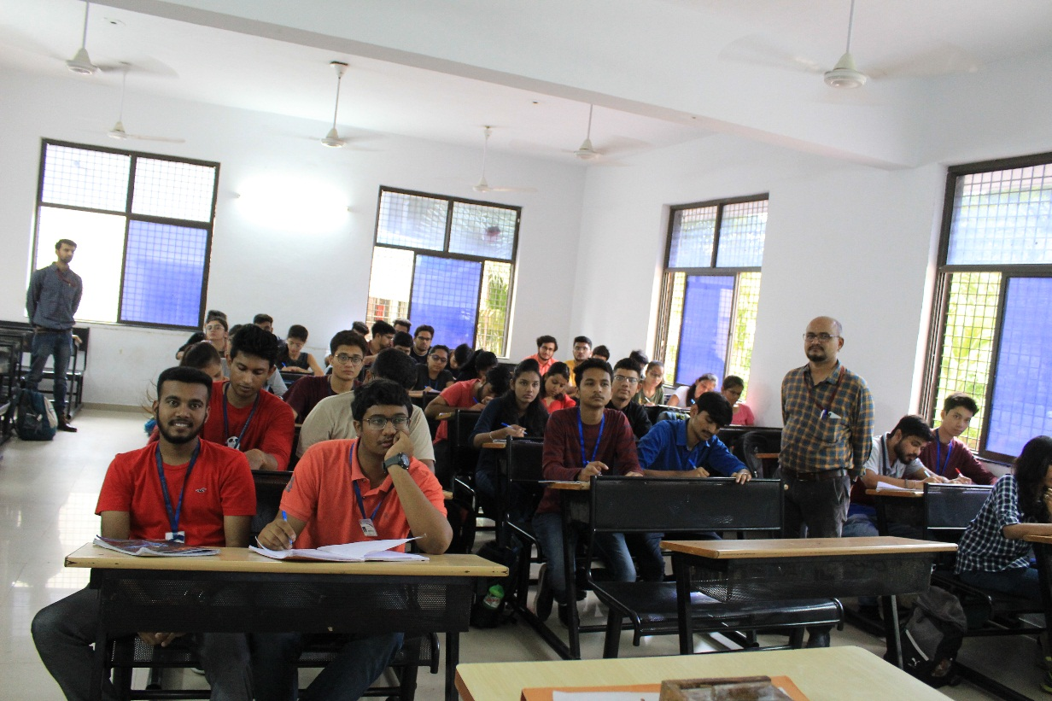
Mentor Interacting with participants
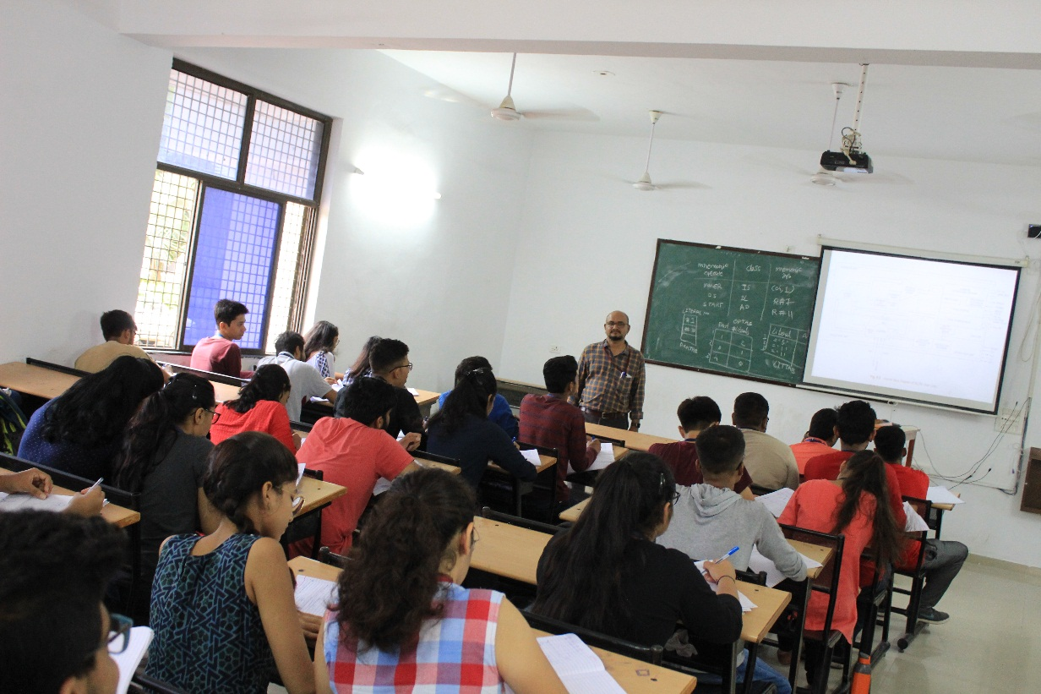
Mentor Delivering Session

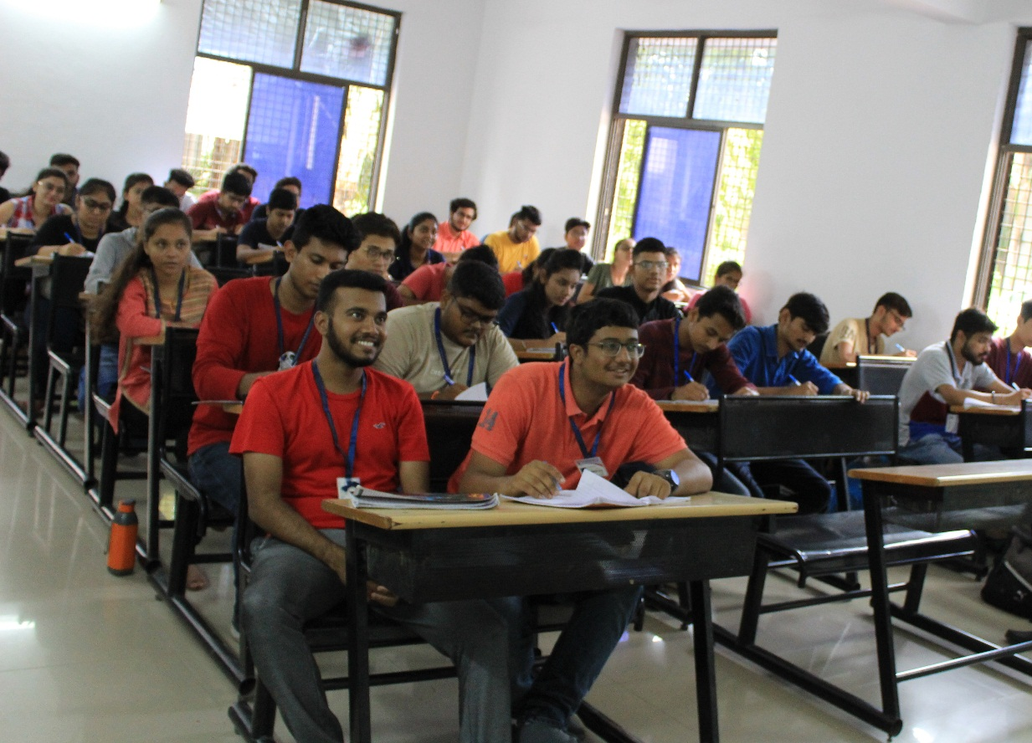
Question Answer Session

