Gandhinagar Institute of Technology
A Report on
“Brainstorming”
(11th July 2019)

Workshop Overview:
The SSIP team of GIT has organized workshop on “Brainstorming” on 11/07/2019 at 12:15 pm in C107. Prof Mukesh Parmar mentored the workshop. The students of Computer Engineering Semester 5 Division B attended the workshop. There were 52 participants. The participants were taught about the technique to derive innovative project definition and its solution during the workshop.

Objective:
The objective of the workshop was to educate the participants about design thinking methodology. The silent objective was to motivate them to attempt for solution without fear of failure. The hidden objective was also to share the information about SSIP and IPR policy launched by Government of Gujarat.

Workshop Detail:
The session started at 12:15 pm in C107. The session commenced by small brainstorming exercise by Prof Mukesh Parmar. He explained the flow of session by the exercise in effect way. He added that today’s market demands upgradation of technology. By the example of Nokia, he explained that the resistance to the change or upgradation will lead to failure. He also added the technological disruptions helped the innovators to serve the society in better way.

He gave the example of the MERU cab. The way OLA and UBER learnt from MERU cab was discussed by him to explain the participants about learning from other’s mistake. He also added the such out of the box thinking will help them to succeed. He also educated the participants about the elements of succeed like idea, team, business plan, fund, timing etc. He also educated them about the Intellectual Property Right. He educated them about the various mode of IP rights like, copyright, trademark, patent etc. He motivated them for patent filling for recognition as well as commercial rewards.

He asked participants to divide themselves into groups and start identifying problems definitions. During the exercise he helped students to complete one loop of problem identification. He also assisted them in ideation exercise wherever they fail. The participants were enjoying the methodology of innovation. The session concluded with the domain selection of all groups and problem selection by few groups. He also informed participants about the benefits of SSIP policy.

The event was a grand success under the enlightenment of Dr H N Shah, Principal of the institute and the participants.

Workshop Memories:
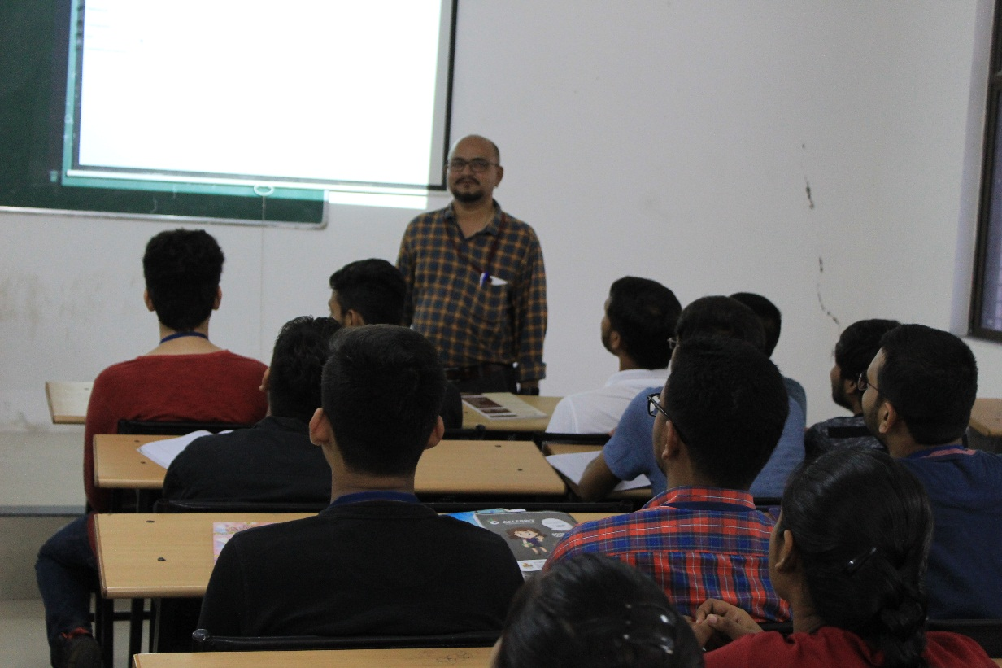
Mentor Delivering Session

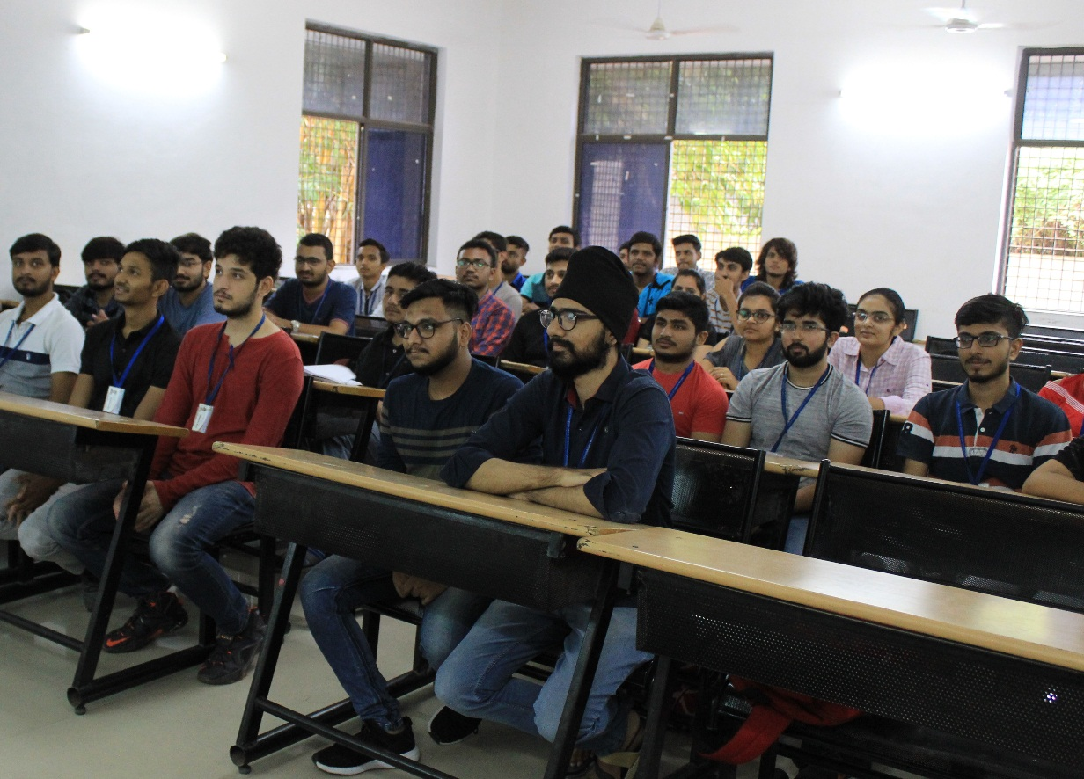
Students Listening to Mentor
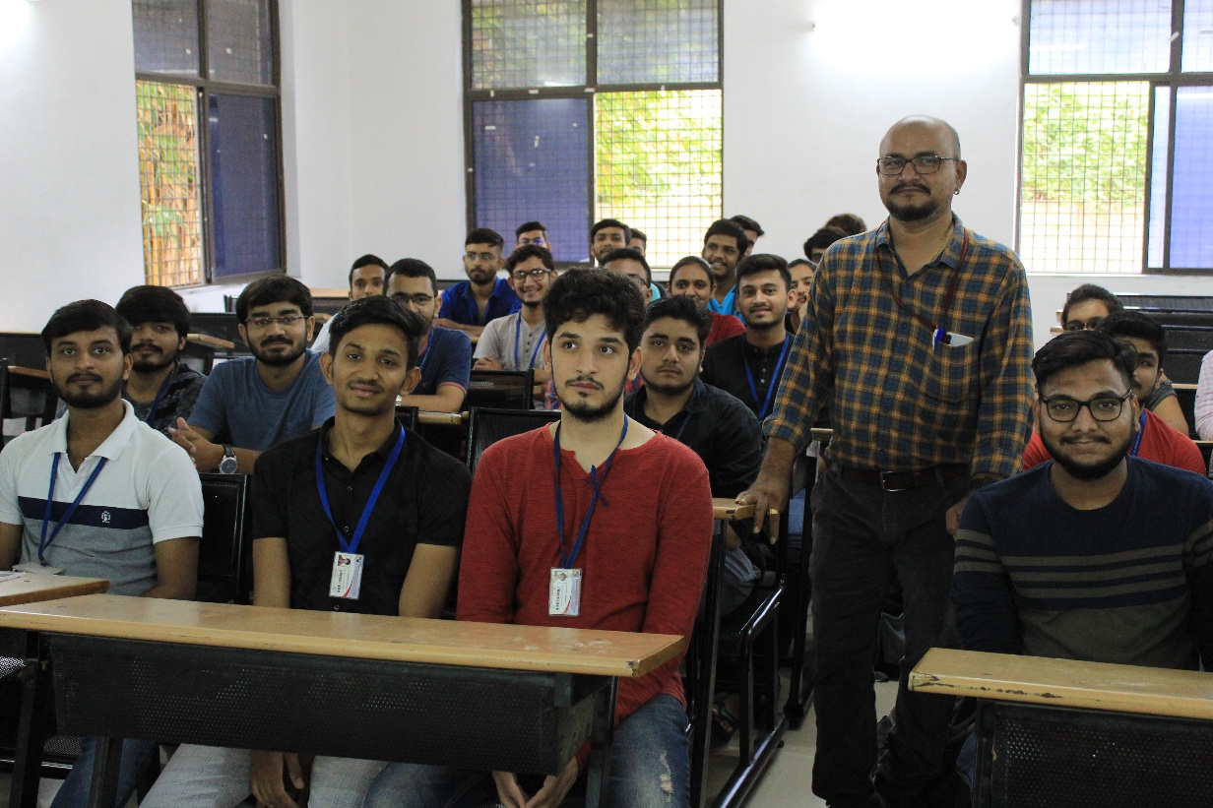
Mentor Interacting with Students

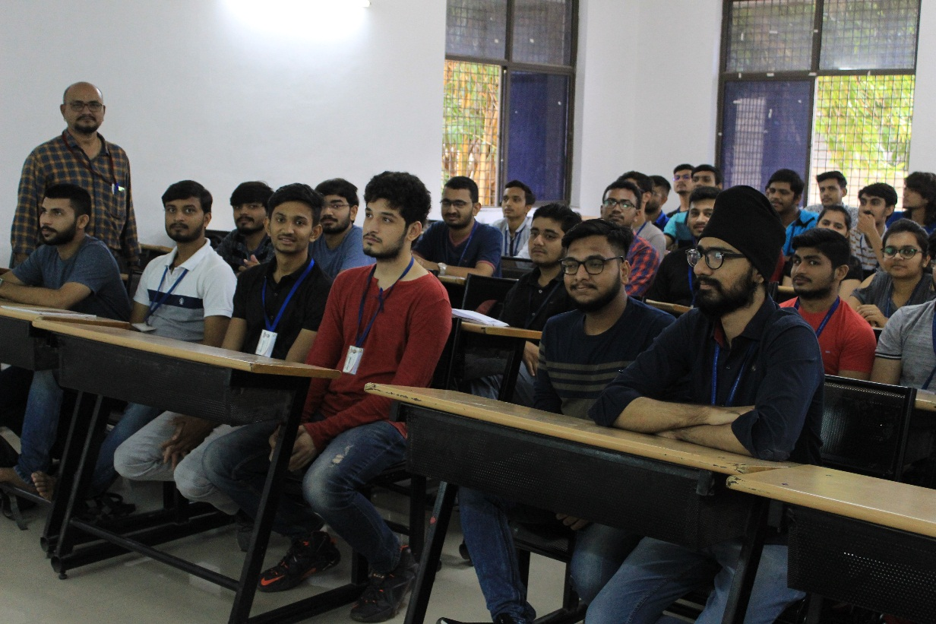
Question Answer Session

