Gandhinagar Institute of Technology
A Report on
“Tap Your Ideas”
(12th July 2019)

Workshop Overview:

The SSIP team of GIT has organized workshop on “Tap Your Ideas” on 12/07/2019 at 1:30 pm in B204. SSIP coordinator Prof Mrugesh B Khatri & Prof Paresh Umredkar mentored the workshop. The students of 5th semester Civil Engineering attended the workshop. There were 32 participants. The workshop was organized to educate them about the tools to derive innovation and a mentoring session for project selection.

Objective:

The objective of the workshop was to educate the participants about the essentials of successful Startup. The silent objective was to guide participants in ideation exercise and mentor them while finalizing project definitions. The hidden objective was also to share the information about SSIP and IPR policy launched by Government of Gujarat.

Workshop Detail:

The session started at 1:30 pm in B204. The tiredness of the participants was removed by small clapping activity at the beginning of the session. Prof Mrugesh B Khatri started sharing information about Startup in the energetic atmosphere. He informed participants about were elements of successful Startup like idea, team, business model, funding, timing etc. He added that there is necessity of unique idea to create your own idea.

He educated participants to make their team comprising of various field experts rather then of friends only. The combination of various field expert in team will reduce the effort of your team to solve any problem at any stage. He also informed participants to make the business model consisting of planning each stage from starting towards the execution. He educated participants about methodology to avail financial benefit through SSIP.

Prof Paresh Umerdkar has debated successful startup stories of Civil Engineering field. He shared innovative project ideas like plastic reinforced concrete, light weight and strong brick alternate, construction equipment rent services, plastic reinforced waterproof roads etc. He asked students to find out similar type of ideas from their domain. He asked students to work in groups of 4 or 5. He helped them in brainstorming the innovation in their respective domain.

The event was a grand success under the enlightenment of Dr H N Shah, Principal of the institute and the participants.

Workshop Memories:
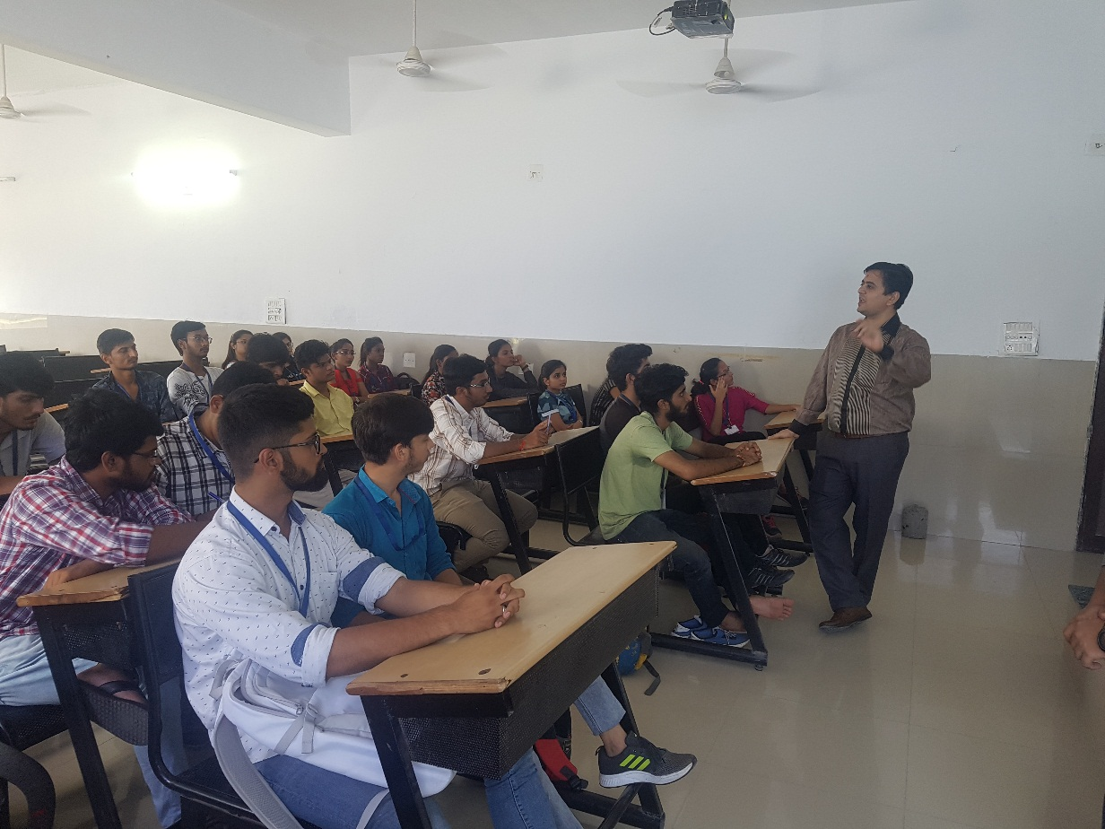
Students Listening to Mentor

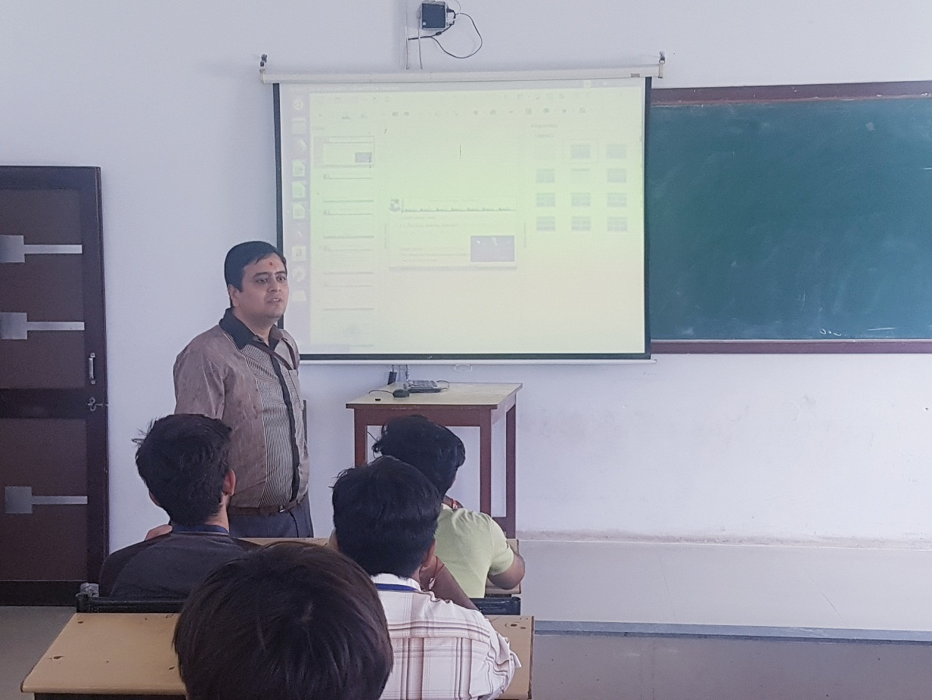
Mentor Delivering Session
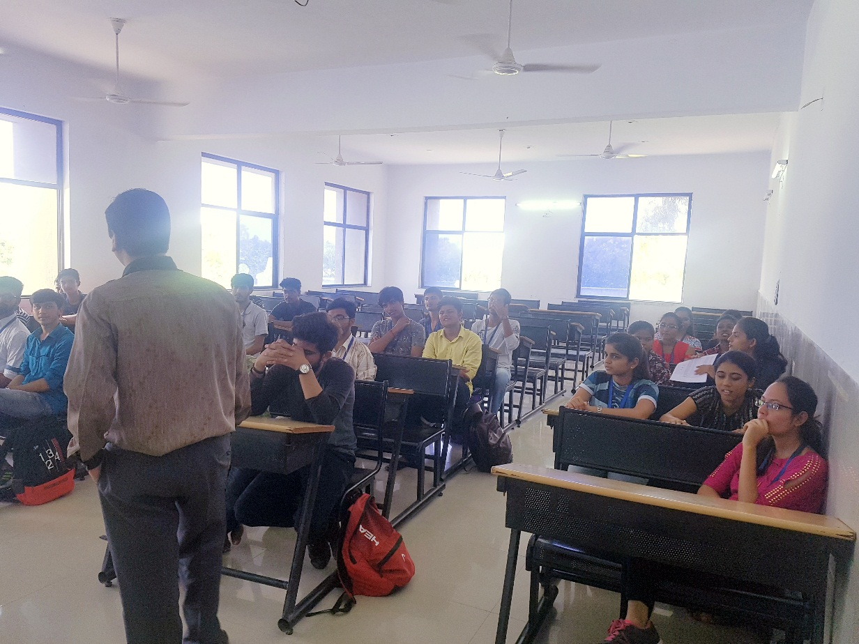
Mentor Addressing Student Query

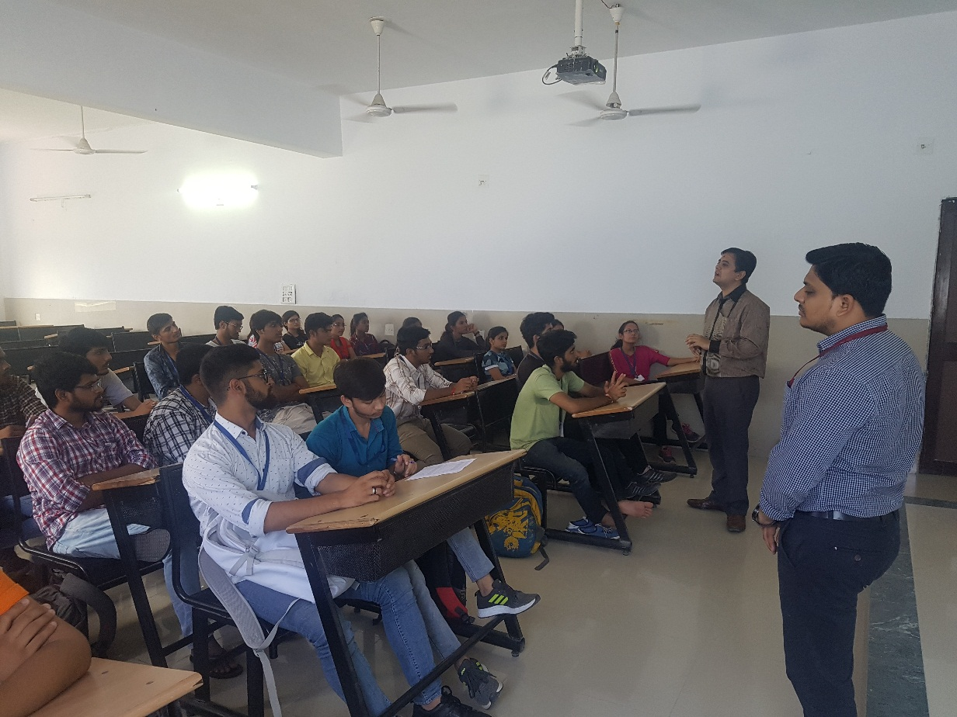
Question Answer Session

