Gandhinagar Institute of Technology
A Report on
“Ideation Algorithm”
(16th July 2019)

Workshop Overview:

The SSIP team of GIT has organized workshop on “Ideation Algorithm” on 16/07/2019 at 1:30 pm in C207. Prof Rohan Prajapati & Prof Prakash Patel mentored the workshop. The students of 5th Semester Information Technology Division B attended the workshop. There were 49 participants. The workshop was organized to mentor the participants and helping them in finalizing their problem statements.

Objective:

The objective of the workshop was to educate the students about the Startup by sharing the information of successful Startup stories of India. The silent object of workshop was to provide group mentoring to participants. The hidden objective of workshop was also to educate them about SSIP and IPR policies launched by Government of Gujarat.

Workshop Detail:
The session started at 1:30 pm in C207. Prof Rohan Prajapati started session by presenting the term Startup. He educated participants about the difference between Entrepreneur and Startup. He added that the Entrepreneur’s primary aim is financial gain whereas for Startup it is not a primary goal. He added that innovation is compulsory in case of startup. The success of your innovation depends on the feedback of actual users of your product.

He added that the chances of success for a startup depends on effective market survey. The actual problems associated with the product can only be identified by interacting with the regular user of the product. There are more chances of success if those problems can be identified before launching your product into the market. He added that to take feedback from customers it is necessary that they used our product. So, the prototyping making is mandatory step for market survey for your startup.

Prof Prakash Patel asked students to divide themselves into groups for ideation exercise. The participants were asked to choose the domain of their choice. He asked them to use AEIOU tool to derive the innovative idea in their respective domain. He along with Prof Rohan Prajapati helped students in searching out different combinations of problems and solutions during the ideation exercise. The students were delighted by finalizing their problem statements under mentoring of both the faculty members.

The event was a grand success under the enlightenment of Dr H N Shah, Principal of the institute and the participants.

Workshop Memories:
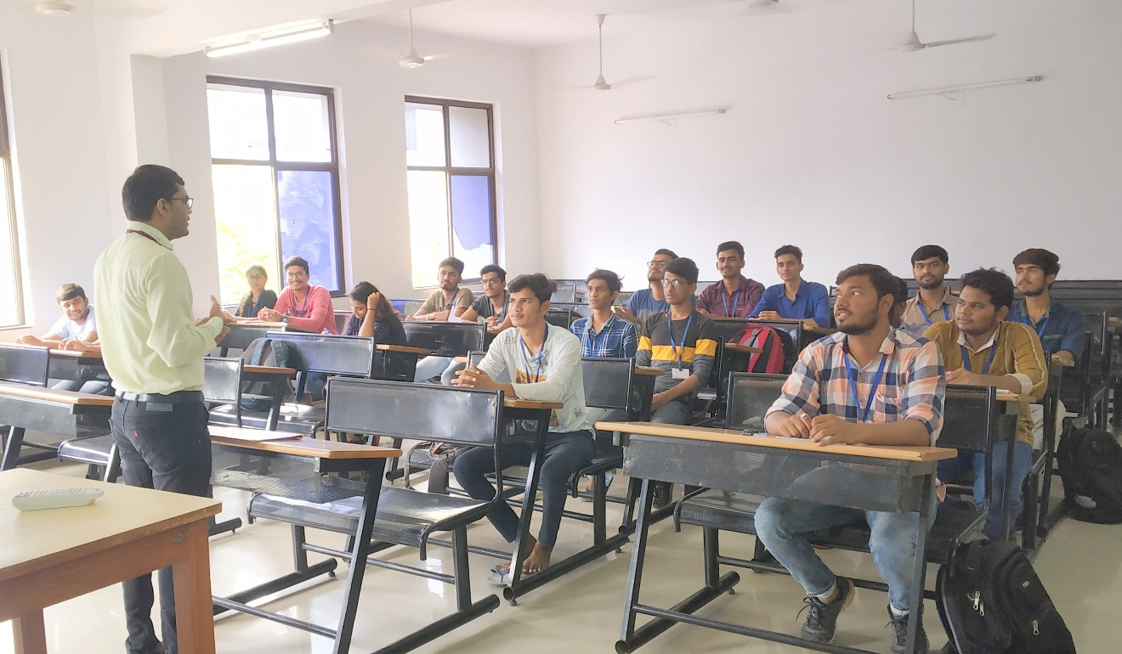
Mentor Delivering the Session

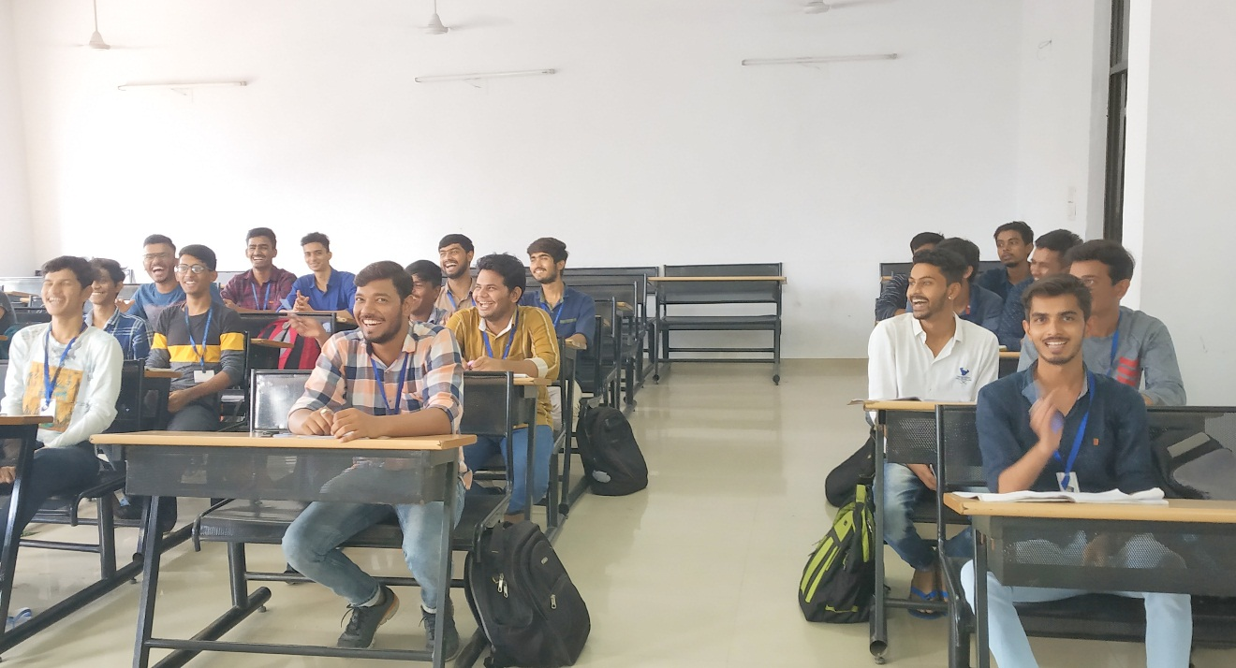
Students Enjoying the Session
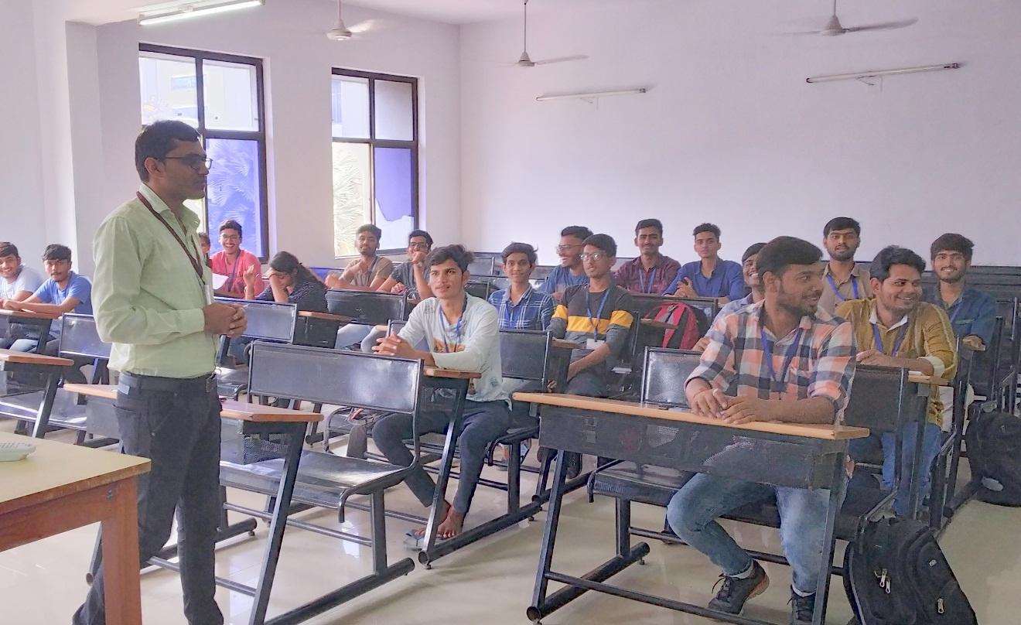
Mentor Responding to Student Query

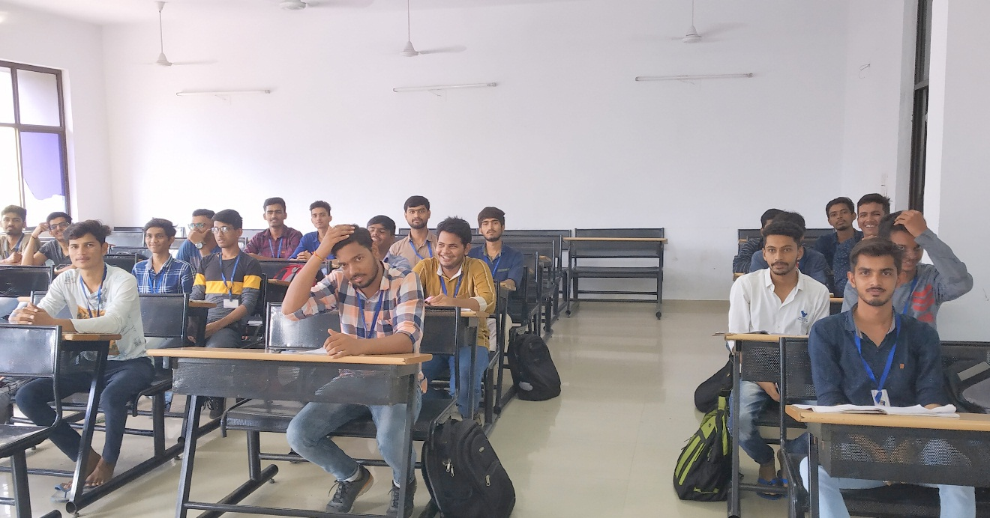
Question Answer Session

