Gandhinagar Institute of Technology
A Report on
“Idea Pinching”
(19th July 2019)

Workshop Overview:

The SSIP team of GIT has organized workshop on “Idea Pinching” on 19/07/2019 at 1:30 pm in C307. Prof Rohan Prajapati mentored the workshop. The students of 5th Information Technology Division A attended the workshop. There were 45 participants. The workshop was organized to educate the participants about Startup and teach them design methodology of identifying problems.

Objective:

The main objective of the event was to sensitize the students about Start-up. The Start-up is mostly misunderstood as synonyms of Entrepreneur. The silent objective of the event was also to educate the students that innovation is mandatory for Start-up. The students were also educated about various Government Policies to promote Start-up.

Workshop Detail:

The workshop commenced with the overview of the sessions at 1:30 pm in C307. The participants were very energetic to know about the flow of workshop. Prof Rohan Prajapati commenced the session by briefing the term Startup to the participants. He informed the participants about the various elements of Startup. The importance of unique business idea was informed by him. He also added that the experience of failure will teach them.

The requirement of identification of need was explained by the mentor. He informed that the observation is the key tool for identifying the requirements. He explained that the various solutions for the problems or needs must be worked out properly. He added that the idea validation includes most important step prototyping. He explained the importance of customer feedback to create successful Start-up. He also educated students to reserve their rights of their idea by introducing Intellectual Property Rights.

The participants were asked to select their team members and form one team. They were asked to note their mind mapping on a piece of paper. The mentor asked them to select their comfortable domain to proceed further. He asked them to barnstorm all the problems associated with their respective domain and figure out the solutions of the same. He educated the participants by selecting one combination out of that brainstorming exercise. Participants were delighted by concluding to their problem statements.

The event was a grand success under the enlightenment of Dr H N Shah, Principal of the institute and the participants.
Workshop Memories:

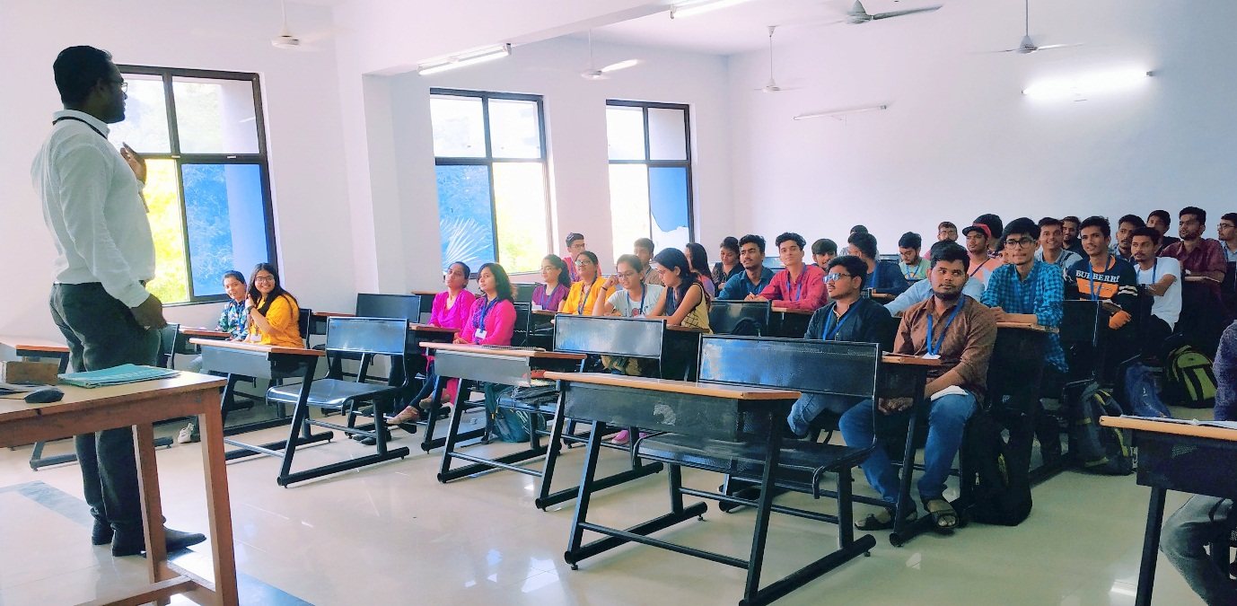
Mentor Delivering Session

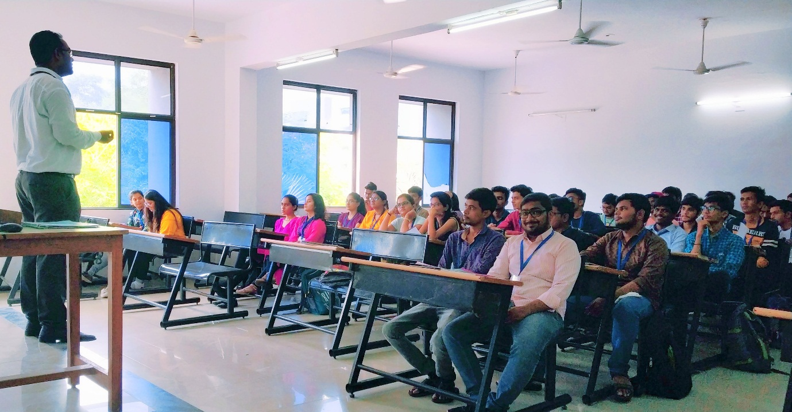
Mentor Interacting with Students

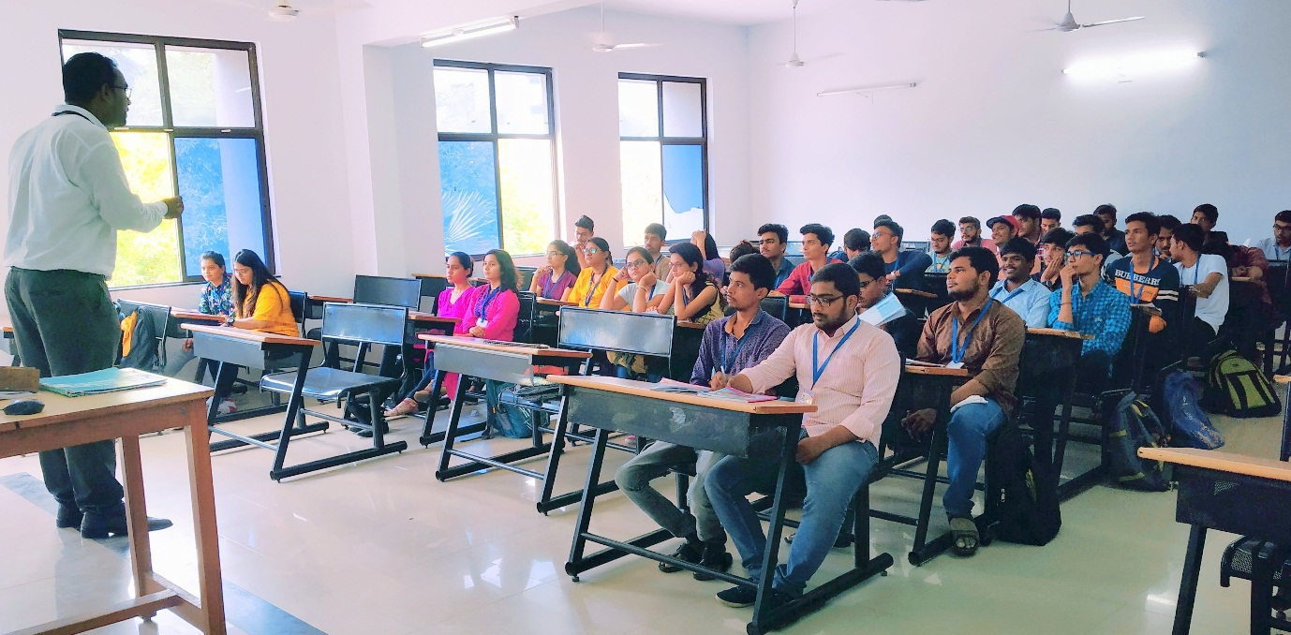
Mentor Answering to Students Questions

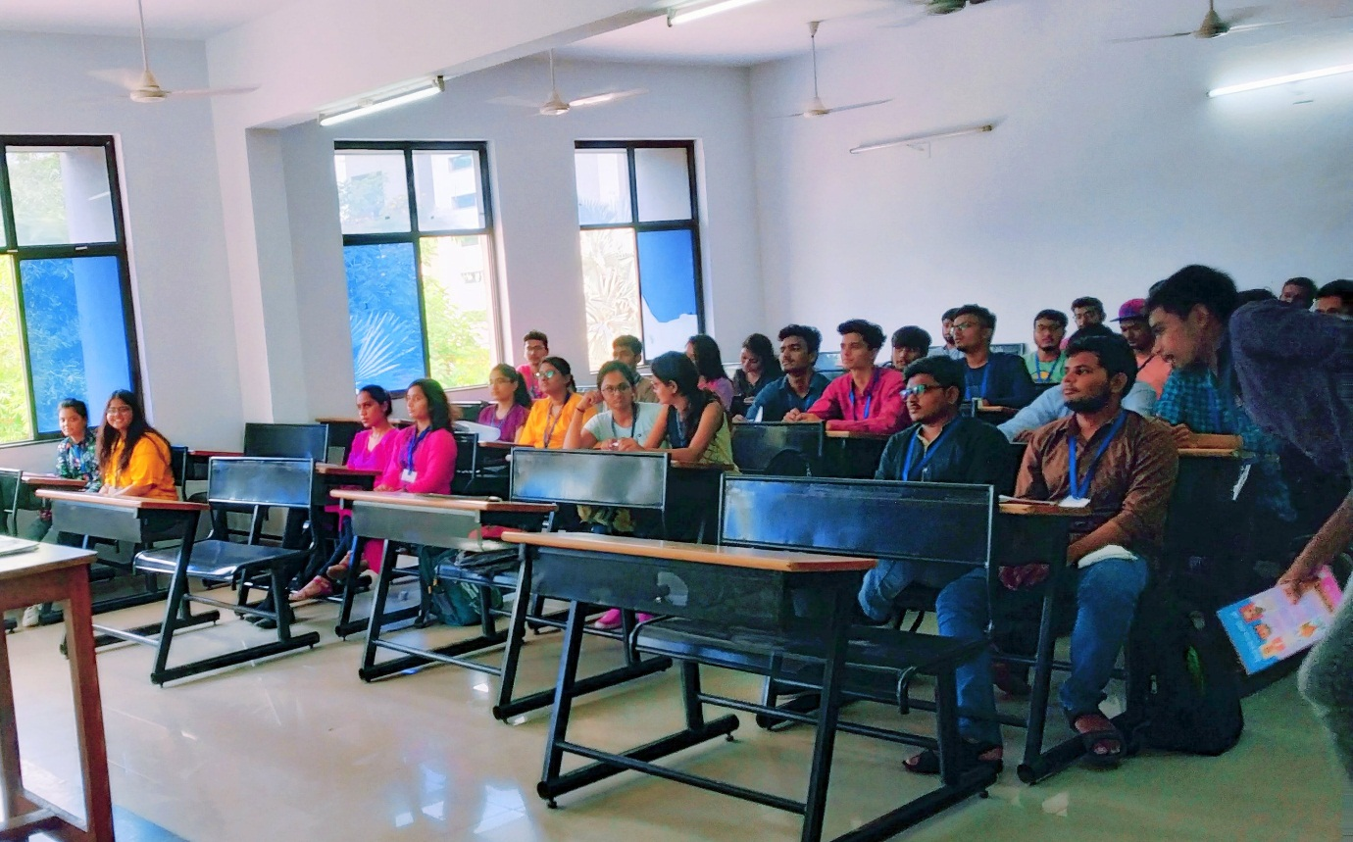
Question Answer Session

