Gandhinagar Institute of Technology
A Report on
“Digital Marketing”
(24th July 2019)

Workshop Overview:

The SSIP team of GIT has organized seminar on “Digital Marketing” on 24/07/2019 at 8:50 am in Seminar Hall (A105). The workshop was mentored by Mr Nirav Mistry, Digital Marketing Consultant. The students from different branches Engineering and Management attended the seminar. There were 170 participants.

Objective:

The objective of the seminar was to educate the participants about digital marketing platform. The silent objective was also to motivate and teach them the trendy tools of digital market to fetch the required information.

Workshop Detail:

The event commenced at 8:50 am in Seminar Hall (A105). The participants registered them initially and occupied their seats. Prof Milan Shah, HOD MBA, welcomed Mr Nirav Mistry with a flower bouquet. The mentor initiated the session by providing information regarding internet users in past 3 year and how the number will increase in upcoming 3 years. He convinced participants with the information that there is huge market for digital marketing.
.
He provided information about SEO (Search Engine Optimization), SEM (Search Engine Marketing), SMM (Social Media Marketing), Email marketing etc. He informed participants that search engine marketing is also an important tool to promote your product or company. He added that search engine optimization is required to be in first choice of customer as 95% of customers do not go beyond 3rd search result. Hence, one should focus on comprehensive content, conceptual presentation of product, content writing for occupying first three positions in any search on search engines.

He added that the proper use of digital tools will help in business promotion also. He added that the search engine data can be optimized, and the requirement of customer can be drawn out of it. The repeated advertisement for this requirement can be sent to customer same as the advertisements of amazon and flipkart we see in other applications. He also educated the participants about the processes done behind one search of any search engine. He convinced participants that effective use of social media also helps in digital marketing.

The event was a grand success under the enlightenment of Dr H N Shah, Principal of the institute and the participants.

Seminar Memories:
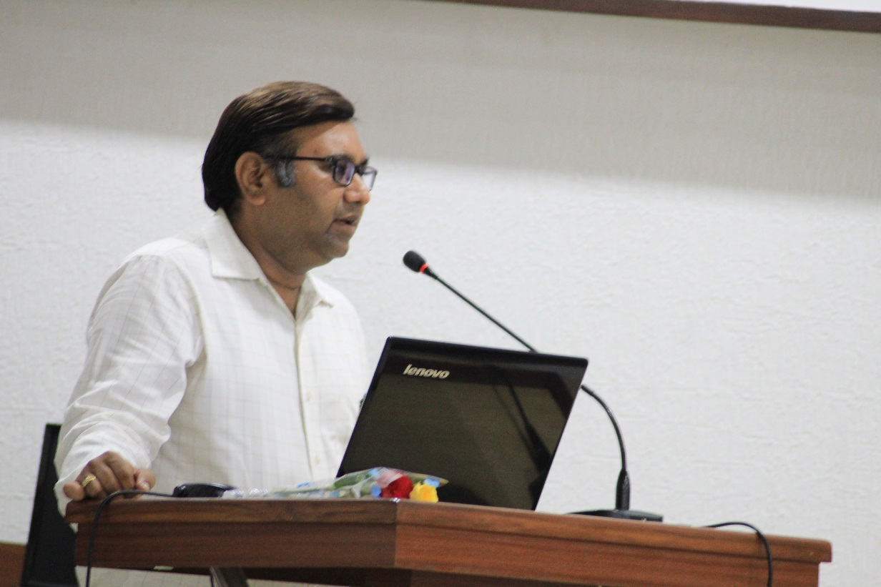
Prof Milan Shah Initiating Session

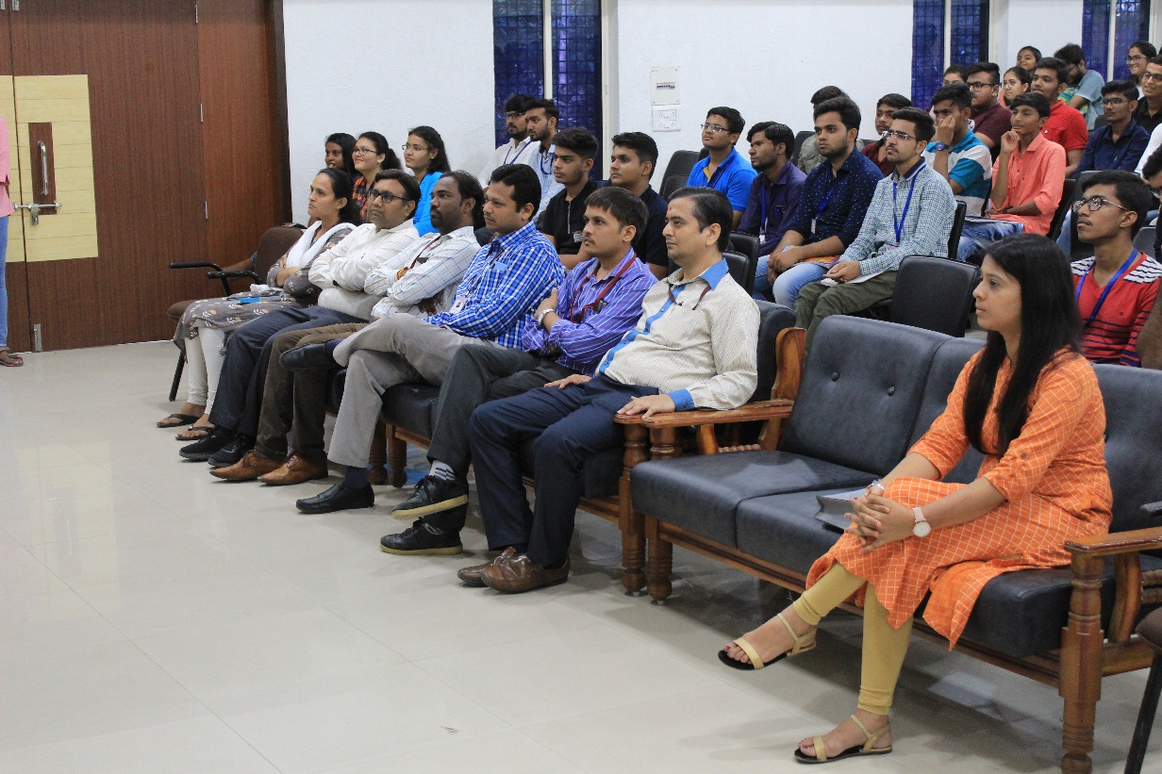
Participants Listening to Mentor
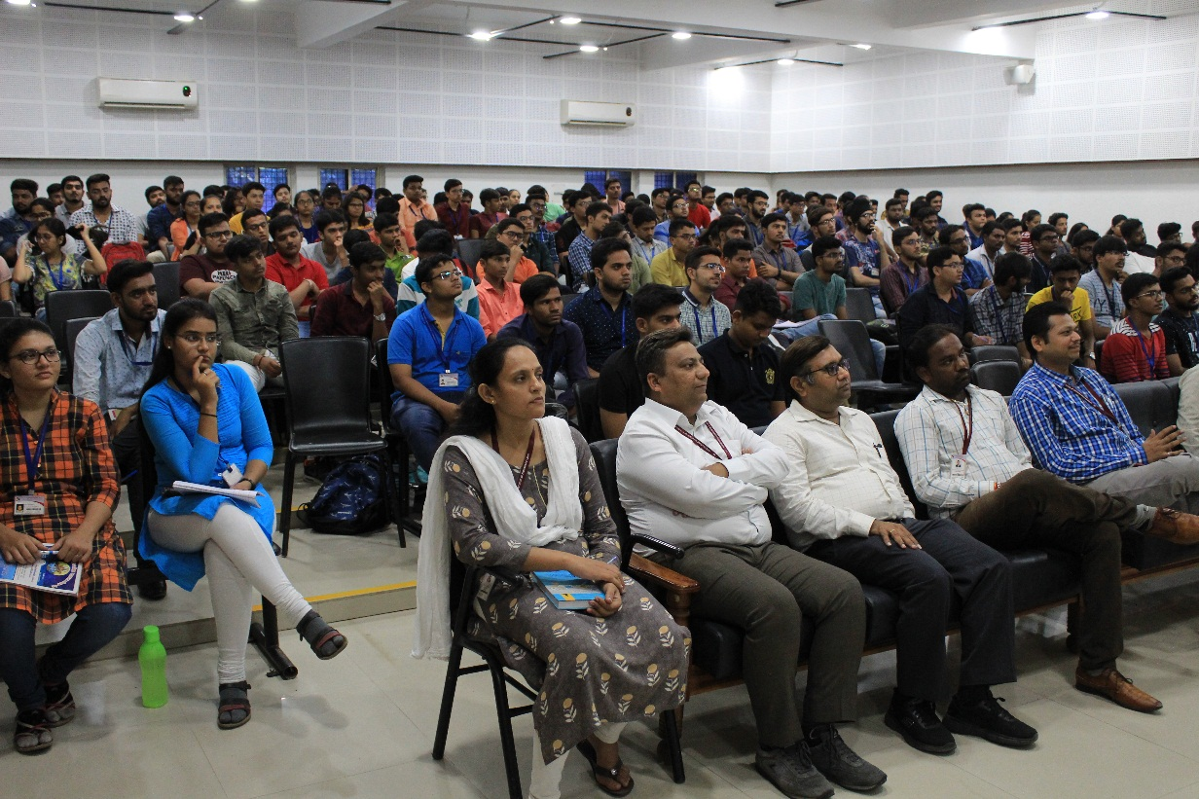
Participants Enjoying Flow of Session

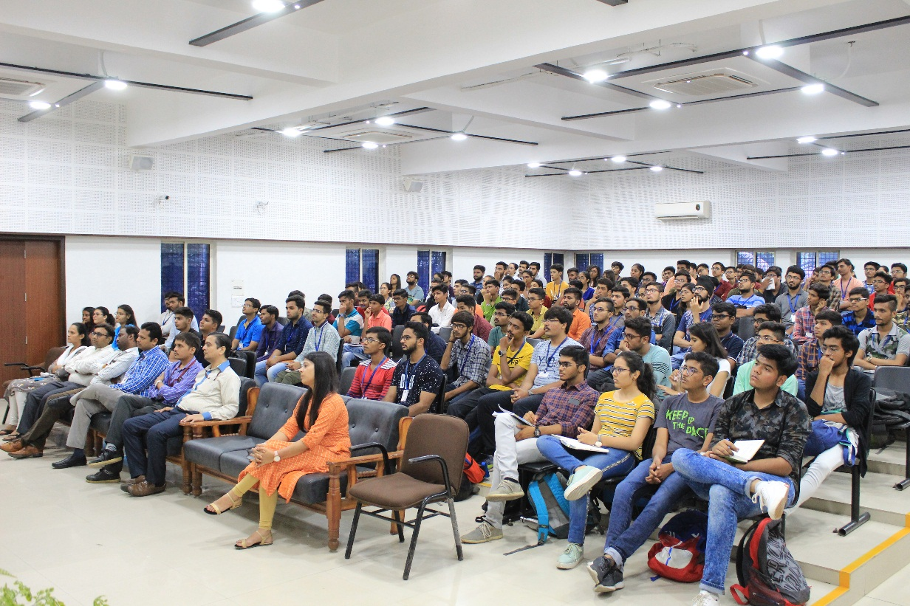
Participants Interacting with Mentor

