Gandhinagar Institute of Technology
A Report on
“A Key to Succeed in Competitive Market”
(25th July 2019)

Seminar Overview:
The SSIP team of GIT has organized seminar on “A Key to Succeed in Competitive Market” on 25/07/2019 at 1:30 pm in C206. Prof Rohan Prajapati & Prof Prashant Jani mentored the seminar. The students of final year Information Technology Division B attended the seminar. There were 42 participants.

Objective:
The objective of seminar was to educate the participants about thinking for problem solution by considering all the aspects of it. The hidden objective was also to make them aware about SSIP & IPR policy launched by Government of Gujarat.

Seminar Detail:
The session commenced at 1:30 pm in C206. The participants were full of enthusiasm to know about the aspects of thinking for problem solution. Prof Rohan Prajapati informed the students about the level of competition in the market. He added that once must come up with unique strategy to satisfy the customer to succeed. He informed participants that sincere work is required to identifying real problem of customers.

He also educated participants about the prior art search before narrating the solution. The prior art will ensure the percentage of success in your idea. The information regarding similar attempts done by others need to be study before finding the problem solution. He added that the research in your domain will reduce the chances of failure. He also informed participants to be ready with other alternative in case of failure at later stage.

Prof Prashant Jani shared information about protection of their idea by means of patent. He added that there is option of provisional patent also. He shared case study of Satyanarayan Gangaram Pitroda to educate the participants about the importance of patent. He informed participants about various forms and documents required for filling patent. He further informed the fees structure for filling different types of patent.

In the last phase of seminar, the participants were educated about SSIP & IPR policy launched by Government of Gujarat to develop ecosystem for Startup. The benefits of SSIP policies were informed to the participants. They were also informed to opt ownership on their idea in form of patent. The provision of support for patent filling was also shared with them. The efforts made by GIT to develop the culture of Startup at GIT were also shared with them.

The event was a grand success under the enlightenment of Dr H N Shah, Principal of the institute and the participants.

Seminar Memories:
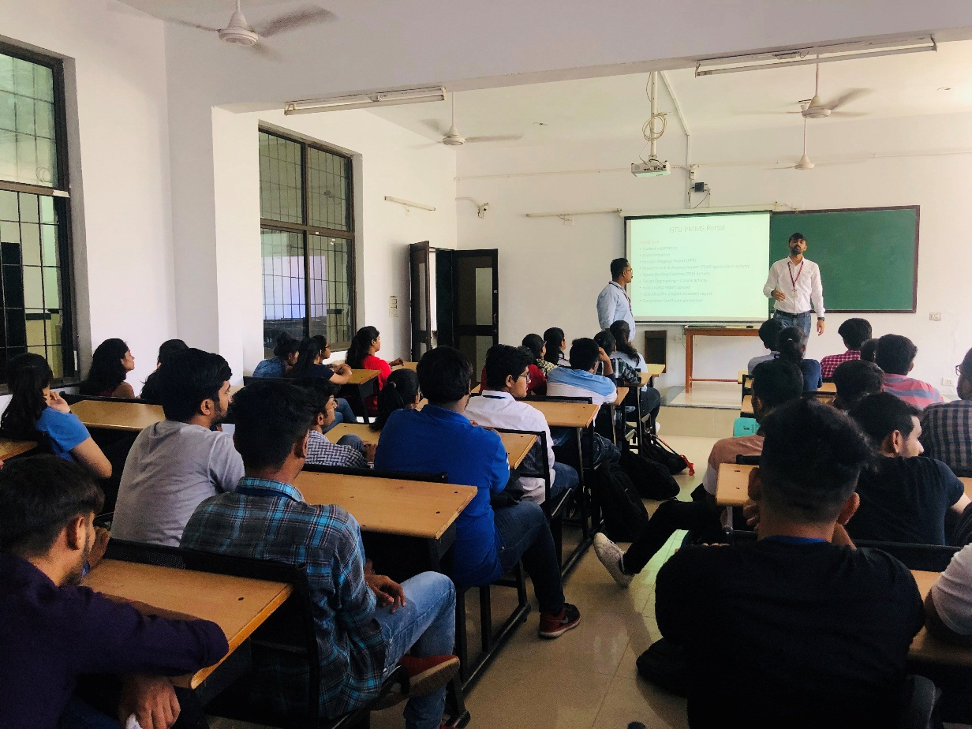
Mentor Delivering Session

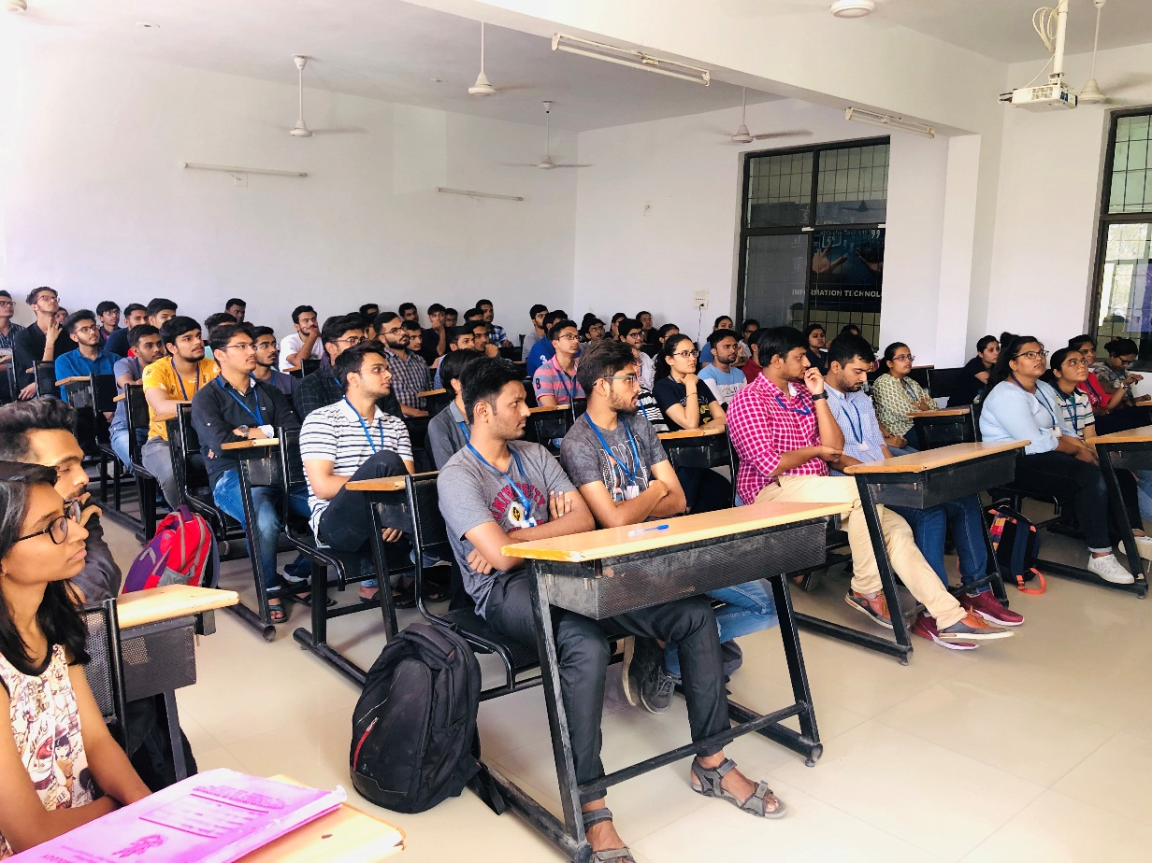
Participants Listening to Mentor

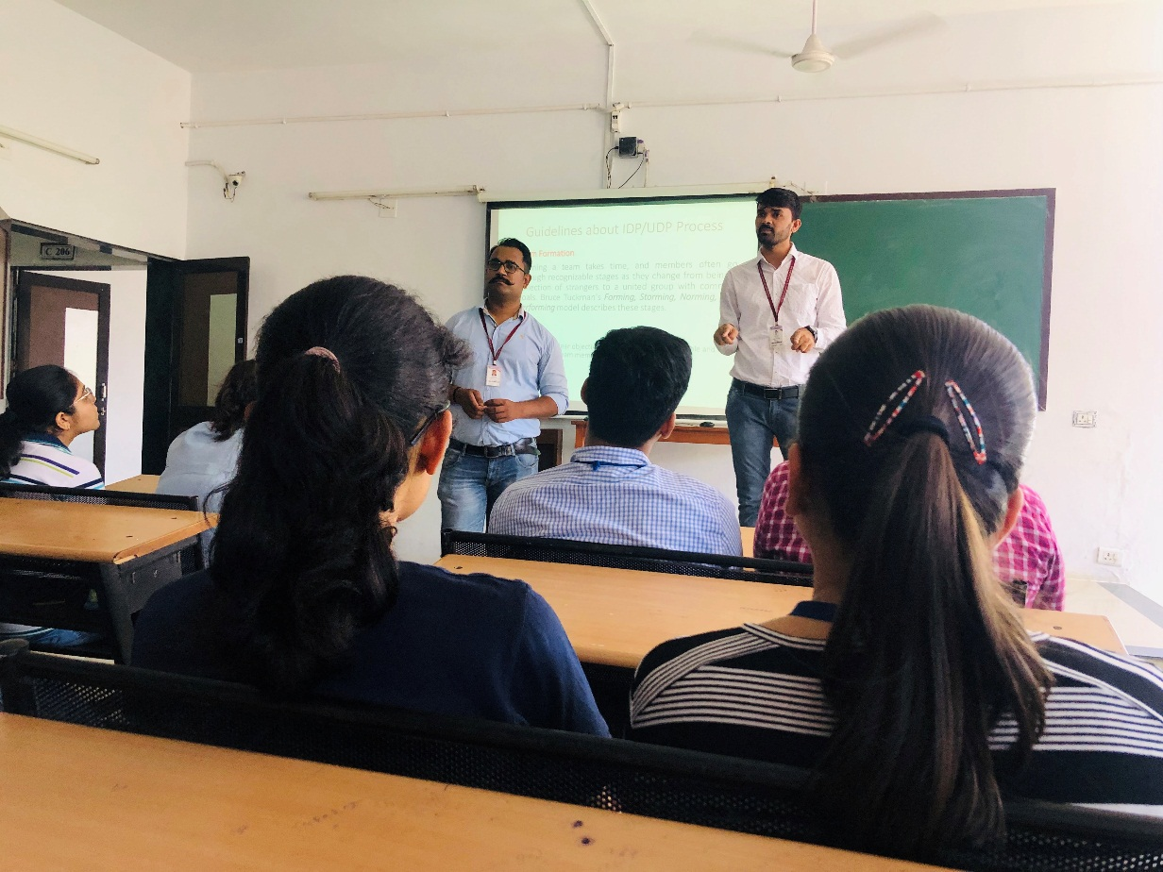
Mentor Interacting with Participants

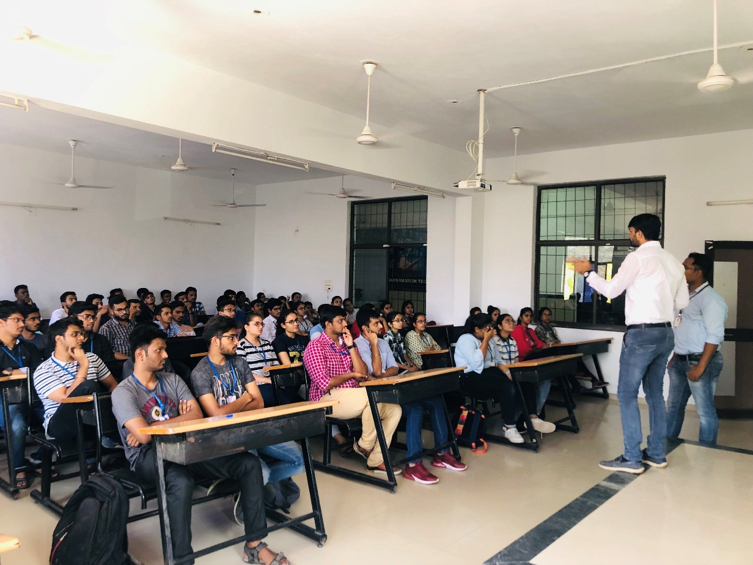
Mentor Addressing Student Query

