Gandhinagar Institute of Technology
A Report on
“Startup Sensitization”
(8th August 2019)

Seminar Overview:
The SSIP team of GIT has organized seminar on “Startup Sensitization” on 06/08/2019 at 8:50 am in C101. SSIP coordinator Prof Mrugesh B Khatri & co-coordinator Prof Jyotin A Kateshia mentored the seminar. The students of 3rd semester Computer Engineering Division A attended the seminar. There were 24 participants.

Objective:
The objective of the seminar was to aware the participants about the term Startup. The hidden objective was also to share the information about SSIP and IPR policy launched by Government of Gujarat.

Seminar Detail:
The session started at 8:50 am in C101. Prof Mrugesh B Khatri started sharing information about Startup in the energetic atmosphere. He educated participants about various elements of successful Startup like idea, team, business model, funding, timing etc. He further informed that there is necessity of unique idea to create your own idea.

He educated participants to make their team including of various field experts rather then of friends only. The mixture of various field expert in team will reduce the effort of your team to solve any problem at any stage. He also informed participants to make the business model containing of planning each stage from starting towards the implementation. He educated participants about procedure to avail financial benefit through SSIP.

Prof Jyotin A Kateshia cultivated participants about the quiring ownership on Intellectual Property Right. He informed participants that the provisional patent will help innovator to reserve the rights on their idea before commencement of a physical patent. He added that for medical, surgical, agriculture and horticulture there is no provision of patent filling. The prior art search in a proper way increases the chances of patent approval.

In the last phase of seminar, the participants were informed about SSIP & IPR policy launched by Government of Gujarat to develop ecosystem for Startup. The benefits of SSIP policies were informed to the participants. They were also informed to opt ownership on their idea in form of patent. The provision of support for patent filling was also shared with them. The efforts made by GIT to develop the culture of Startup at GIT were also shared with them.

The event was a grand success under the enlightenment of Dr H N Shah, Principal of the institute and the participants.

Seminar Memories:
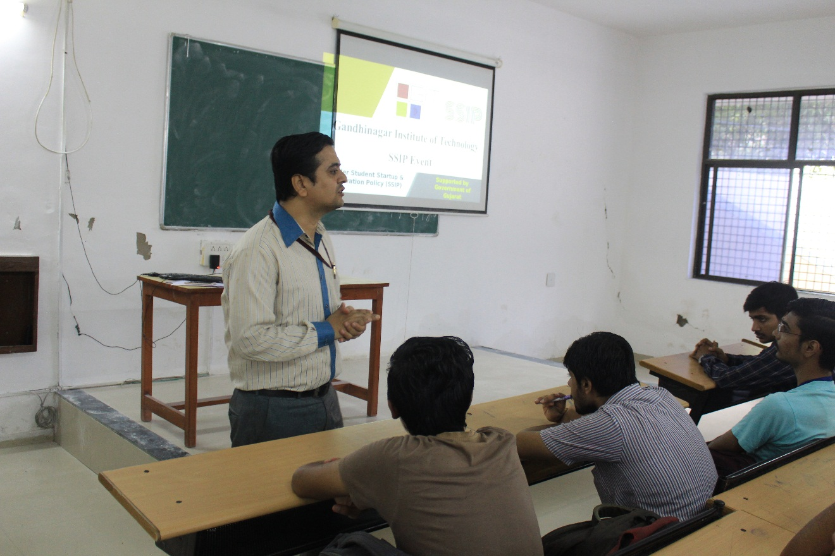
Mentor Addressing Participants

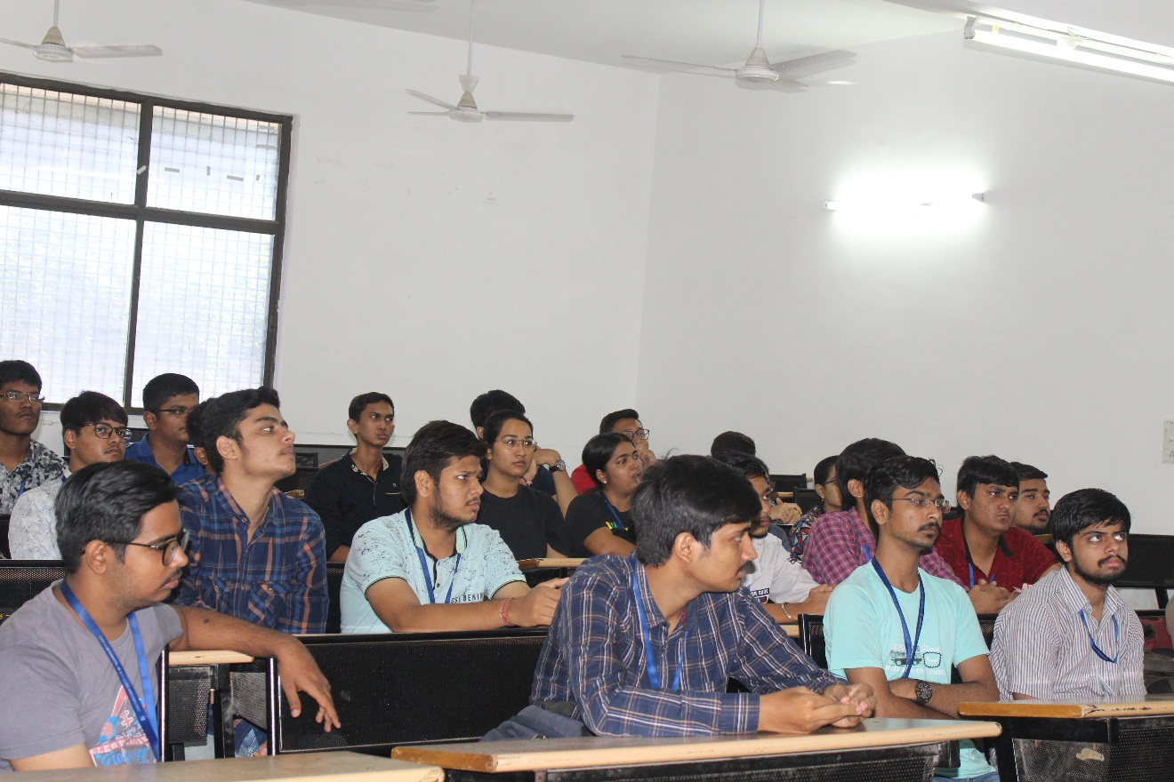
Participants Listening to Mentor
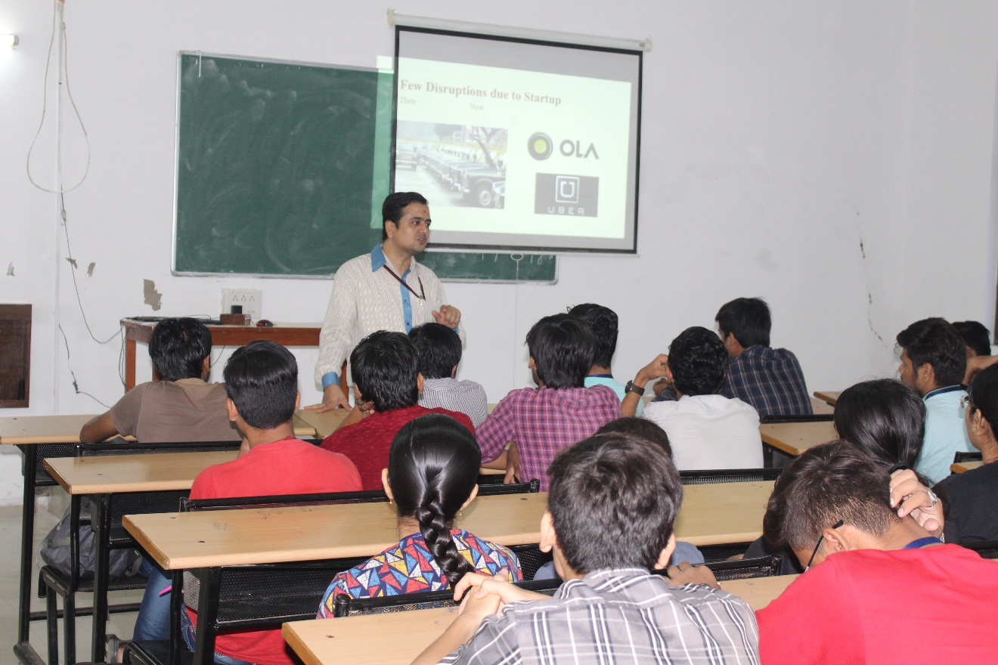
Mentor Explaining Startup Disruptions

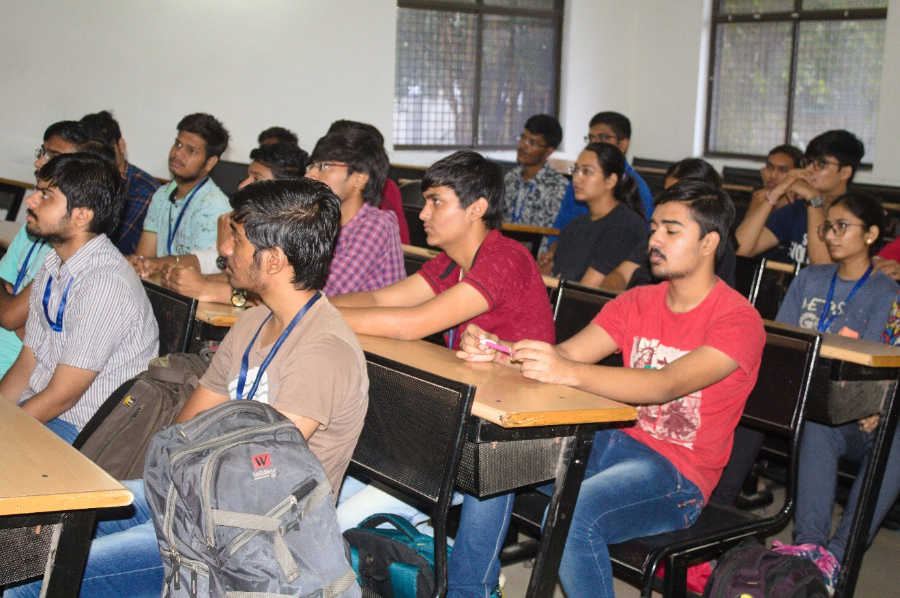
Question Answer Session

