Gandhinagar Institute of Technology
A Report on
“All About Startup”
(22nd August 2019)

Seminar Overview:
The SSIP team of GIT has organized seminar on “All About Startup” on 22/08/2019 at 2:30 pm in C304. SSIP coordinator Prof Mrugesh B Khatri & co-coordinator Prof Jyotin A Kateshia mentored the seminar. The students of 3rd semester Information Technology attended the seminar. There were 31 participants.

Objective:
The objective of the seminar was to educate the participants about the Startup. The hidden objective was also to share the information about SSIP and IPR policy launched by Government of Gujarat.

Seminar Detail:
The session started at 2:30 pm in C304. Prof Mrugesh Khatri started the session by briefing them about the content of the seminar. He initiated the session by deliberating the case study of Mr Ritesh Agrawal, founder of OYO Rooms. He added that the desire behind execution of idea is mandatory. He also informed the participants about the equation for the Startup. He added that technological improvement is required to serve the society.

The participants were educated about various types of Intellectual Property Rights. He informed them about the importance of prior art search before filling the patent. He showcased the benefits of patent filling like recognition & economical reward. He motivated participants to apply for the patent for their innovations.

He also showcased five successful startups of india. He added that the founders all the time do not require 10 or 20 years’ experience of the similar filed. The treatment to the real pain of customer will put you on a different level of success. He educated them about various phase between idea and prototype. He added that the innovation is essential for startup.

In the last phase of seminar, the participants were educated about SSIP & IPR policy launched by Government of Gujarat to develop ecosystem for Startup. The benefits of SSIP policies were informed to the participants. They were also informed to opt ownership on their idea in form of patent. The provision of support for patent filling was also shared with them. The efforts made by GIT to develop the culture of Startup at GIT were also shared with them.

The event was a grand success under the enlightenment of Dr H N Shah, Principal of the institute and the participants.

Seminar Memories:
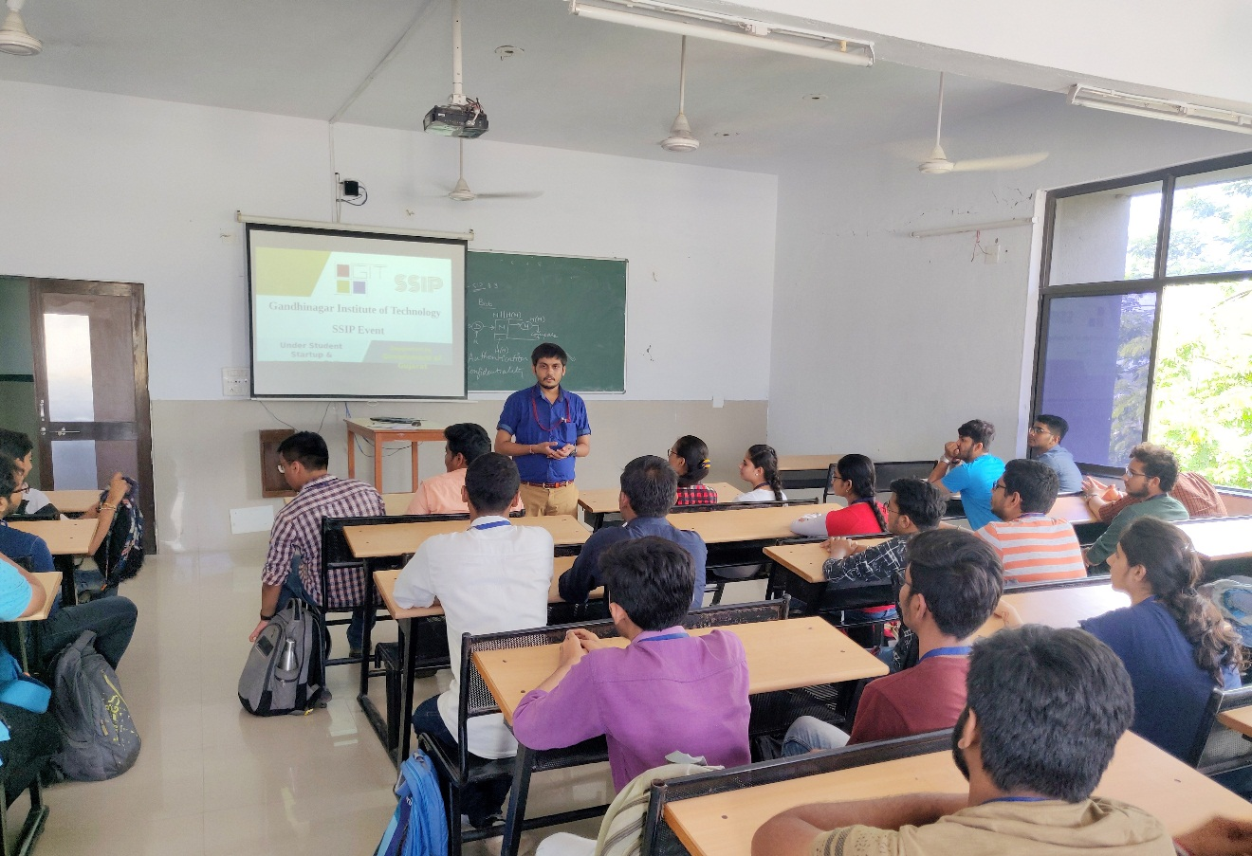
Mentor delivering Session

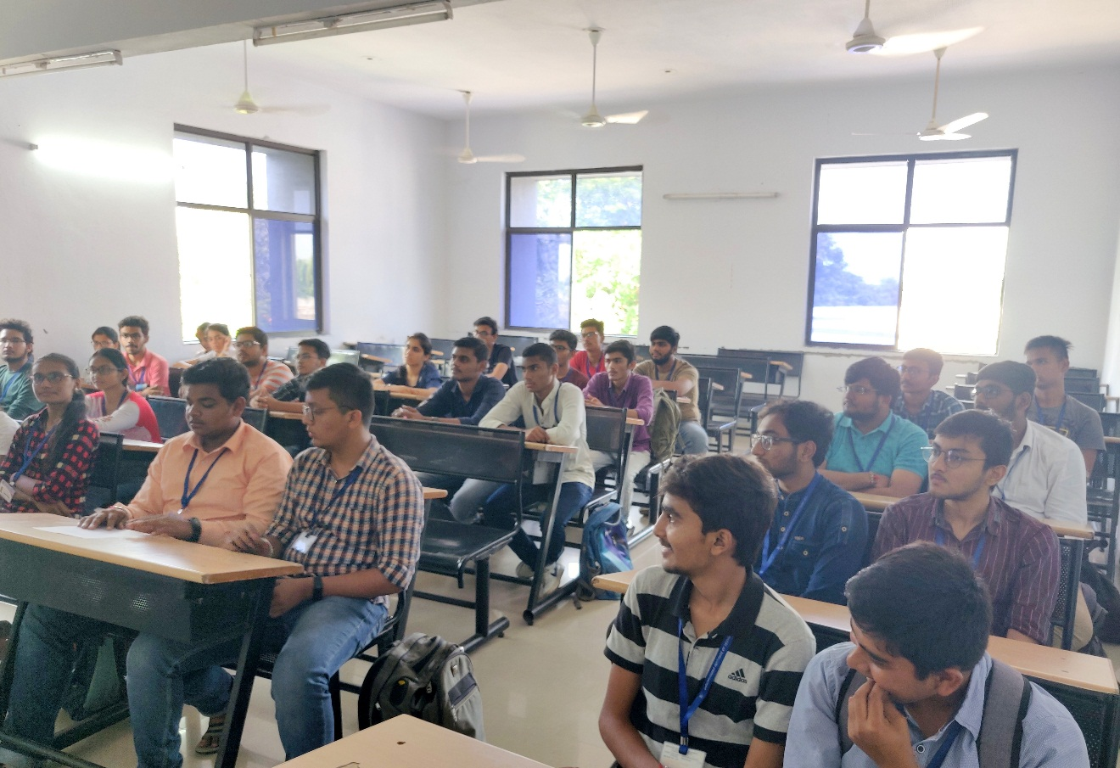
Participants listening to mentor
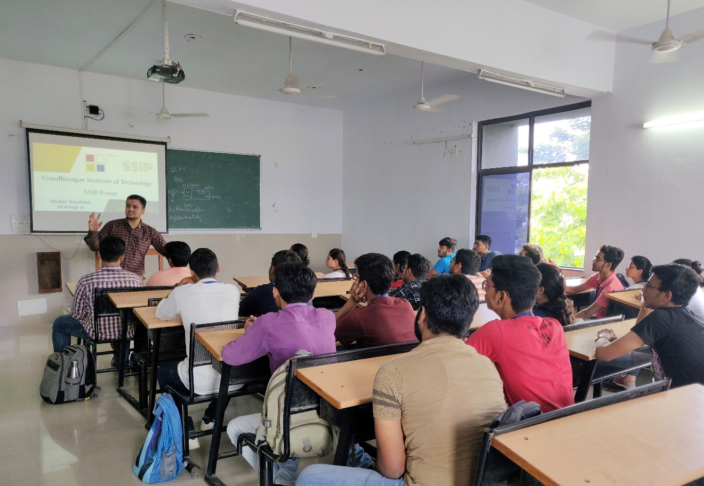 Mentor Addressing student query

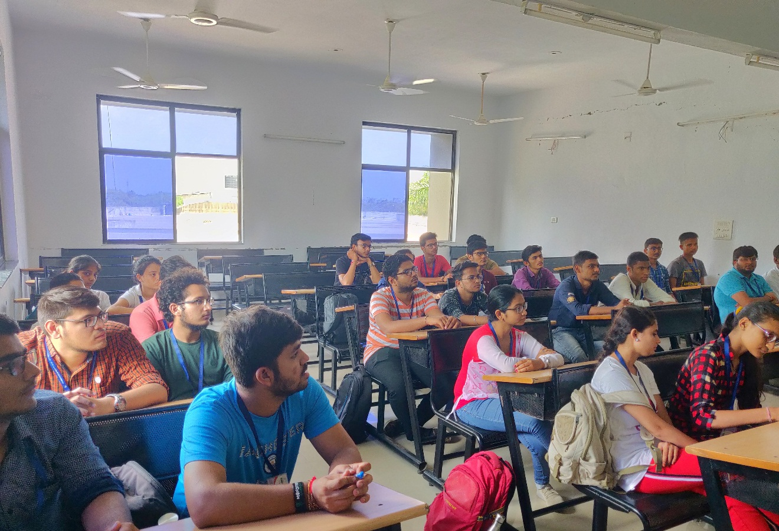
Students interacting with mentor

