Gandhinagar Institute of Technology
A Report on
“Intellectual Property Right Awareness Workshop”
(17th December 2019)

Objective:
Gandhinagar Institute of Technology IPR Cell conducted a workshop ‘Intellectual Property Right Awareness Workshop’ on 17th December, 2019 in association with GTU. The workshop was organized to provide a valued platform for the final year students of GIT to know about Patent filing, searching, and drafting. There was hands on session on patent searching using various paid and unpaid tools. This event was organized in association with GTU. To celebrate the 150th birth anniversary of Mahatma Gandhi, and to give him novel kind of academic tribute, GTU has planned to conduct 150 Intellectual Property (IP) awareness and advanced workshops at schools, colleges & other universities across the state of Gujarat. As a part of this mission GIT conducted the IP awareness workshop for all final year students. This was the first activity of GIT IPR cell.
Program Overview:
The workshop was conducted by Prof. Dulari Bhatt & Prof. Madhuri Chopade, both from IT Department of Gandhinagar Institute of Technology. The event was graced by the presence of Dr H N Shah, Director of Gandhinagar Institute of Technology. Total 130 participants of GIT took part in the workshop. The workshop started with participant registration. Dr H N Shah in presence of HOD of all departments inaugurated GIT-IPR Cell. Prof. Dulari Bhatt as on being GIT IPR Cell coordinator explained about the objectives and expected outcomes of GIT IPR Cell.
Workshop was organized in two session. First session was conducted by Prof Dulari Bhatt, she included details regarding trademark, patents, GI, etc. First session mainly focused on what is patent? How to file patent in India? And what are the benefits of filing patent? First session was having small question answer round also. All the participants who gave correct answers were motivated by small gifts.
Second session was hands on session which was conducted by Prof. Dulari Bhatt and Prof. Madhuri Chopade. They explained students regarding various patent search tools. Students were given the exercise to solve on patent search portal like WIPO. All the students who correctly solved the patent search exercise were motivated by small gifts. Then there was a presentation on patent drafting. In patent drafting how to fill form 1 and 2 were focused mainly. Students were also guided to convert their final year project in patent. After that students asked their questions regarding filing patent and they were answered.
Students gave their feedback regarding session and all the students were given the workshop participant certificate at the end of the workshop.

Photo Gallery:
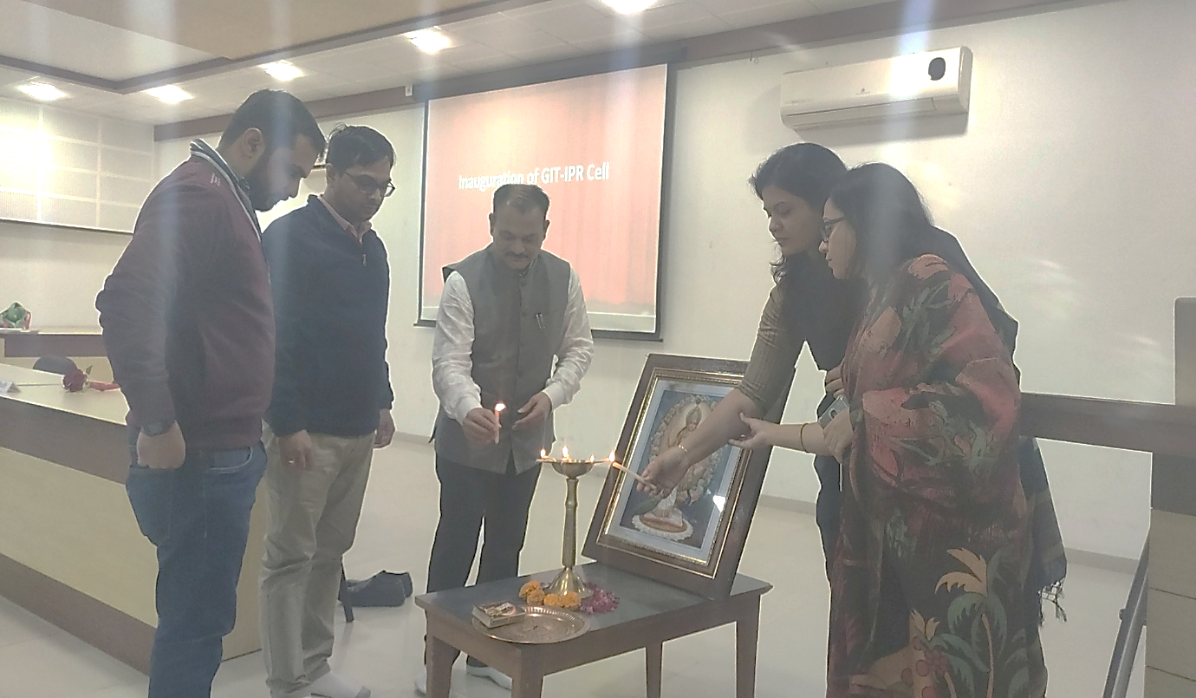

GIT IPR Cell Inauguration
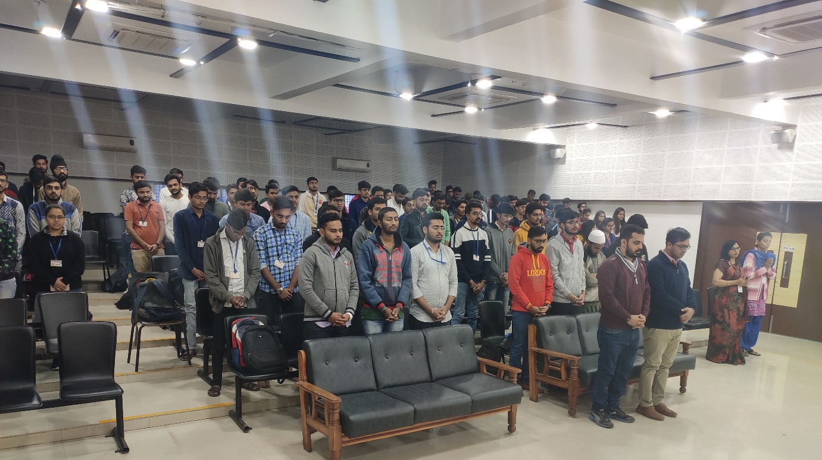
Prayer
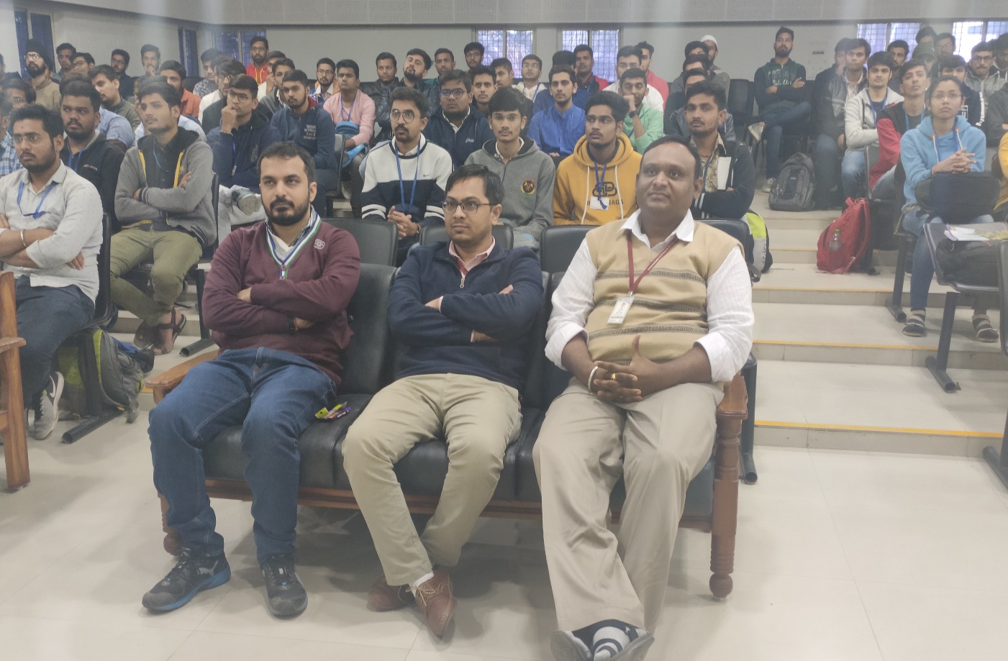
Participants attending workshop
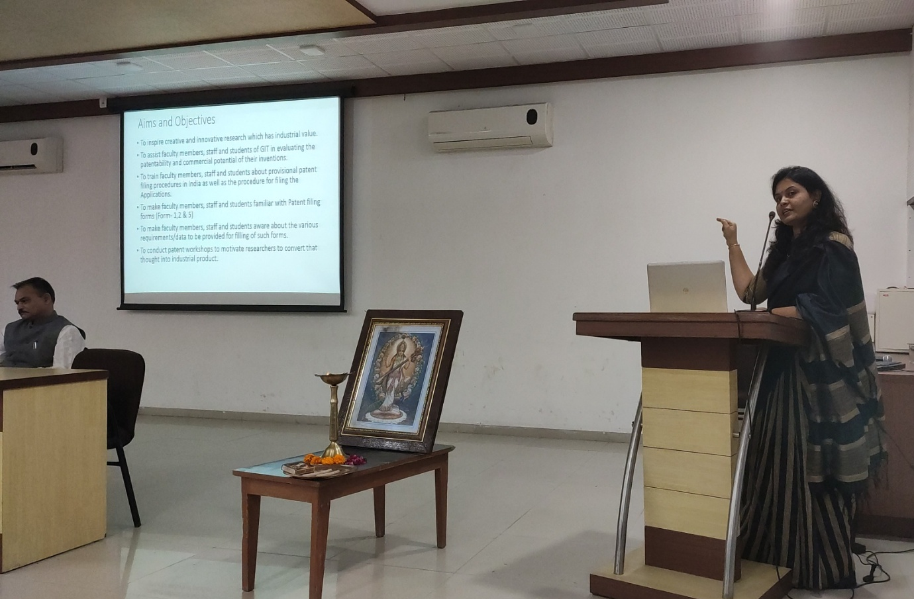
Prof. Dulari Bhatt explaining GIT IPR Cell
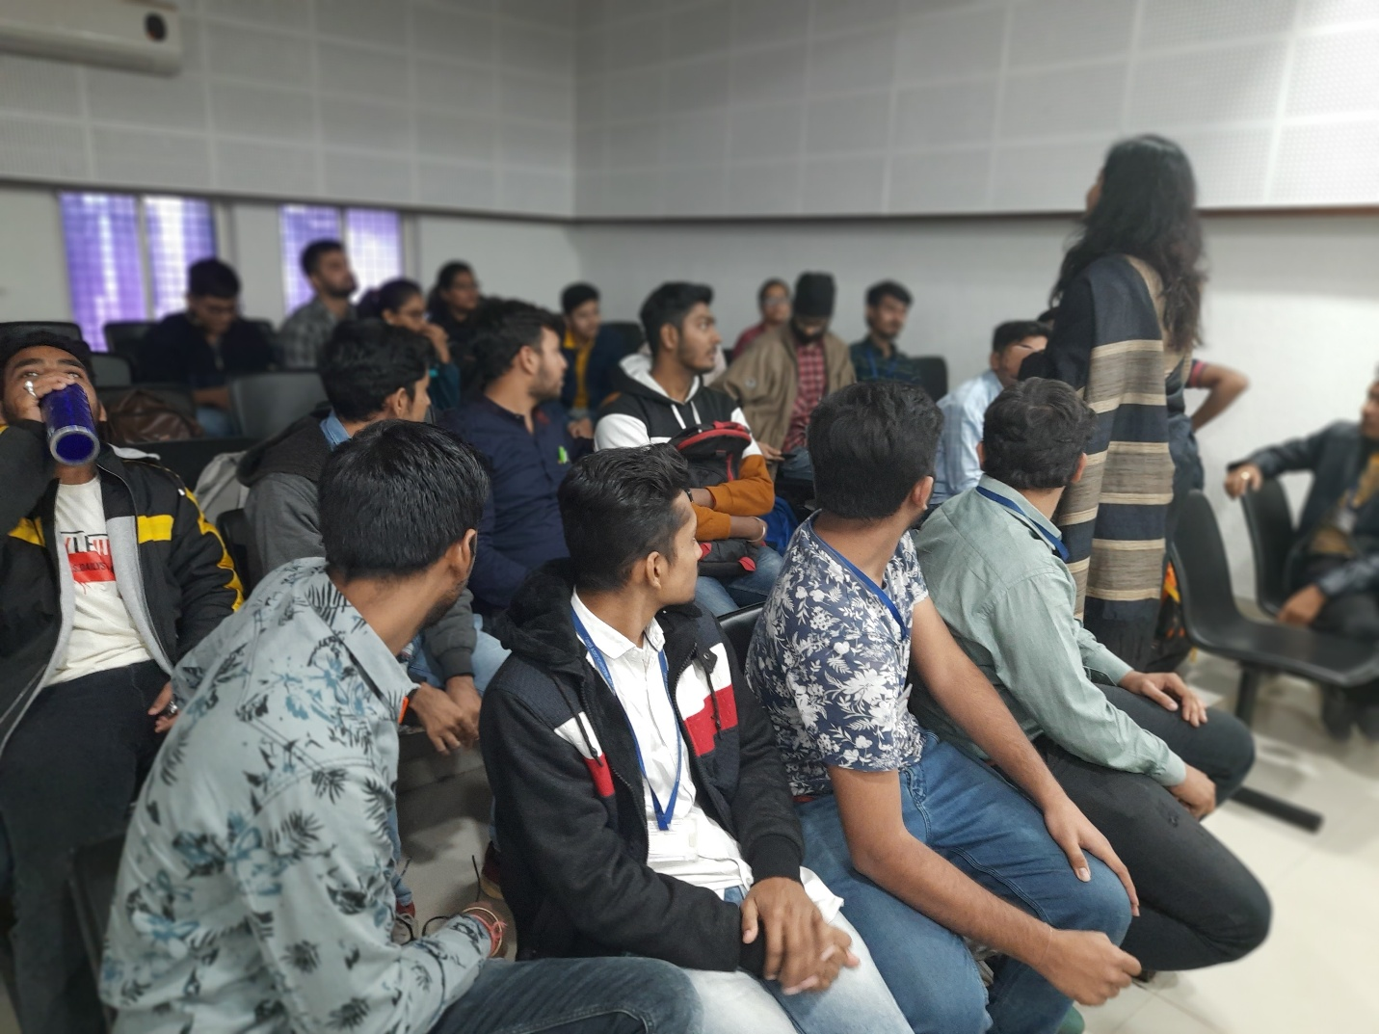
Question answer session for participants’ query

Group Photo of Workshop

