Gandhinagar Institute of Technology
A Report on
“SOIC Awareness Seminar”
(01st Jan 2020)

Seminar Overview:
The SSIP team of GIT has organized Seminar on “SOIC Awareness” on 01/01/2020 at 12:15 pm in seminar hall A105. Prof Mrugesh Khatri & Prof Jyotin A Katshia mentored the workshop. The students of Mechanical Engineering, Civil Engineering, Electrical Engineering & Electronics & Communication Engineering Semester 4 attended the workshop. There were 23 participants. The information about Student Open Innovation Challenge was given to them. The participants were taught about the technique to derive innovative project definition and its solution during the workshop.

Objective:
The objective of the seminar was to spread awareness about the Student Open Innovation Challenge. The silent objective was to motivate them to attempt for solution without fear of failure and to share the information about SSIP and IPR policy launched by Government of Gujarat.

Workshop Detail:
The session started at 12:15 pm in seminar hall A105. The session commenced by small brainstorming exercise by Prof Mrugesh Khatri. He explained the flow of session by the exercise in effect way. He added that today’s market demands upgradation of technology. By the example of Nokia, he explained that the resistance to the change or upgradation will lead to failure. He also added the technological disruptions helped the innovators to serve the society in better way.

He gave the example of the MERU cab. The way OLA and UBER learnt from MERU cab was discussed by him to explain the participants about learning from other’s mistake. He also added the such out of the box thinking will help them to succeed. He also educated the participants about the elements of succeed like idea, team, business plan, fund, timing etc. Prof Jyotin A Kateshia educated them about the Intellectual Property Right. He educated them about the various mode of IP rights like, copyright, trademark, patent etc. He motivated them for patent filling for recognition as well as commercial rewards.

The objective of SOIC was explained to the students. They were also motivated to utilize their free time of summer vacation in productive activities like SOIC. He also informed participants about the benefits of SSIP policy.

The event was a grand success under the enlightenment of Dr H N Shah, Director of the institute and the participants.

Workshop Memories:

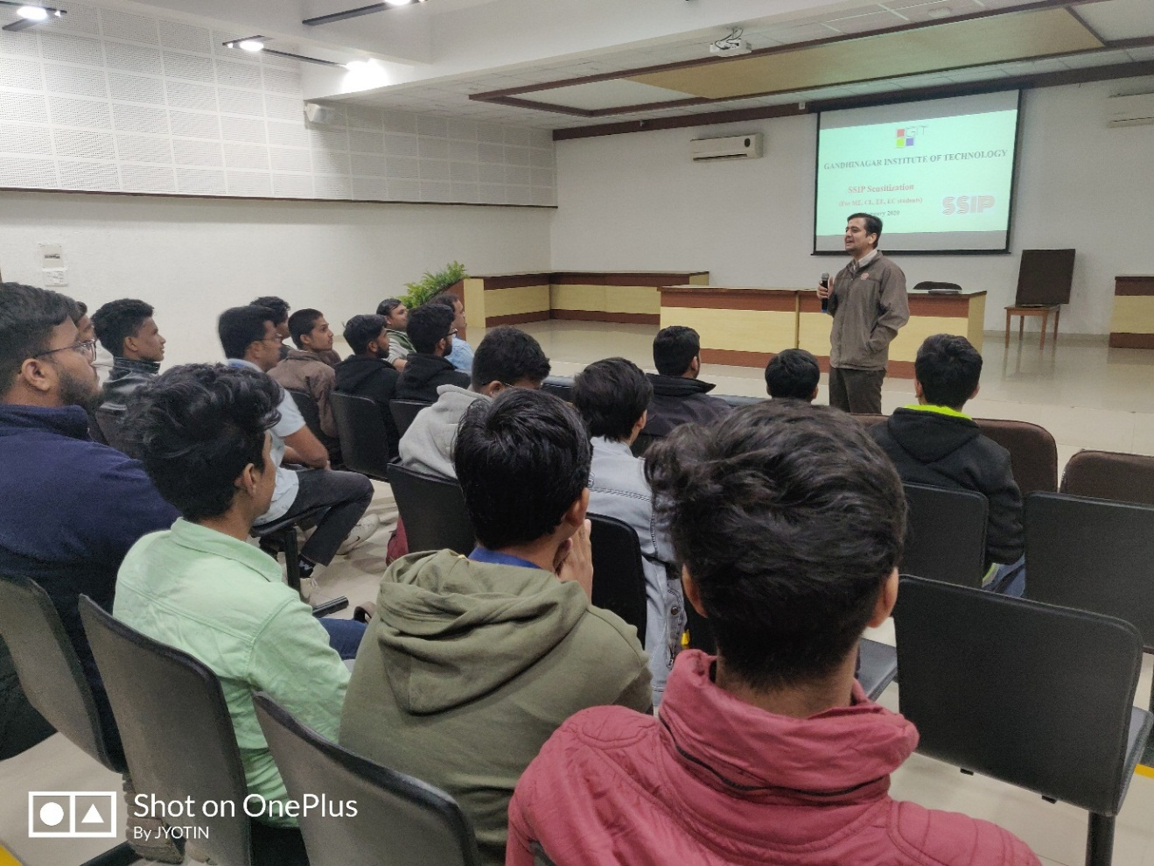
Mentor delivering session

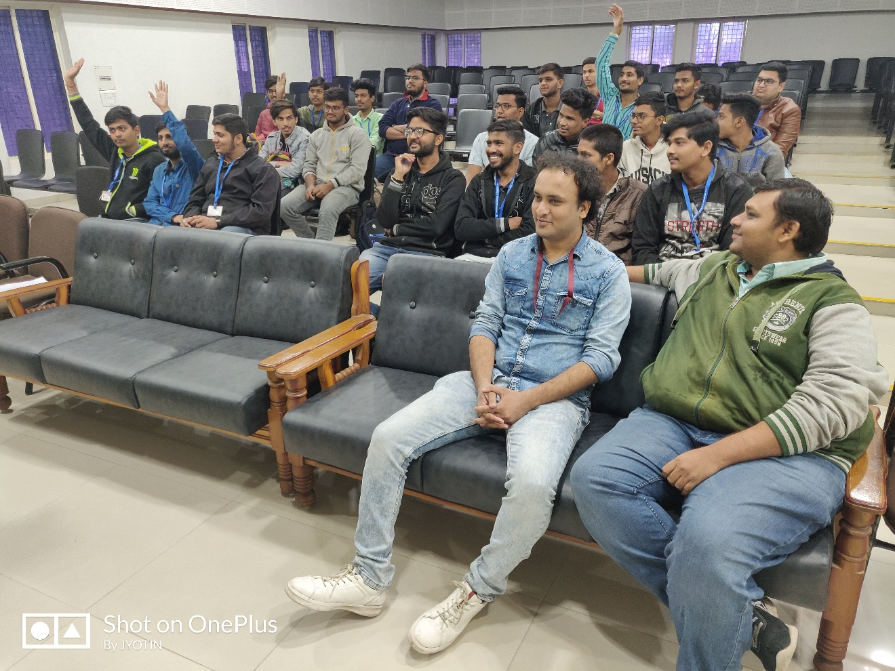
Interaction both side

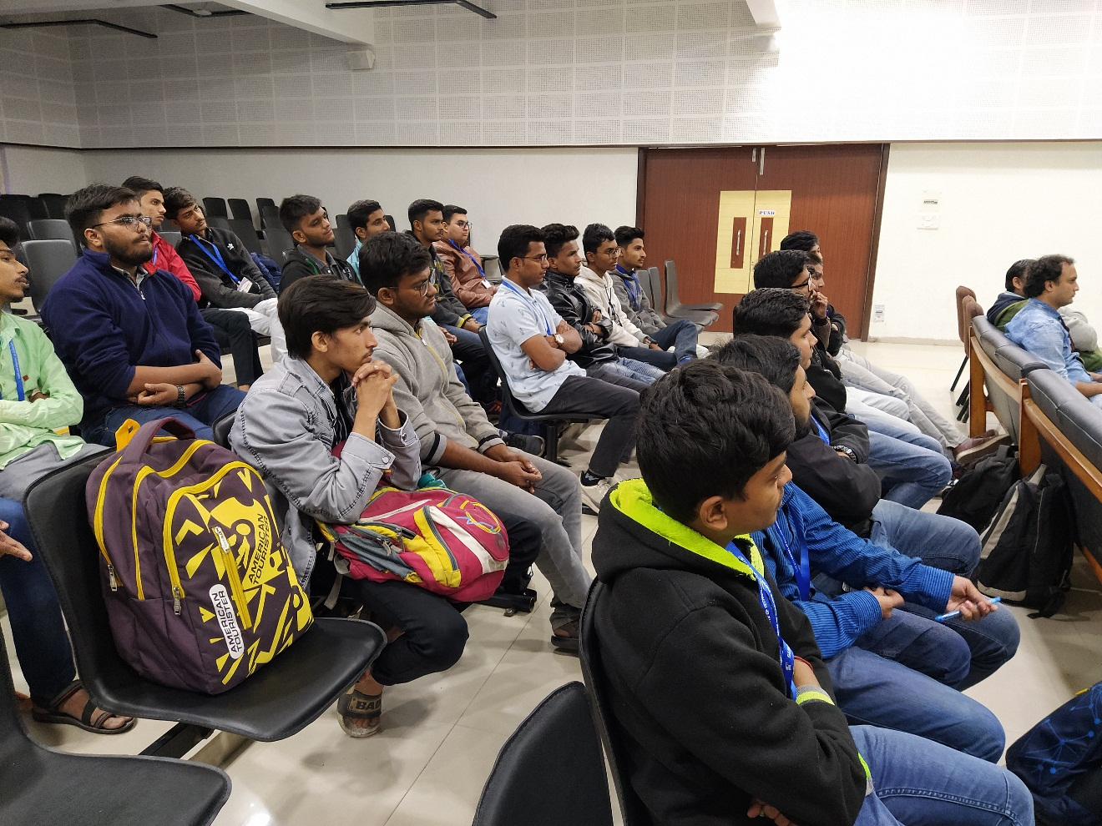
Participants attending session

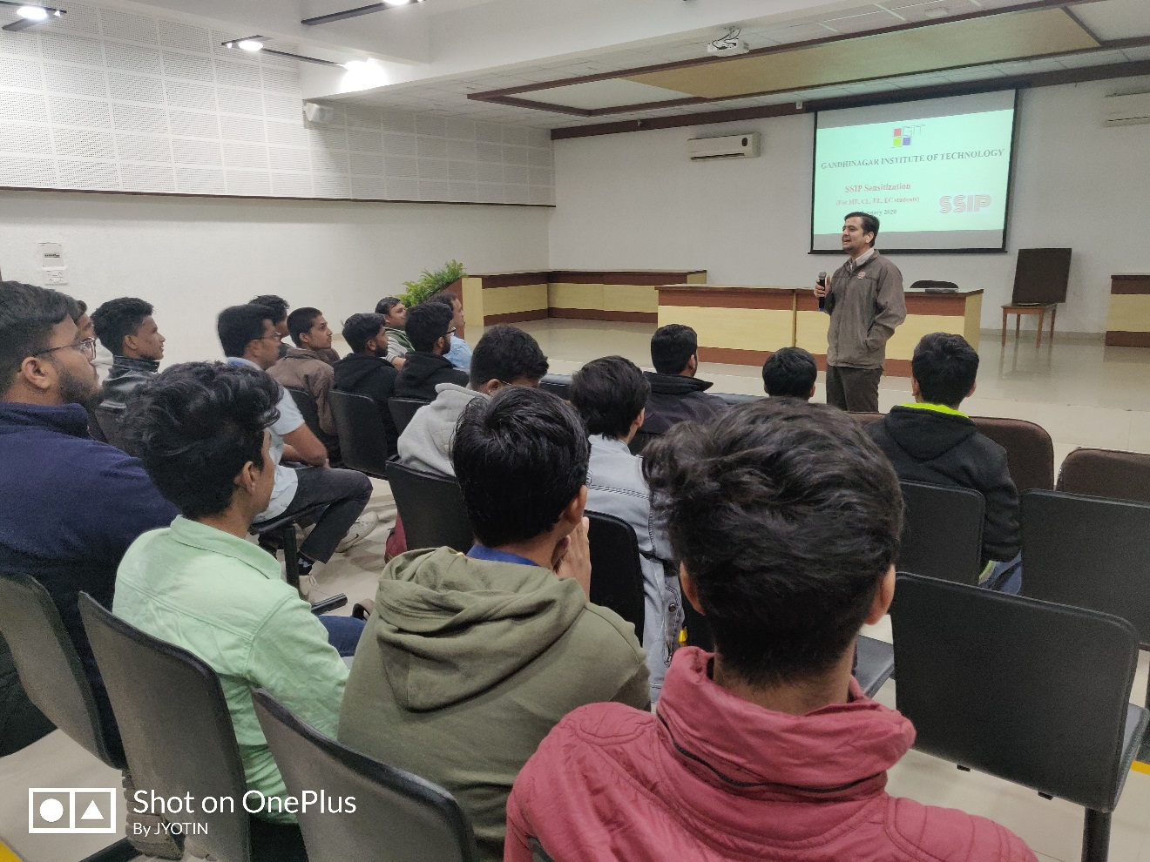
Introduction to SSIP by mentor
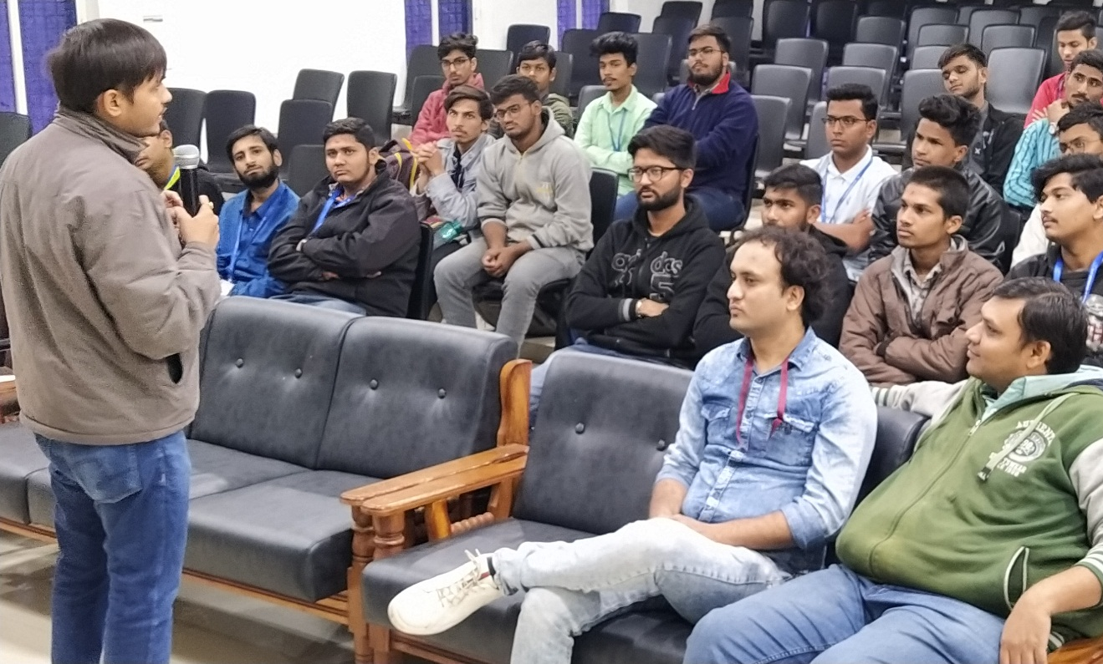
Participants listening mentor

