Gandhinagar Institute of Technology
A Report on
“SSIP & SOIC Faculty Awareness”
(4th Jan 2020)

Seminar Overview:
The SSIP team of GIT has organized seminar on “SSIP & SOIC Faculty Awareness” on 04/01/2020 at 2:00 pm in seminar hall A105. SSIP coordinator Prof Mrugesh B Khatri & co-coordinator Prof Jyotin A Kateshia mentored the seminar. Total 27 faculties from different branches attended the seminar.

Objective:
The objective of the seminar was to inform faculties about objective and various activities under banner of SSIP & procedure of Student Open Innovation Challenge (SOIC). The hidden objective was also to share the information about SSIP and IPR policy launched by Government of Gujarat.

Seminar Detail:
The session started at 2:00 pm in seminar hall A105. Prof Mrugesh B Khatri started the session by briefing them about the content of the seminar. He started the session by debating the case study of Mr Ritesh Agrawal, founder of OYO Rooms. He added that the passion behind accomplishment of idea is mandatory. He also educated the participants about the equation for the startup. He added that technological advancement is required to serve the society.

He also showcased five successful startups of India. He added that the founders all the time do not require 10 or 20 years’ experience of the similar filed. The treatment to the real pain of customer will put you on a different level of success. He educated them about various phase between idea and prototype. He added that the innovation is essential for startup.

The participants were educated about various forms of Intellectual Property Rights by Prof Jyotin A Kateshia. He informed them about the importance of prior art search before filling the patent. He showcased the benefits of patent filling like recognition & economical reward. He motivated participants to apply for the patent for their innovations.

In the last phase of seminar, the participants were educated about SSIP & IPR policy launched by Government of Gujarat to develop ecosystem for Startup. The benefits of SSIP policies were informed to the participants. They were also informed to opt ownership on their idea in form of patent. The participants were given information about SOIC. The efforts made by GIT to develop the culture of Startup at GIT were also shared with them under banner of SSIP.

The event was a grand success under the enlightenment of Dr H N Shah, Director of the institute and the participants.

Seminar Memories:

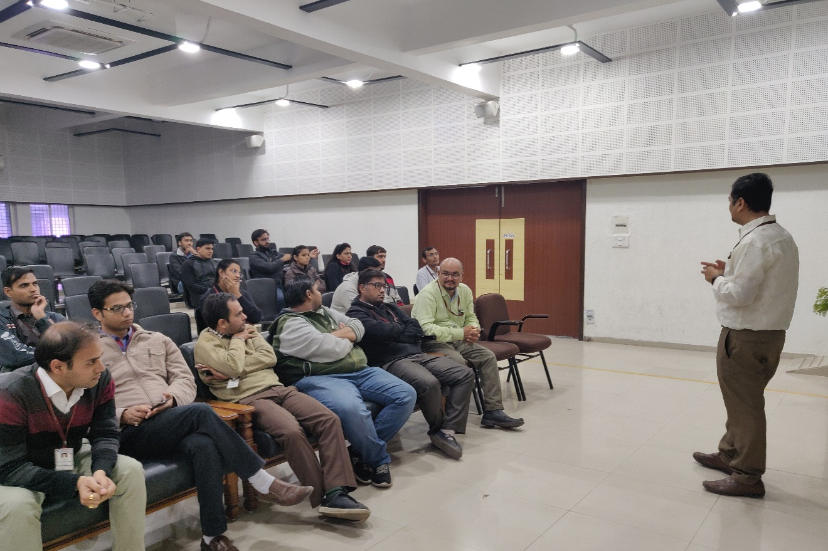
Information session

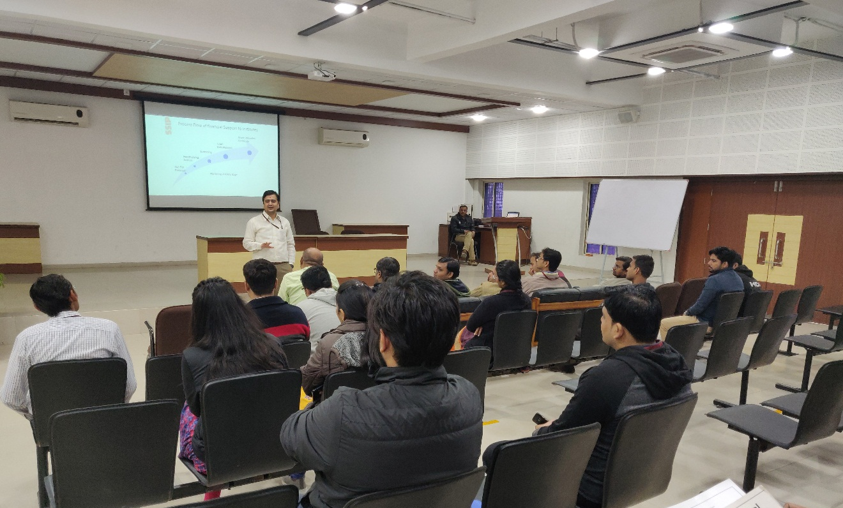
Discussion with mentor

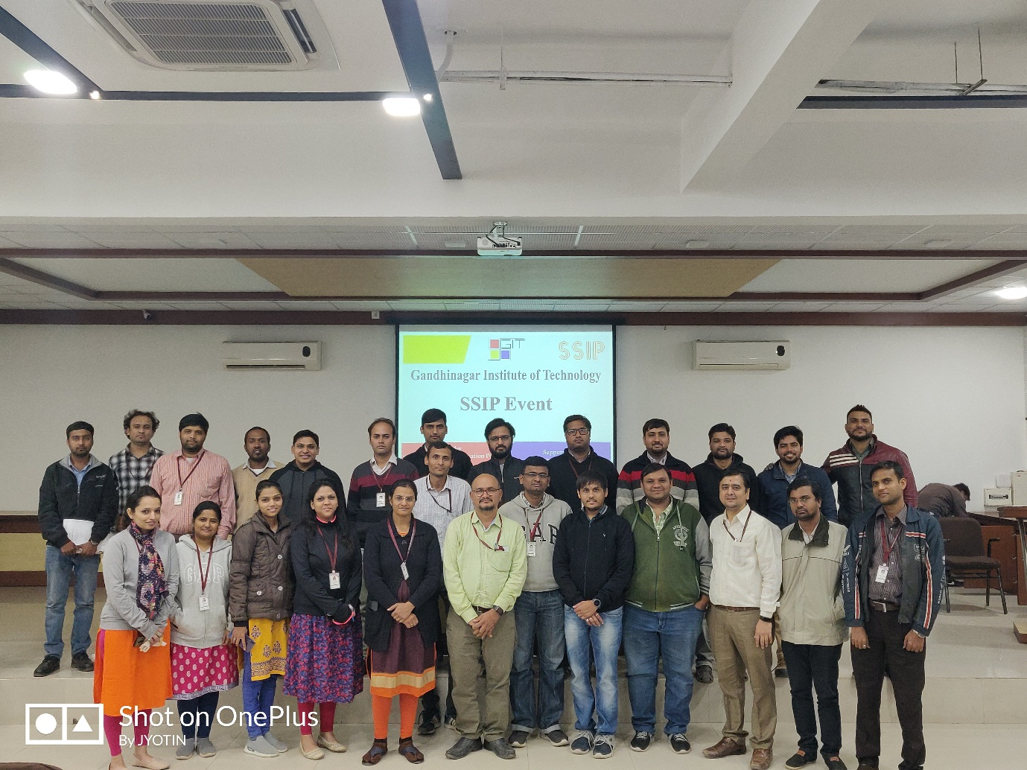
Group Photo

