Gandhinagar Institute of Technology
A Report on
“Faculty Development Program on Intellectual Property”
(22 November 2020)

Event Overview:
Gandhinagar Institute of Technology has organized "Faculty Development Program on Intellectual Property" on 22.11.2020 under SSIP & IPR Cell. In the meeting held on 21.11.2020, Director Dr H N Shah sir has informed all to accelerate SSIP & IPR activities. For which Director Sir convinced Dr Anish Gandhi to share his experience as a Registered Patent Agent and guide the faculties for the same. Total 68 faculties including HODs have attended the FDP.

Objective:
The objective of FDP was to spread awareness about IPR among the faculty members. The silent objective of the FDP was also to share information about various type of IPR and the importance of IPR for the economical growth of the country.

Event Detail:
The FDP started with an inspiring speech of Dr H N Shah, Director Sir at 10:15 am. He informed the faculty members that in this era of knowledge-based society the Intellectual Property Rights plays a vital role. He introduced the resource person Dr Anish Gandhi. The expert Dr Anish Gandhi has completed his graduation, post-graduation and doctorate from SVNIT, Surat. He is registered patent agent in Indian Patent Office. His experience includes from teaching to the course development, teaching tool development, research in the area of manufacturing related field, patent filling to communication with patent office till successful completion of patent filling.

Dr Anish Gandhi sir initiated the session with detailed information regarding various type of IPR like patent, design, trademark, copyright, semiconductor integrated circuit layout design, plant variety & farmer protection right act, trade secrets, geographical indications etc. He added that for strong protection combination of different IP is very essential. He shared examples of CNC machining centre, Cococola, KIA Sonet car, Waghbakri Darjeeling tea etc to differentiate between various types of IPR. He also added examples of Patan na patoda, Rajkot penda, Nagpur orange, Alphanso rantagiri etc to explain the geographical indications.

He explained the term of Innovation by demonstrating various examples. He also added that the prior art search is very essential for the applicant to increase the chances of patent approval. He also added that one should not go for any publication before going for the patent application.
Prof Archana Singh has given concluding remarks of the session.

The event was a grand success under the enlightenment of Dr H N Shah, Director of the institute and the faculty members.

Event Memories:

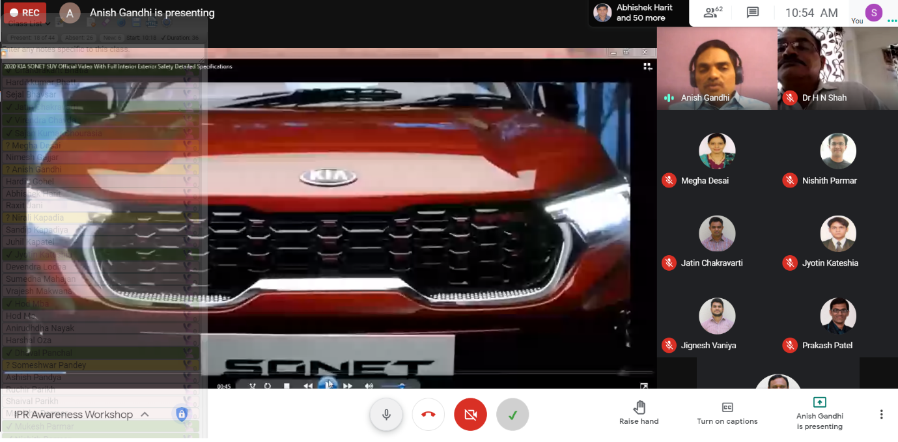
Mentor explaining types of IP using example of KIA SONET

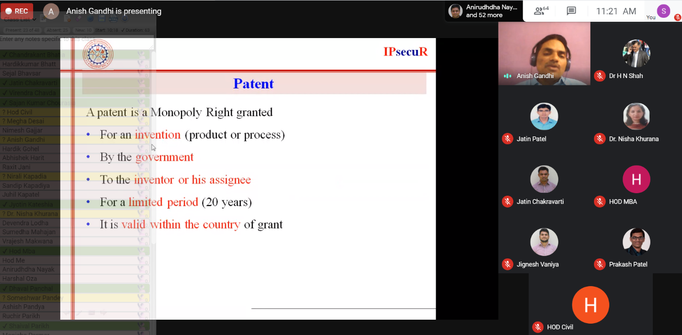
Mentor explaining the term Patent
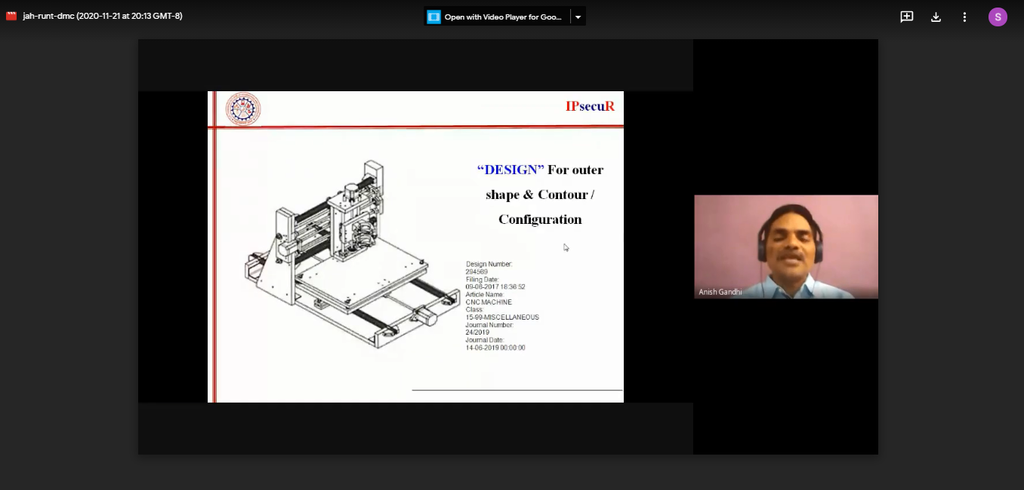
Discussion on DESIGN is going on

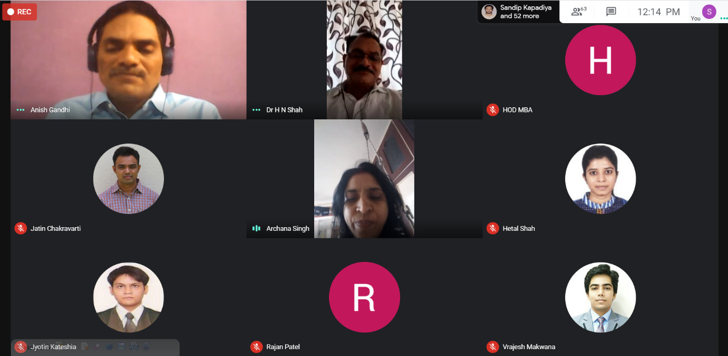
Prof Archana Singh giving concluding remarks

