Gandhinagar Institute of Technology
A Report on
“A Startup Talk 2021”
(14 October 2021)
Event Overview:
GIT has celebrated "Student Innovation & Startup Day" on 14/10/2021, on the birth anniversary of former President of India Dr A P J Abdul Kalam. “A Startup Talk 2021” was organized by SSIP, IPR, IIC & IQAC Cell. A Startup Founder of “Booxwoox”, Mr Maurya Bhatt shared his journey of launching his startup. The session was organized for the students of Bachelor of Engineering with the permission of Dr H N Shah, Director. The seminar was organized to provide exposure regarding the steps involved in initiated startup.
Objective:
The objective of the session was to share the information regarding the important aspects of startup at the institute, the benefits of SSIP, IPR, IIC etc. The silent objective was also to educate them about need of startup in the current situation.
Program Overview:
There were 35 students participated in the session. The session started at 11:00 am at Seminar Hall (A105). Prof Mrugesh Khatri has initiated the session by introducing Mr Maurya Bhatt, a startup founder of “Booxwoox”. His startup is incubated at Entrepreneurship Development Institute of India. He shared the information about his startup during initial phase of the session. The Booxwoox allows all individual and institution to share the books on rent basis. He added that this initiative creates a culture of reading among the youth.
He informed that the design thinking and passion to work on the idea is very essential for a startup founder. He explained about the stepwise procedure to share the book on his application. He motivated students to learn from own’s mistake. He interacted the students and solved their queries regarding the startup. He added information regarding the current opportunities for a startup under various state and national policies like SSIP, AICTE, IIC, NISP, IPR etc.
The event was a grand success under the enlightenment of Dr H N Shah, Director of the institute and the participants.
Photo Gallery:
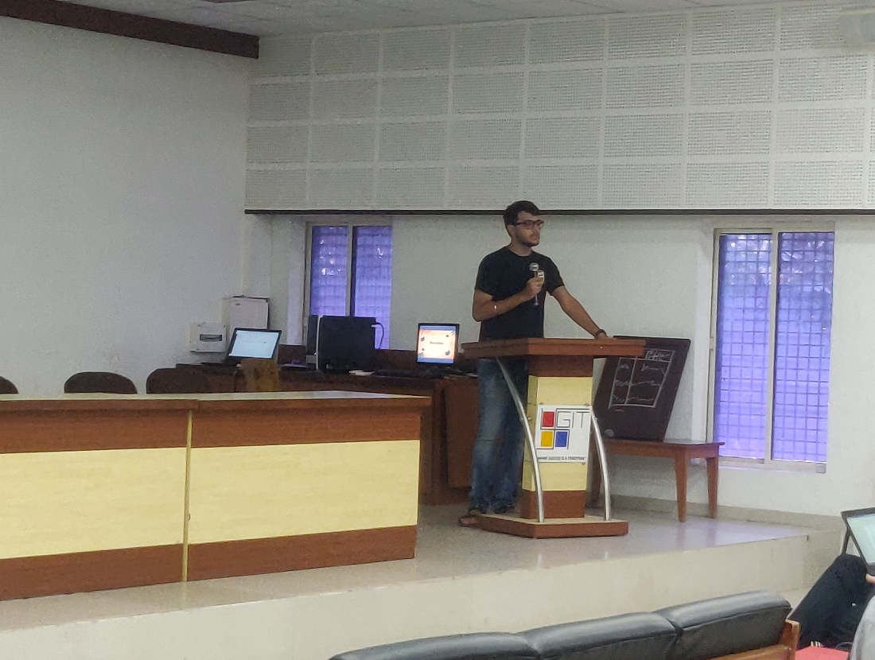
Mr Maurya Bhatt initiated the session

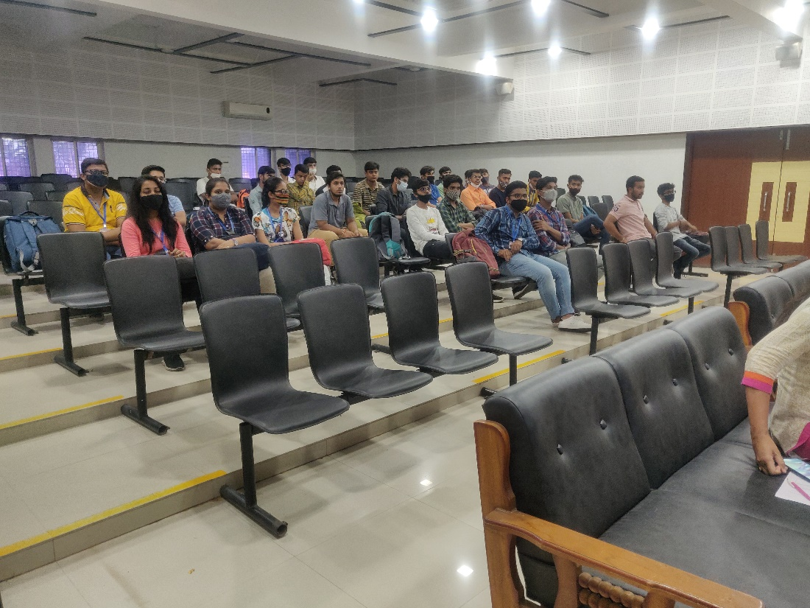
The participants are interacting with Mr Maurya Bhatt

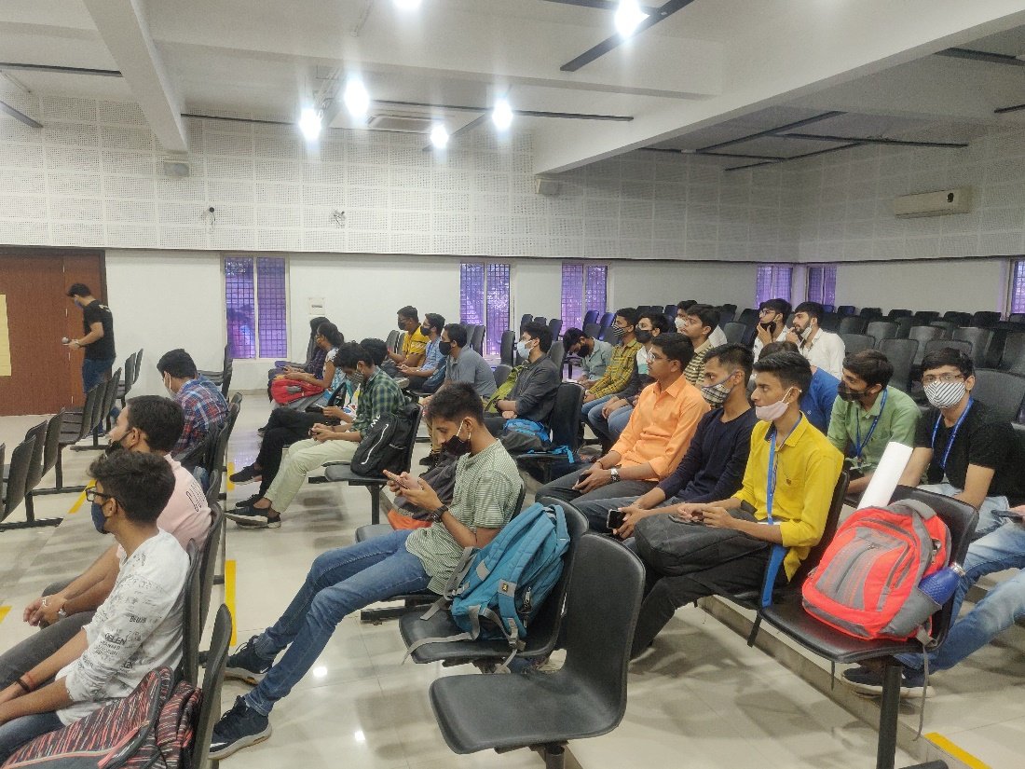
Participants following instrucions for downloading Booxwoox application

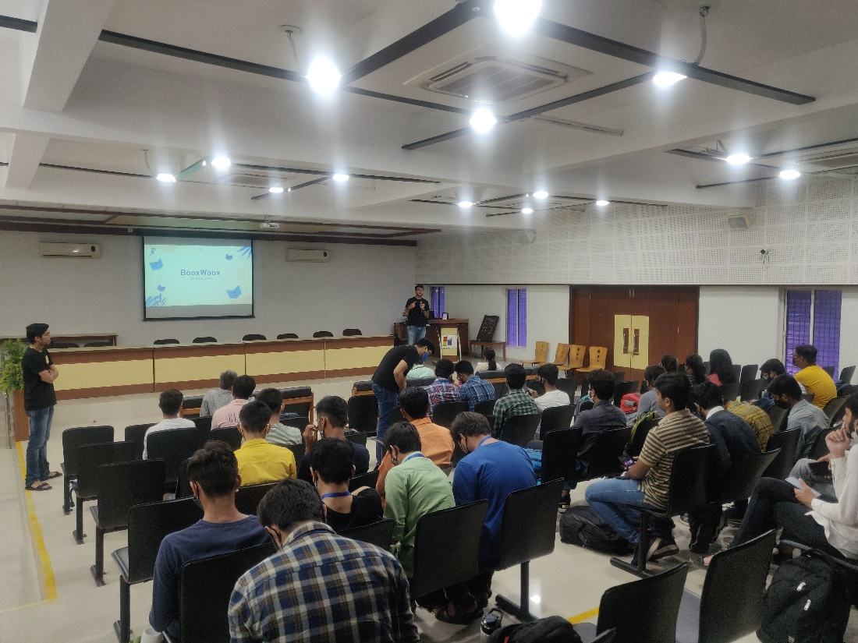
The information sharing is going on

