Gandhinagar Institute of Technology
A Report on
“Intellectual Property Rights for Start-up Enthusiasts”
(27 April 2022)
Event Overview:
A seminar on “Intellectual Property Rights for Start-up Enthusiasts" on 27/04/2022 in collaboration with NIPAM and KAPILA to celebrate World IP Day. Session was taken by Mr. D. A. Nayak, Assistant Controller of patents and designs, Indian patent office, Mumbai. Faculty members and students of all branches of engineering registered for the seminar.
Objective:
The Objective of the session is to give detailed information about various types of IPR like Patents, Designs, Trademarks, Geographical Indications, Copyrights, Semiconductor Integrated Circuits Layout Designs (SICLD) etc. The silent objective is to feed and nurture the seeds of IPR among the students.
Program Overview:
Total 221 Faculty members and Students of all branches of GIT have participated in this Seminar. The session was started with problems faced by India for registration of various IPR. The main problem which is faced by India is to put problems into implementation which is very important for execution of IPR. After that the speaker has given brief explanation of various types of IPR with various examples of individuals. He has given the example of famous inventor named “George Alfred De Penning”, a Civil Engineer, of Calcutta Petitioned the Government of India for grant of Privileges for this invention “An Efficient Punkah Pulling Machine”. Additionally, he has given the example of different IPs in a single product like Patent for LED display, Design for body of laptop, Trademark for Apple Sign, Copyright for User Manual and SICL design for layout of IC.
In the middle of the seminar, the speaker explained each IP in a detailed form. He has given the names of famous Indian Inventions like Nano Car, Hepatitis Vaccine and Jaipur foot for patents and examples of various designs of bottles, toys, pens, and watches for Designs. Then after the detailed discussion about Trademarks was started with its definitions and various advantages provided by it to customers. Various examples of Trademarks are Google, McDonalds, Coca-Cola, Adidas and Naukari.com. In addition, how to protect your Trademark are also discussed. Then after Criteria for work to be Copyright like Creativity, Originality and Fixation is discussed. Various electronic Gadgets, Computers etc. are protected by Semiconductor Integrated Circuit Layout Designs (SICLD). The main office is in Delhi where applications on layout designs of IC are filed. The Products which have specific geographical area are identified by Geographical Indication (GI) like Darjeeling Tea, Makrana Marble, Kancheepuram silk, Ratlami Sev, Coorg Oranges etc. At the end of the program, he explained the validity period of various IPR, various points which are remembered and Career Opportunities in Government sector as well as private sector also.
The event was a grand success under the enlightenment of Dr H N Shah, Director of the institute and the participants.

Photo Gallery:
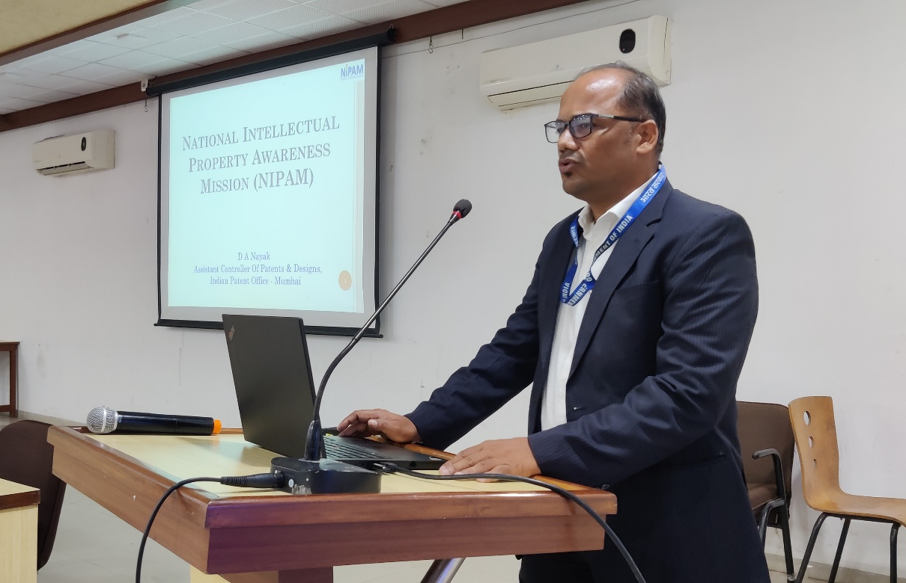
Mr. D. A. Nayak started session

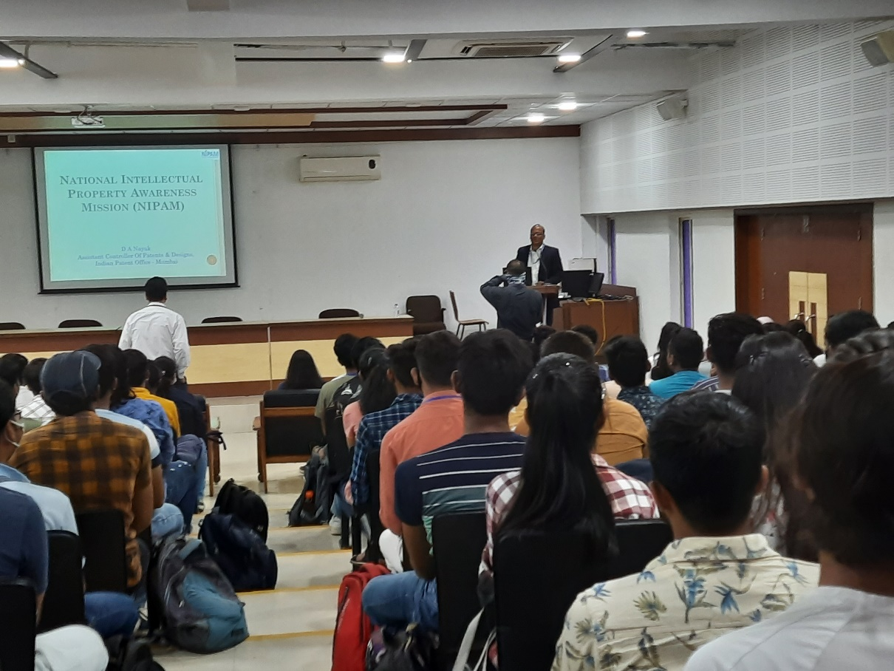
Expert introducing the NIPAM and motivating participants for IP

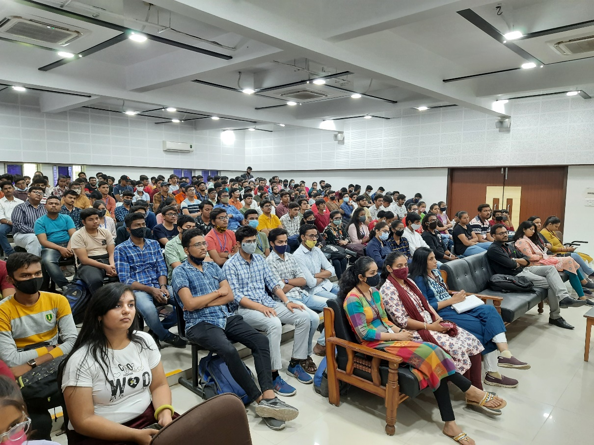
Participants listening to expert
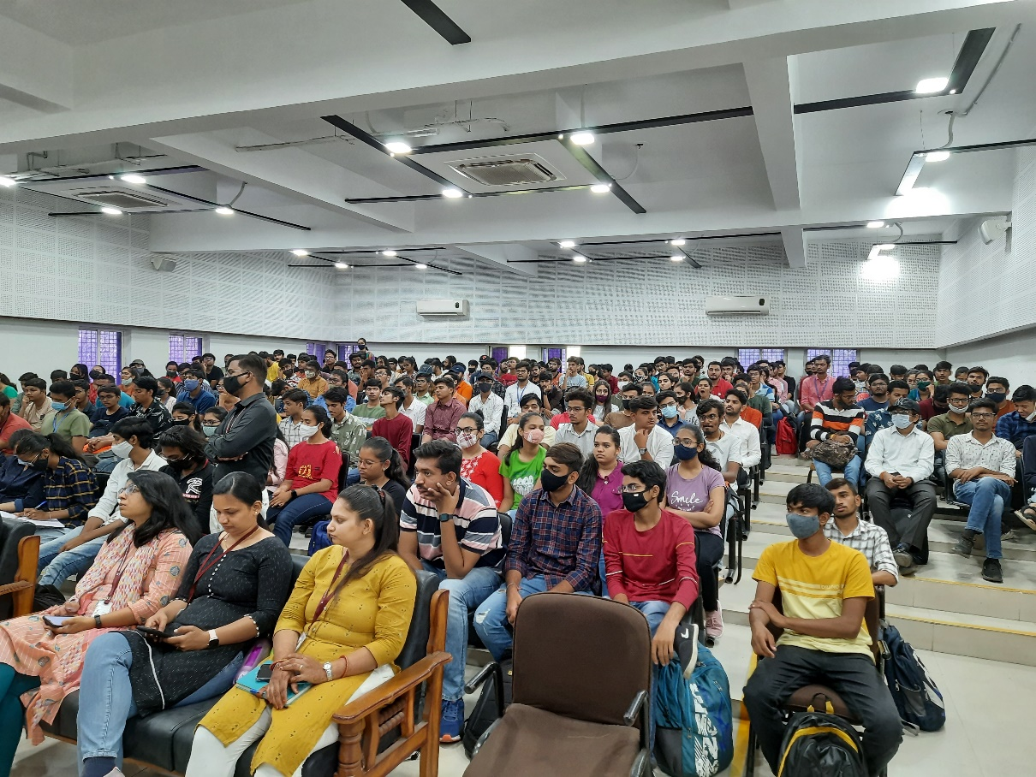
Participants interacting with expert

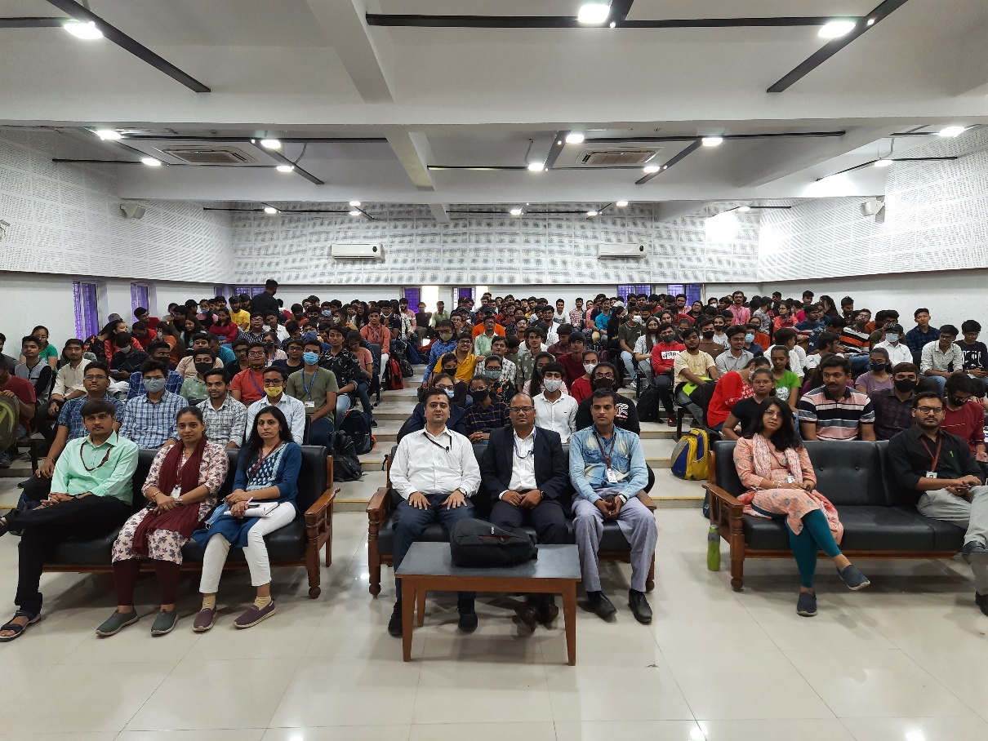
Group Photo with expert

