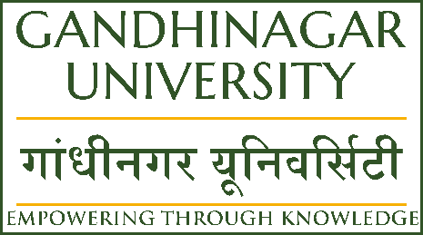
Gandhinagar University
A Report on “Workshop on National Education
Policy & Financial Planning” (21st January 2023)

Event Overview:
The Workshop on National Education Policy & Financial Planning was organized at Gandhinagar University on 21/01/2023. The workshop was arranged for Teachers / Principal / Directors of schools & Coaching class & also for our faculty members of Gandhinagar University.
The workshop Session - 1 was conducted by Prof. Hardik Bhatt, Dy. Registrar (Academics), Gandhinagar University on National Education Policy & Session -2 was conducted by Mr. Brijesh Parikh, Director – Planet Wealth, SEBI registered on Financial Planning.
Objective:
The objective for this type of Workshop is for social awareness amongst the Teachers / Principal / Directors / Faculty members about National Education Policy & Financial Planning. Prof. Hardik Bhatt, Dy. Registrar (Academics), Gandhinagar University explained in brief the parameters of National Education Policy.
The second session was for financial planning for all participants for personal finance, how to invest wisely and how to save tax.
Mr. Brijesh Parikh, Director – Planet Wealth, SEBI registered, had given valuable input for financial planning, and creating wealth. He had given some tips and secrets of creating wealth by investing wisely.
Program Overview:
The workshop was attended by more than 20 participants in Session -1 and more than 35 participants in session 2.

The event started at 10:45 am.

The first session started with a welcome speech by Dr. Milan Shah, Dean Management, Gandhinagar University, he greeted all participants and given a warm welcome at Gandhinagar University and further he introduced Prof. Nirav Joshi, Dy. Registrar (Administration), Gandhinagar University to give the presentation of Gandhinagar University. He explained the successful journey of Gandhinagar University.

Then the session was handed over to Prof. Hardik Bhatt, Dy. Registrar (Academics) , Gandhinagar University for the expert session on National Education Policy (NEP). He had started the session and discussed in detail the key points from National Education Policy (NEP).

The second session started with a welcome speech by Dr. Milan Shah, Dean Management, Gandhinagar University, and then after the expert session of Financial Planning was taken by Mr. Brijesh Parikh, Director – Planet Wealth, SEBI registered.

He started the session with basic introduction of Financial Planning and various sources of Investments and further given importance of creating wealth by starting investment at the early age. He had given various tax saving information as well as tips for creating wealth.

The vote of thanks was offered by Dr. Milan Shah, Dean Management, Gandhinagar University and appreciated the collective efforts made by Director Sir, teachers, faculty members and Admission Team to make this event successful.

The event was a grand success under the enlightenment of Trustee, Director, and the participants.

Feedback:

The majority of participants reported that they had found this workshop very helpful & innovative. Overall, they were happy to attend this full day workshop.

Photo Gallery:
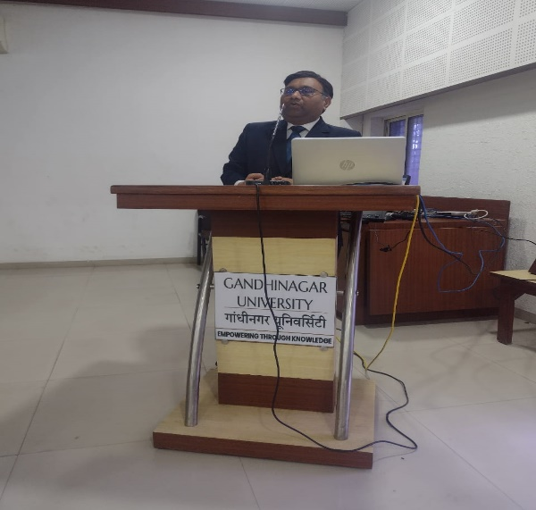
Welcome Speech by Dr. Milan Shah, Dean Management, Gandhinagar University.
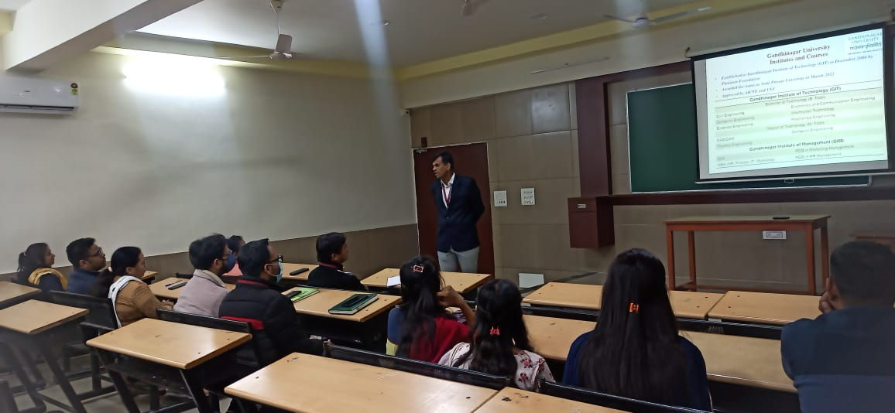

GU presentation by Prof. Nirav Joshi, Dy. Registrar (Administration), Gandhinagar University.

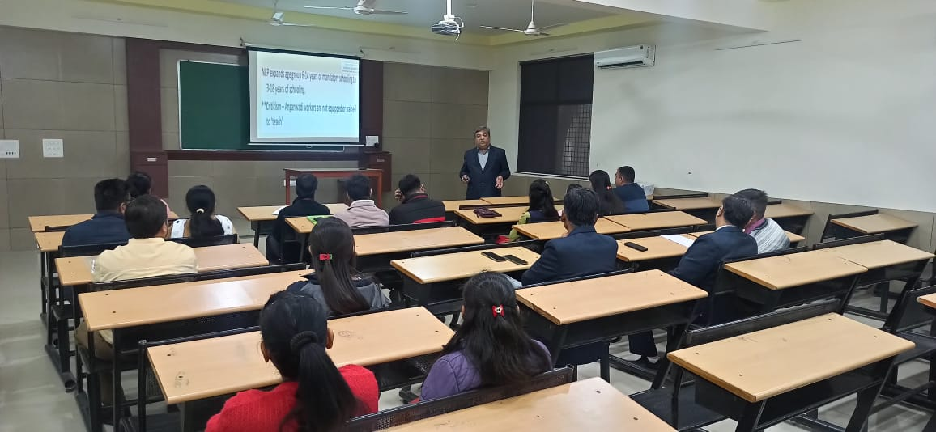

Teachers / Faculty members attending the first session of workshop on National Education
Policy by Prof. Hardik Bhatt, Dy. Registrar (Academics), Gandhinagar University.

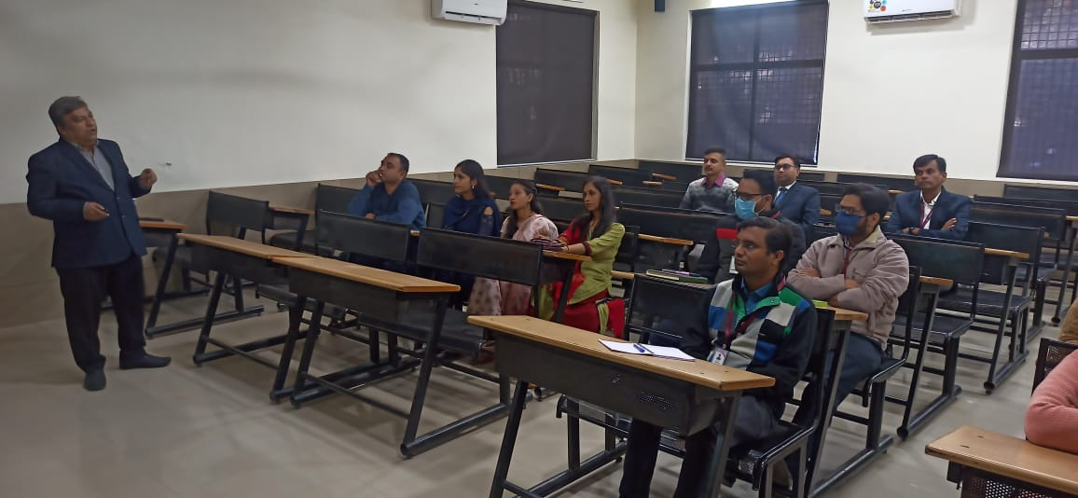

Teachers / Faculty members attending the first session of workshop on National
Education Policy by Prof. Hardik Bhatt, Dy. Registrar (Academics), Gandhinagar
University.

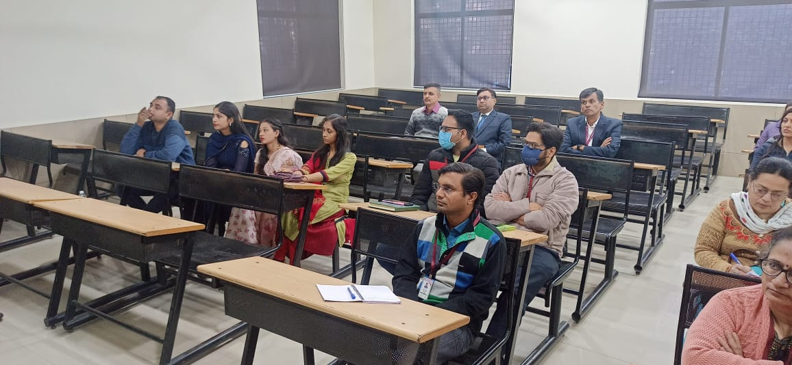

Teachers / Faculty members attending the session -1 of NEP.

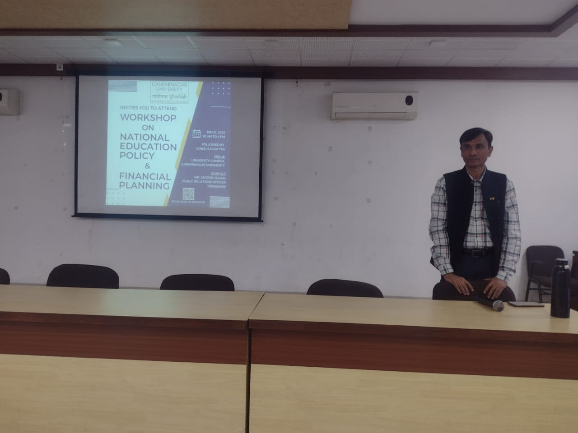
Expert Mr. Brijesh Parikh, Director – Planet Wealth, SEBI registered to give the second session of the workshop on Financial Planning.

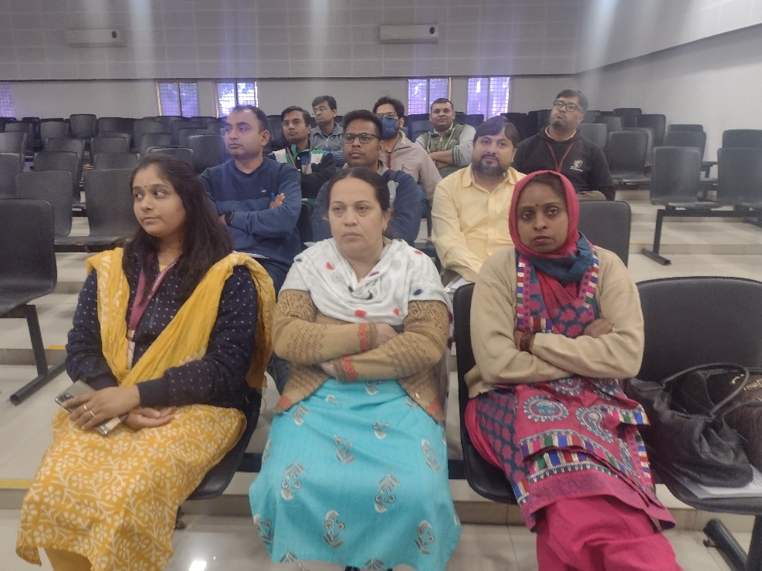
Teachers / Faculty members attending the Second session of workshop for financial Planning.
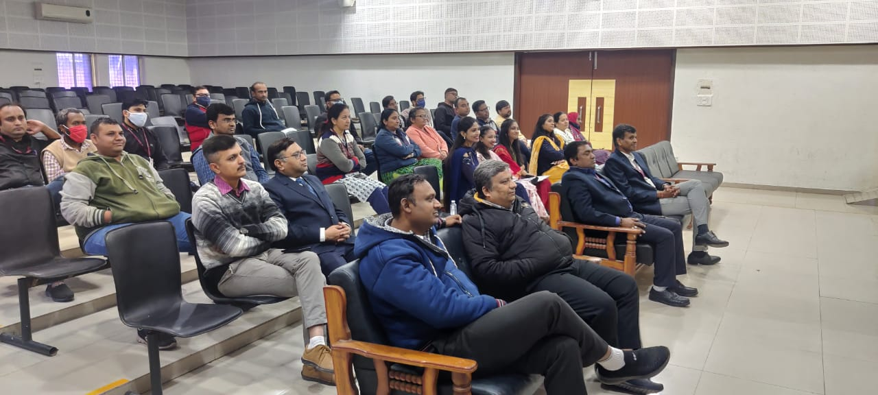
Teachers / Faculty members attending the Second session of workshop for financial Planning.

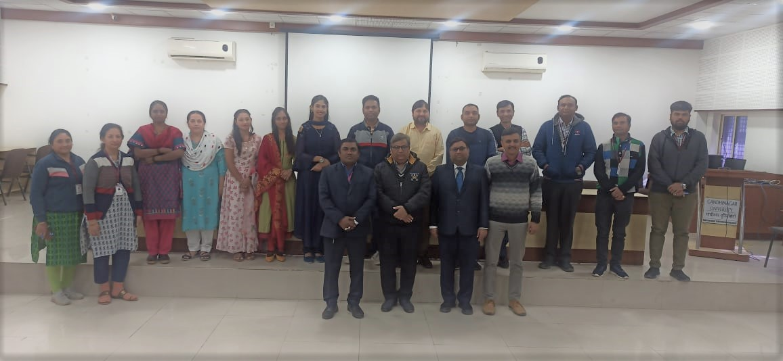
Group Photo of Teachers / Faculty members attending the Workshop.

