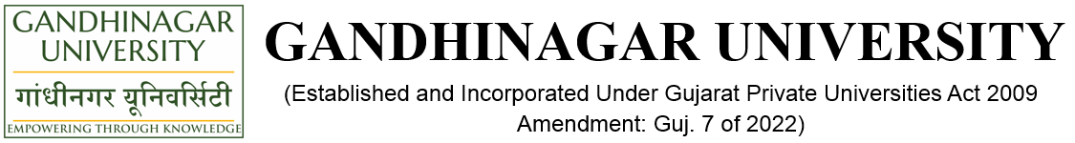
A Report on
“ISHRAE Chapter Level Quiz Competition”
(25th January 2023, Wednesday)
Introduction:
Gandhinagar Institute of Technology is member of ISHARE Students Chapter since 2014 and from then GIT is actively involved with all activities of ISHRAE. The purpose of an ISHRAE student chapter is to get more students interested, concerned, and involved in pursuing a career in the field of heating, ventilating, air conditioning and refrigeration. An ISHRAE student chapter increases knowledge to members and other interested people in the discussed sciences through Lectures, Workshops, Product Presentations and Expositions. Rendition of career guidance and financial assistance of the said sciences are also there for students for better future. ISHRAE chapter encourages all members for scientific research.

Objective:
To develop an interest in HVAC field ISHRAE Students Chapter organised different events at college level as well as at chapter level also. Aquest is a national level technical quiz competition organised by ISHRAE Students chapter for their registered students. There are total 43 students chapter associated with ISHRAE across the nation. For the grand finale of event, they called nomination of team from the individual chapter. Chapter were asked each college to nominate their representative for the quiz and arranged a competition at their chapter level. The winning team will get an opportunity to face national level quizzes at ACREX framed in the same line to test and generate student’s interests in HVAC.
ACREX’23 is a south Asia’s largest exhibition on Air Conditioning, Heating, Ventilation and Intelligent buildings organised by ISHRAE every year at different location across the India. As a knowledge sharing with the young engineers from colleges, they merge Aquest as a part of Acrex, so student may get the idea about the latest technology used in the industries latest. Mumbai is a host city for ACREX’23 this year.

Program Overview:
ISHRAE GIT Student Chapter got an opportunity to organised ISHRAE Ahmedabad chapter level technical quiz competition. Total six teams of students from different colleges like Gandhinagar Institute of Technology, L D College of Engineering, PDEU, GEC - Bhavnagar, GEC - Palanpur, GEC - Godhra represent their institute. Eminent members Mr Gaurang Patel (President ISHRAE Ahmedabad Chapter), Mr Avdhesh Namdev (HVAC Consultant), Mr Frank Gandhi (HVAC Design Engineer) from Industries and Prof Swati Sarswat (L D College of engineering), Prof Hardik Shukla (GEC- Godhra) Academics attended the event. Total 3 round were played in a quiz competition amongst the team. Question were mainly from the domain of Refrigeration and Air-condition, Fluid Mechanics, Heat Transfer and Workshop Technology. Team IAC - United (Mr Meetkumar Hareshbhai Suthar – LDCE and Ms. Priya Girishbhai Chauhan – GEC Godhra ) was a winner of the event and team is nominated for the further round of Aquest.
The event was accomplished under the guidance of Trustees and Director -GIT and executed by ISHRAE GIT Student Chapter Coordinator and ISHRAE Students volunteer.

Photo Gallery:

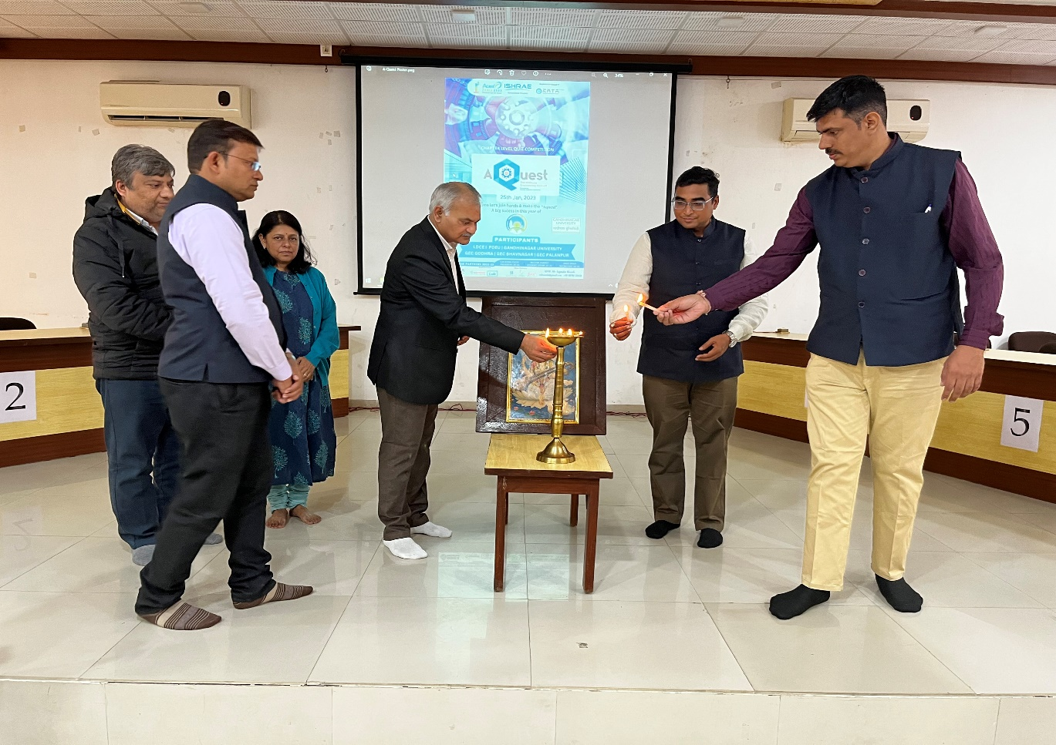
Lamp Lightning by Director Sir and Guest
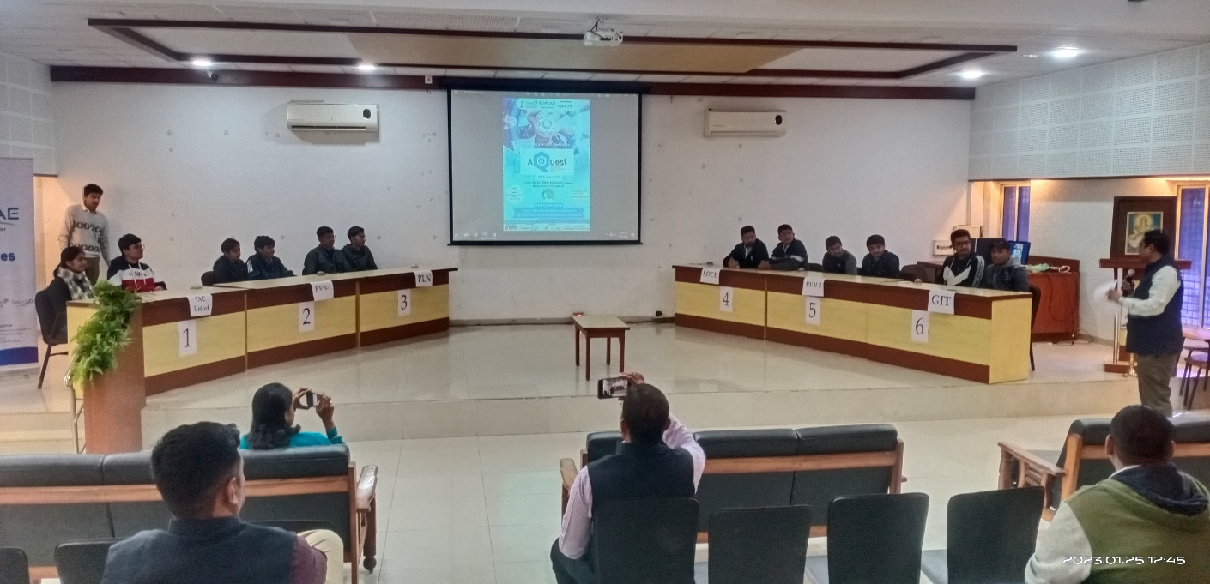
Round of Quiz Competition
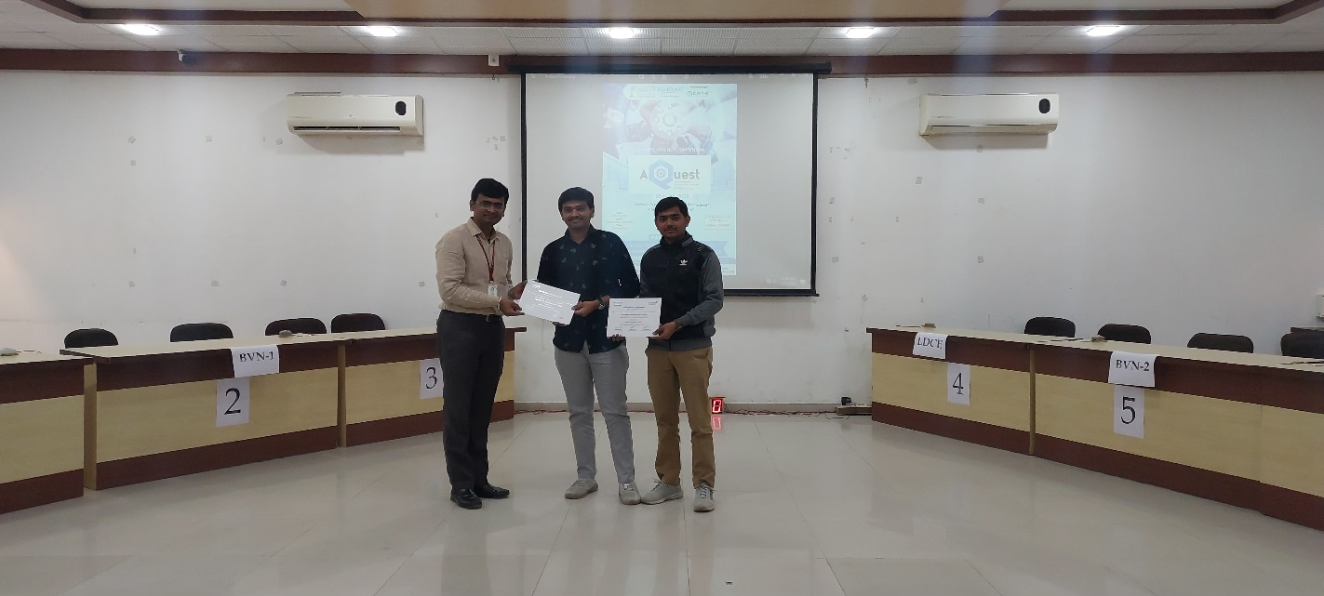
Felicitation of Winners
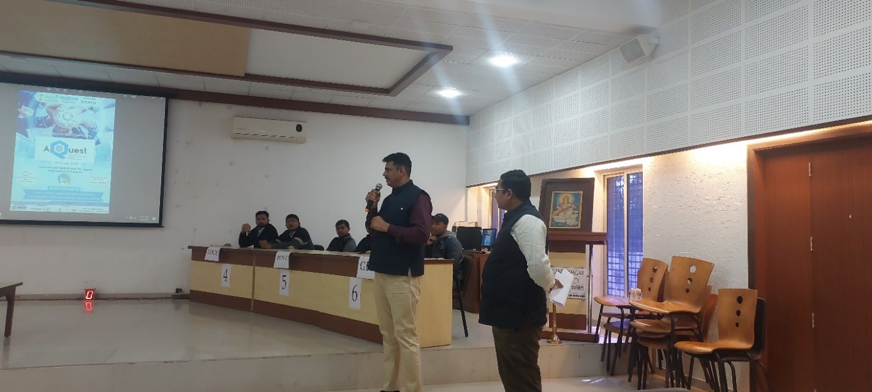
Special announcement by ISHRAE President
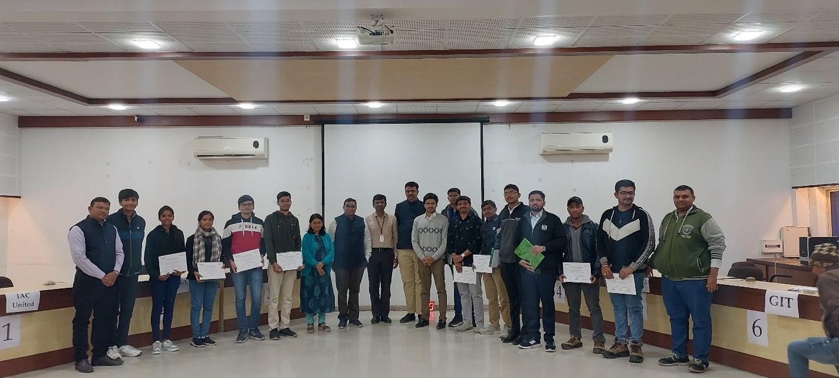
Students Members from various colleges along with guest
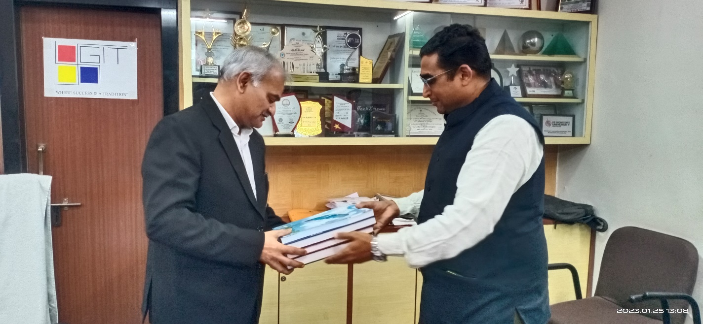
Handbooks published by ISHRAE handed over to Director sir by ISHRAE Ahmedabad President
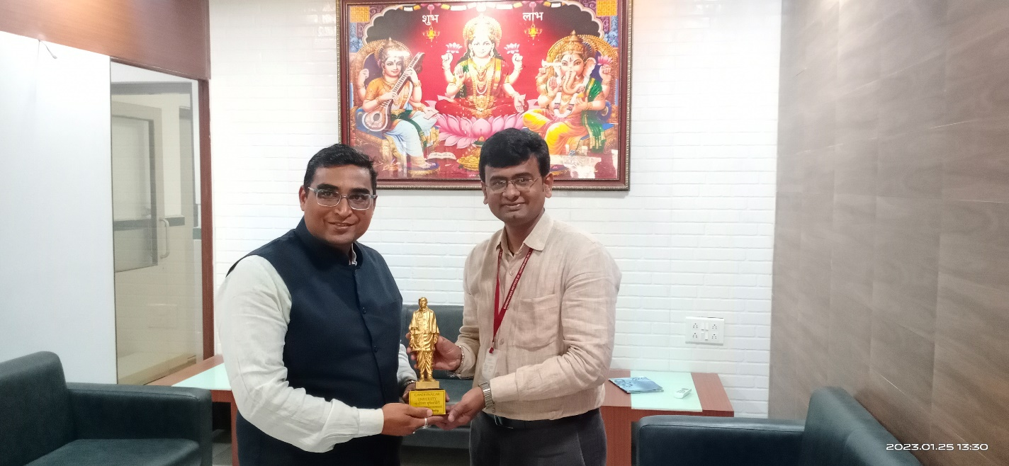
Falicitaion of ISHRAE Ahmedabad President by ISHRAE GIT Student Chapter Coordinator

