Gandhinagar University
A Report on
“Certification for AIVSC Camp Completion of GIT NCC cadets” (15/03/2023)

Event Overview:
The All India Vayu Sainik Camp was organized by 2 gujarat air sqn unit from 24th Sep to 5th Oct 2022. GIT NCC cadets have participated in camp and undergo the series of 04 preliminary camp on progressive selection basis at each stage for finally representing the NCC Directorate Gujarat at AIVSC-2022. The Certification were issued to two cadets for completion of AIVSC-2022 in March 2023

Objective:
The Goal behind the camp was too aware the cadets about the challenges in field of NCC. The cadets are trained for the futuristic goal in terms of social service, mankind and leadership for serving the society and nation.

Program Overview:
On primary basis volunteer cadet were selected at unit level among which 18 cadets from GIT NCC units have participated and undergone training for various activities in August 2022. On the progressive selection basis 7 cadets from GIT completed primary training and got selected for PVSC-1 (Primary Vayu Sainik Camp) from 32 cadets representing Ahmedabad Air Sqn.
For Next round 5 cadets from GIT were selected for PVSE-2 (in contingent of 20) and for final representation 2 were selected to represent Gujarat directorate in All India Vayu sainik camp.
During the camp training cadets have undergone various activities like, Logical thinking, Leadership Skills, sports, Air flying and rifle shooting. The camps were organized at Ahmedabad, Bhavnagar and final round at Jodhpur unit.
The Certification were issued to two cadets for completion of AIVSC-2022 and they have felicitated to Director and Registrar of Gandhinagar university as an token of Thanks for providing support and guidance for participation in camp. The seven cadets have share their camp experience with Director Sir.

Photo Gallery:

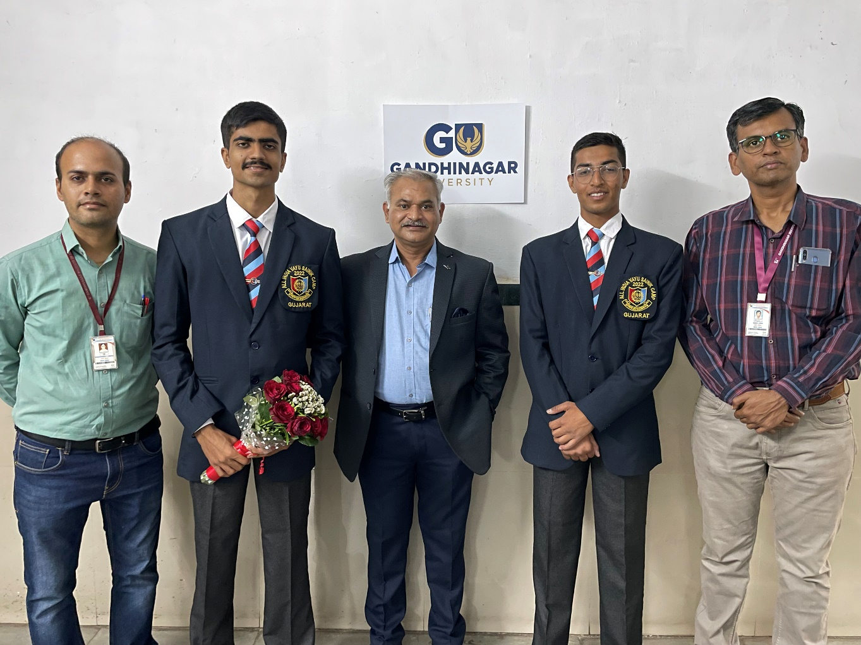
AIVSC camp completion cadets
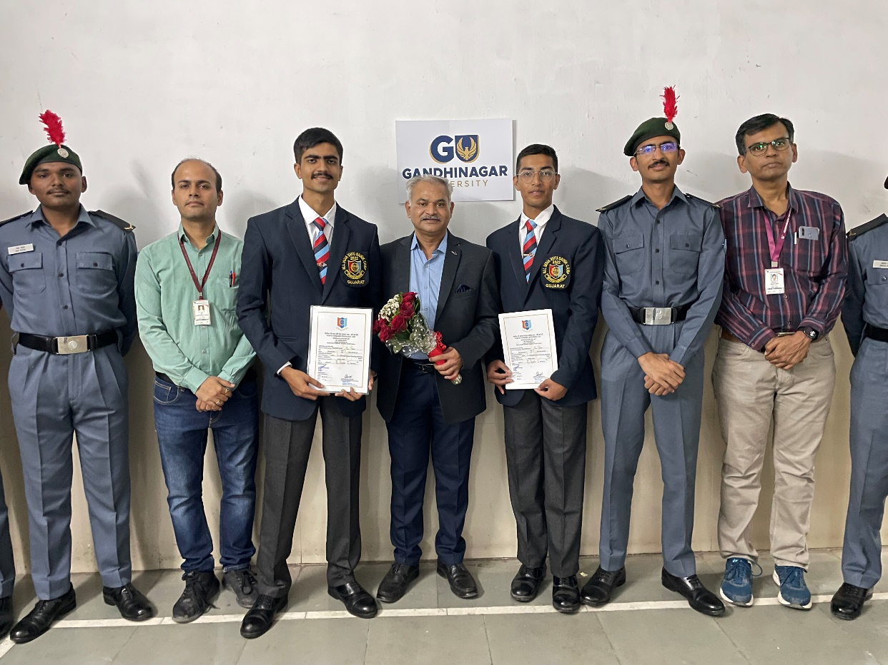
PSVC-1camp completion Cadets
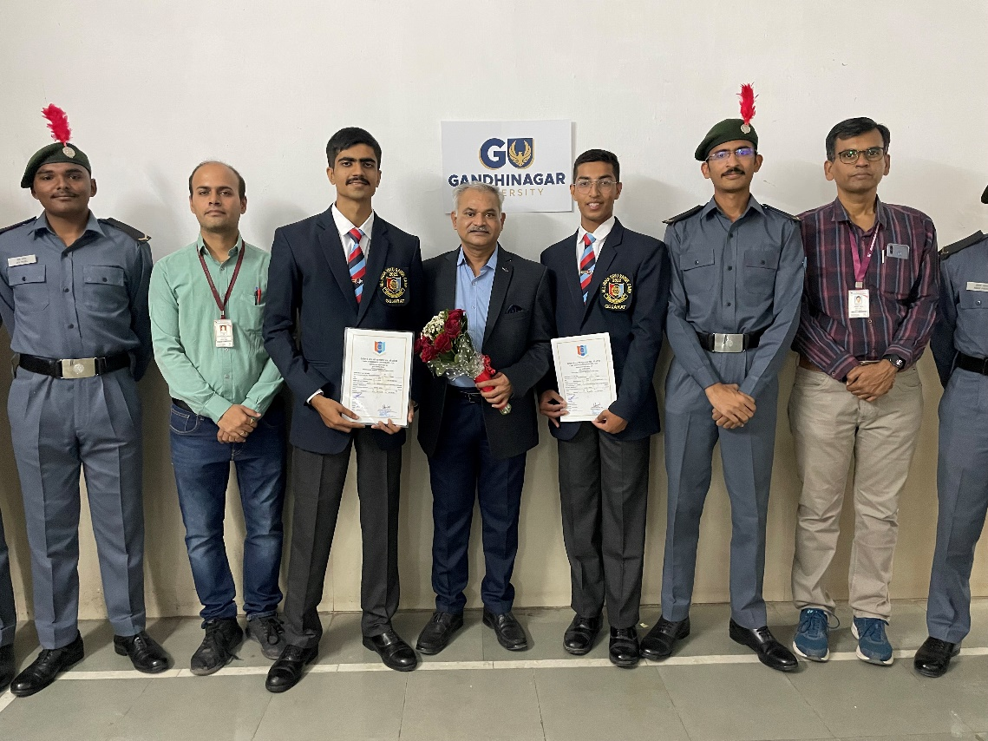
PSVC-1camp completion Cadets 1
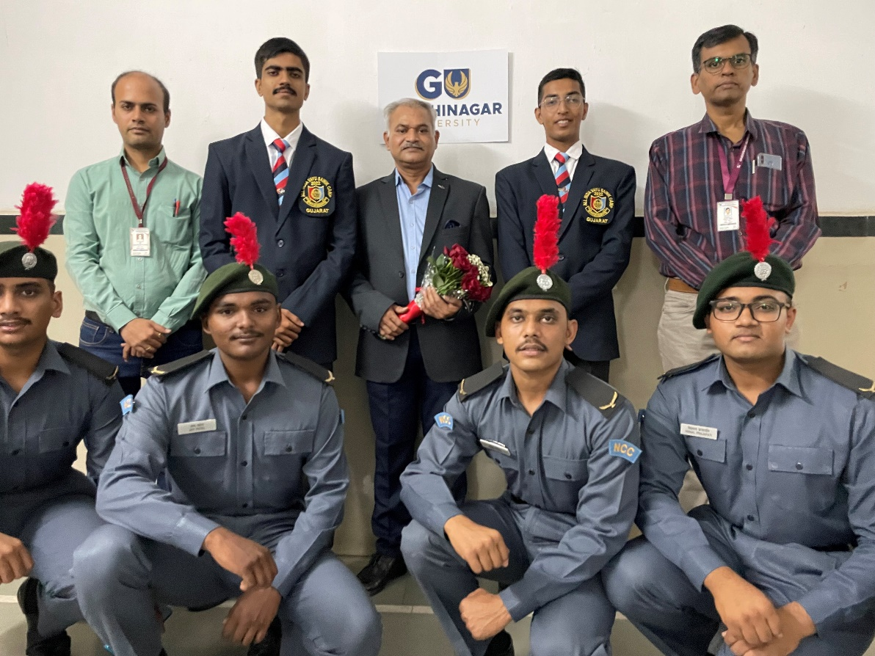
PSVC-1camp completion Cadets 2

