A Report on
“Visit of International Exhibition ACREX’23 and Final Quiz Competition at Mumbai by ISHRAE GIT Students” (16th & 17th March 2023)
Introduction:
Gandhinagar Institute of Technology is member of ISHARE Students Chapter since 2014 and from then GIT is actively involved with all activities of ISHRAE. The purpose of an ISHRAE student chapter is to get more students interested, concerned, and involved in pursuing a career in the field of heating, ventilating, air conditioning and refrigeration. An ISHRAE student chapter increases knowledge to members and other interested people in the discussed sciences through Lectures, Workshops, Product Presentations and Expositions. Rendition of career guidance and financial assistance of the said sciences are also there for students for better future. ISHRAE chapter encourages all members for scientific research.

Objective:
To develop an interest in HVAC field ISHRAE Students Chapter organised different events like seminar, webinar, workshop, product presentation, industrial visits, design competition, Hackathon at college level as well as at chapter level also.
Aquest’23 is a national level technical quiz competition organised by ISHRAE Students chapter for their registered students. There is total 43 students chapter associated with ISHRAE across the nation. For the grand finale of event, they called nomination of team from the individual chapter. Chapter were asked each college to nominate their representative for the quiz and arranged a competition at their chapter level. The winning team of quarter-final & semi-final will get an opportunity to face national level quizzes at ACREX framed in the same line to test and generate student’s interests in HVAC.
ACREX’23 is a south Asia’s largest exhibition on Air Conditioning, Heating, Ventilation, and Intelligent buildings organised by ISHRAE every year at different location across the India. As a knowledge sharing with the young engineers from colleges, they merge Aquest’23 as a part of ACREX’23 so student may get the idea about the latest technology used in the industries latest. Mumbai is a host city for ACREX’23 this year.

Program Overview:
Students of ISHRAE GIT Student Chapter Mr Bhragav Pathak, Mr Milan HIrapara & Mr Mahim Pathak along with Faculty coordinator Dr Ruchir Parikh got an opportunity to visit ACREX’23 and Aquest’23. Students had visited ACREX’23 which was organised at BEC, Goregaon Mumbai on 16th march and Aquest’23 which was held at Rajiv Gandhi Institute of Technology, Andheri(W), Mumbai on 17th march. Around 100s of multinational companies participated in the exhibition. Students had interacted with so many companies as per their interest and latest technology in HVAC field. On next day in Aquest’23 final total six teams participated. Teams were from Ahmedabad, Nagpur, Vadodara, Mumbai, Kolkata and Madurai represent their chapter. So many eminent personalities like ISHRAE President Mr N Chandra Shekharan, President Elect Mr Yogesh Thakkar, National Student Chair Mr A Madhukar and Mr Arvind Vegda as a entertainer of event. Total 4 round were played in a quiz competition amongst the team. Questions were mainly from the domain of Refrigeration and Air-condition, Fluid Mechanics, Heat Transfer and Workshop Technology. Team from Kolkata was winner of the event. Students for GIT were fully enjoyed these 2 days visit.
I, Dr Ruchir Parikh as a Faculty coordinator of ISHRAE GIT Students chapter wanted to express appreciation for the support and guidance of Trustees, Director, and Dean -GIT.

Photo Gallery:

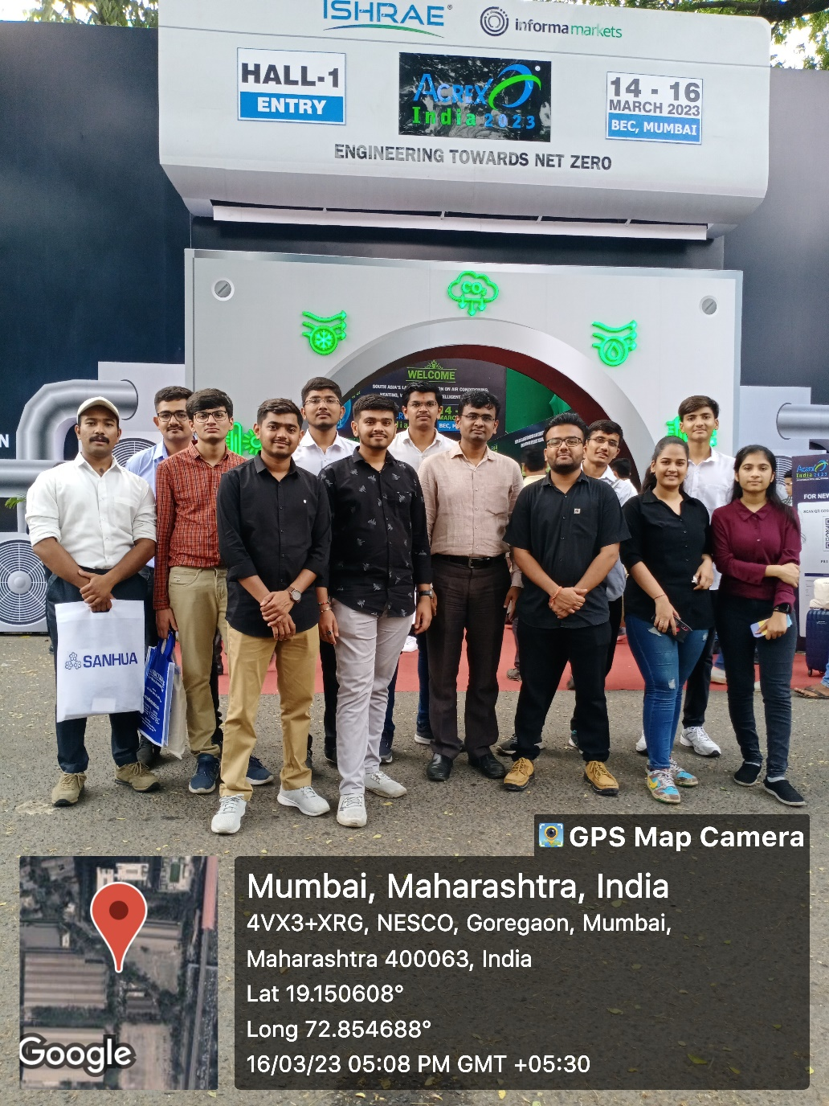
Students at the ACREX’23 Exhibition, Goregaon, Mumbai
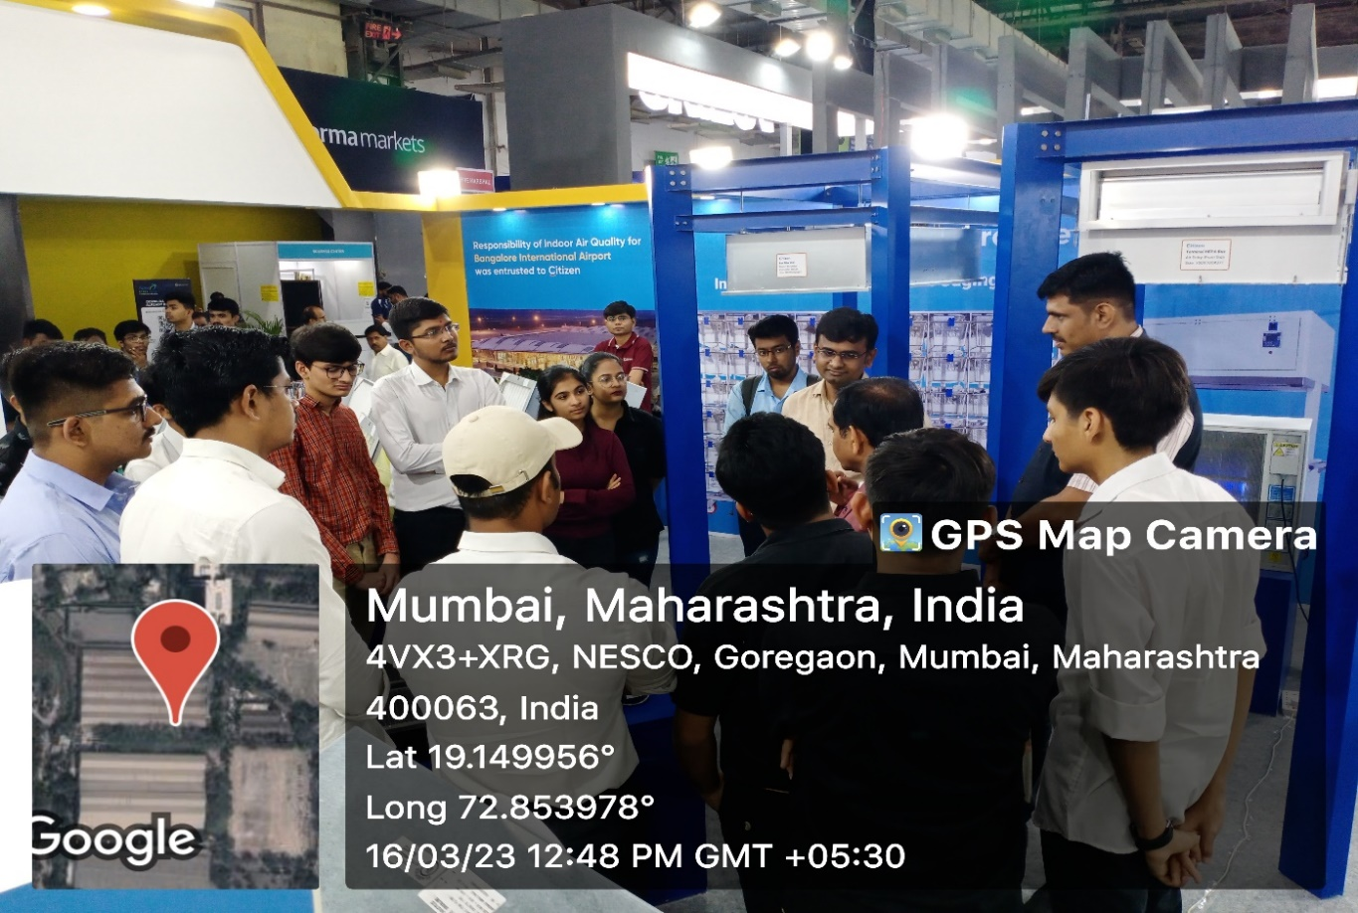
Student Interaction with the exhibitors
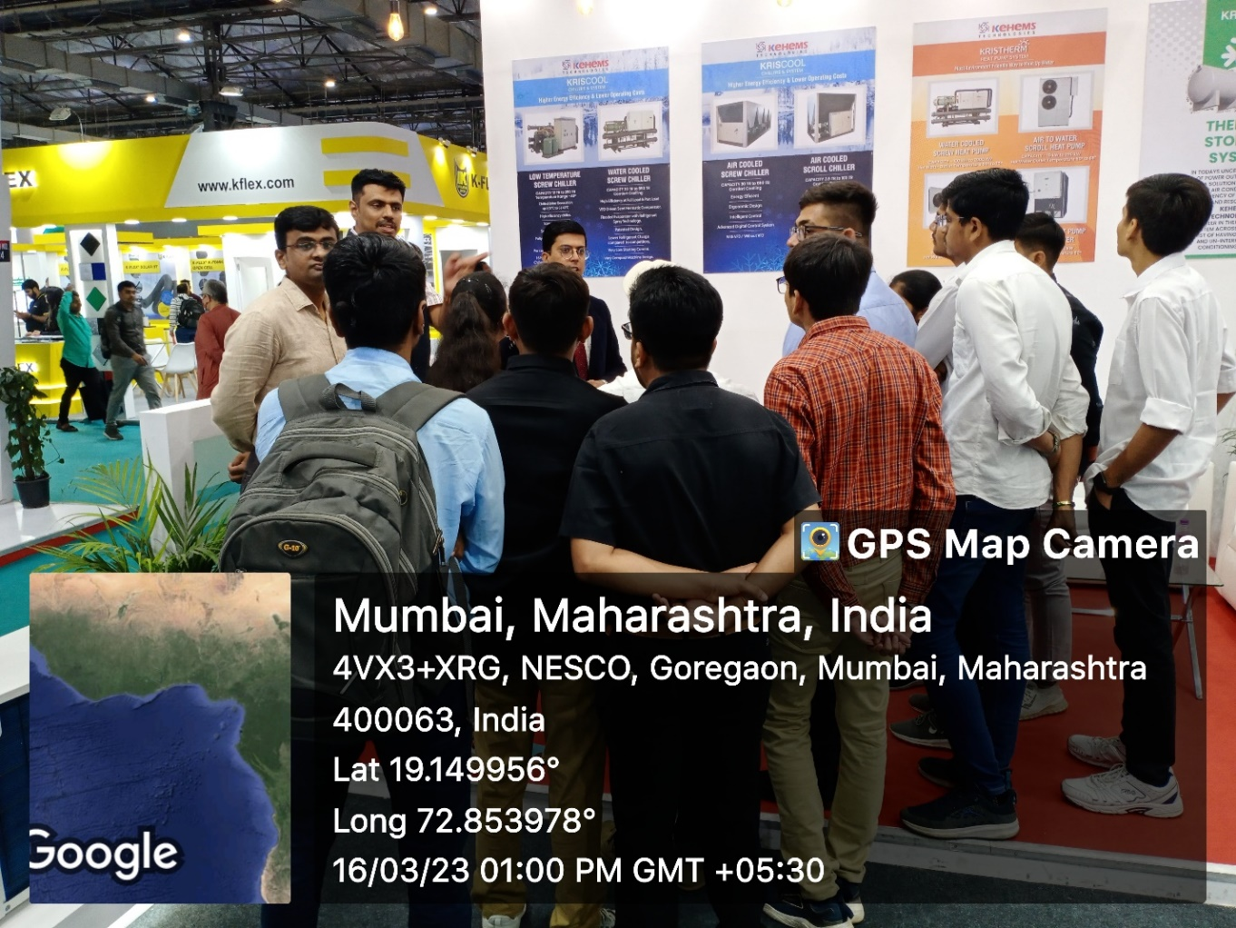
Student Interaction with the exhibitors
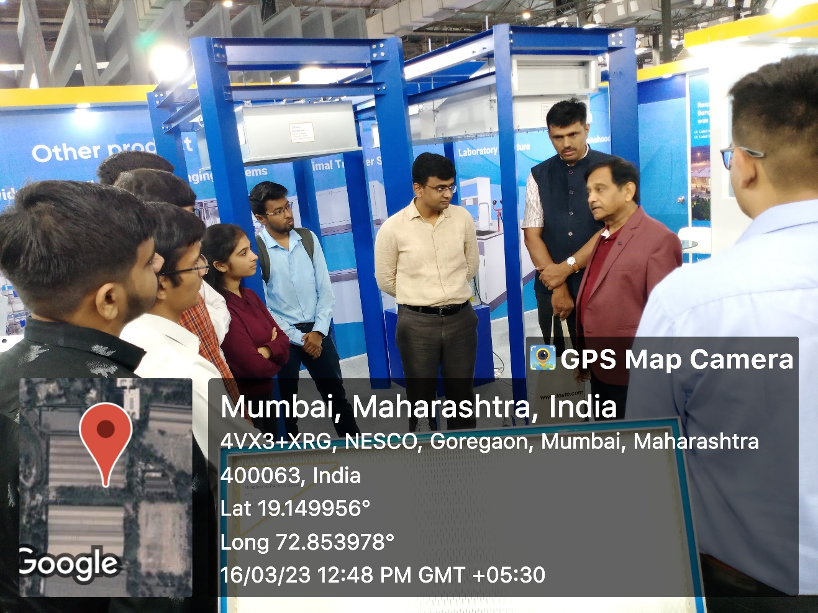
Student Interaction with the exhibitors
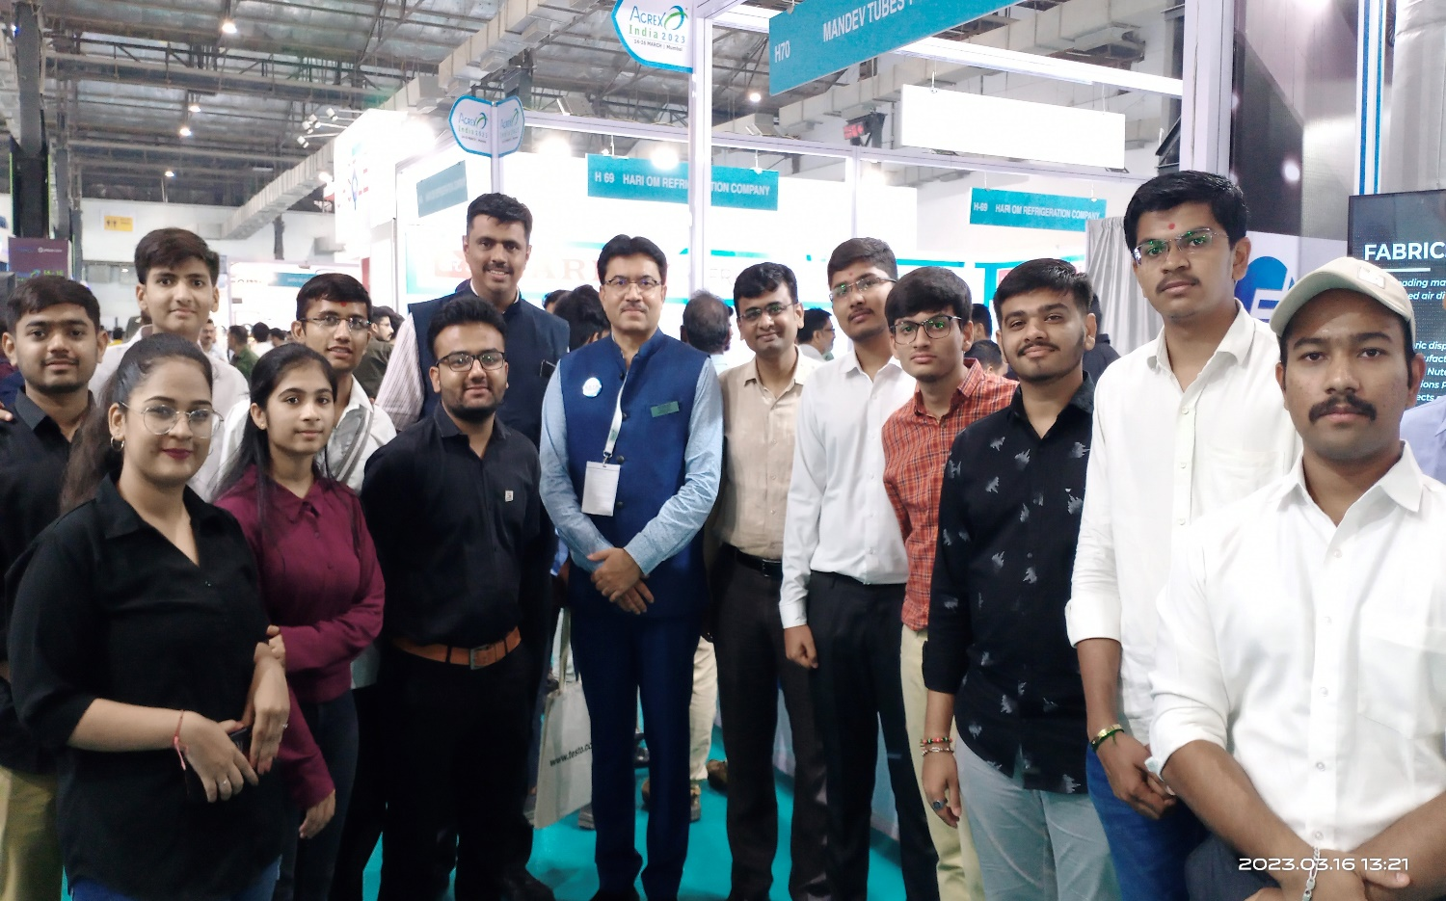
Students with Regional Director West Mr Urvish Shah
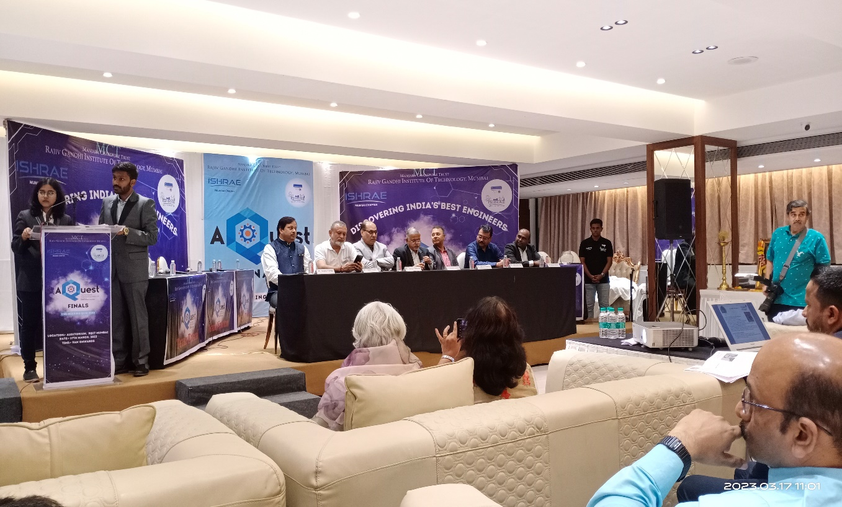
Aquest’23 - Dignitories on the dias at Rajiv Gandhi Institute of Technology
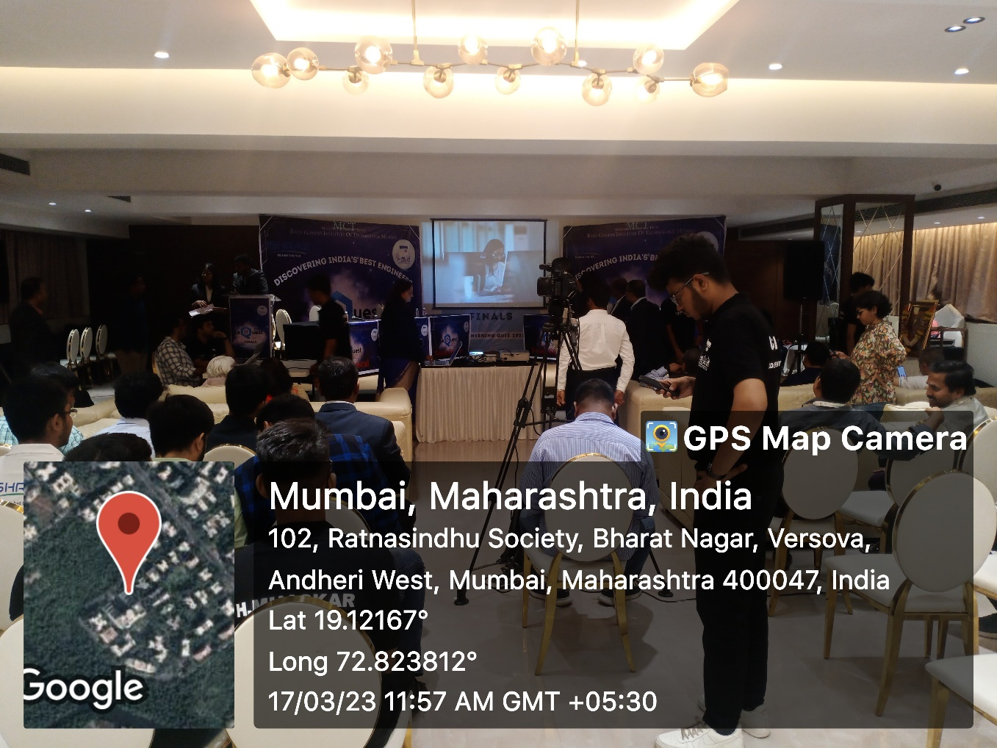
Set up of Final Quiz Competiton Aquest’23
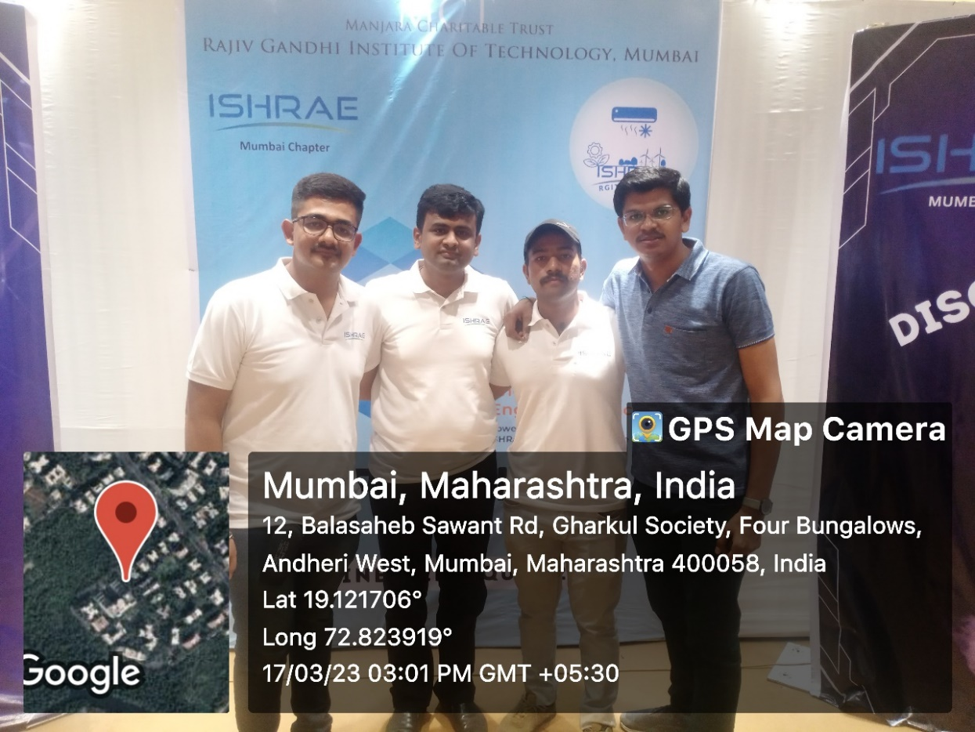
With studets of Gandhinagar Institute of Technology ISHRAE Chapter
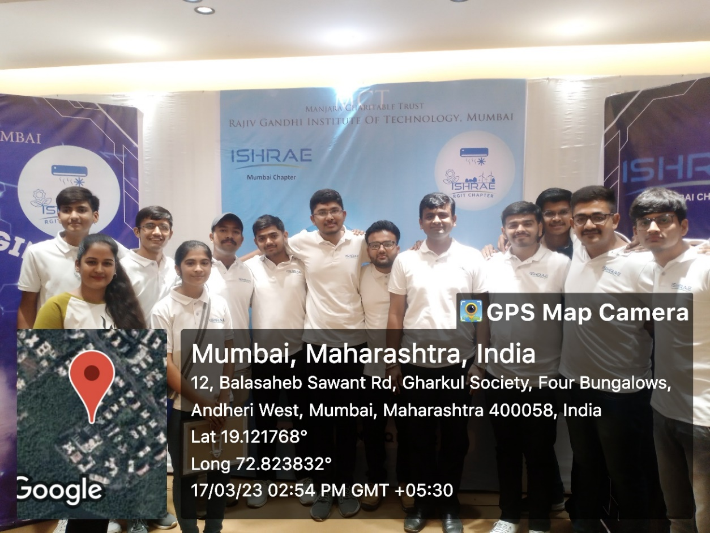
With students team of ISHRAE Ahmedabad Chapter

