Gandhinagar University
A Report on
“Awareness Session on NDLI & NDLI Club”
4th March 2023, Saturday

Event Overview:
Resource Centre and IQAC of Gandhinagar University organized “An awareness session on NDLI & NDLI Club” on 4th March 2023 for all staff and faculty members under the guidance of Dr H N Shah, Director and co-ordinated by Ms. Rupam Gupta, I/c Librarian, Gandhinagar University. National Digital Library of India (NDLI) is an initiative of MHRD, Govt. of India, and developed by IIT Kharagpur. It is a digital repository that provides free access to learning materials from primary to post-graduate levels across various subject domains to benefit all kind of life-long learners. The G20 forum is playing an important role in shaping and strengthening global architecture and governance on international economic issues. Libraries are also working as partners in G20, by contributing government initiatives through promoting lifelong learning, digital contents, media and information literacy, enabling access to information and the preservation of cultural heritage across geographies, languages, genres and levels.

Objective:
The primary objective of the session was to instil a passion for reading the different resources available in Resource centre and NDLI among staff members. It is to aware about the resources and content available at NDLI in various forms and its usefulness and aware about the function and activities of NDLI Club.

Program:
The session was organized, for staff and faculty members of university. More than 40 staff and faculty members participated. The session was started at 2.15 pm onwards in the seminar hall with an introductory speech from club president, Ms. Rupam Gupta. She has initiated her speech with a vision and mission of NDLI and its history. She has also explained the benefits of NDLI & NDLI Club to the staff and faculty members.

Ms. Rupam Gupta explained in detail about the type of content available at NDLI and types of activities conducted by NDLI Club at university level and globally. She briefed about the benefits to all students, staff and faculty members as well as university through NDLI Club. She demonstrated the NDLI website and provided detailed information about the organization of content on the website. She showcased the interface availability in various languages, types of formats, types of access availability, category wise availability of content, educational level wise availability through browsing NDLI website. She also briefed about the registration process on the portal. The queries from faculty members have been answered during questions and answers session. Ms. Rupam Gupta concluded the session with vote of thanks to all staff and faculty members and assisting staff members who directly or indirectly a part of this event to make it successful. She especially thanked Gandhinagar University and Dr H N Shah, Director(Patron of NDLI Club) for continuous support and motivation for such type of events. The seminar was effectively accomplished with the consistent efforts of members of NDLI Club (Ms. Dipti Joshi, Secretary and Prof. Chintan Barelwala, Executive Member).

Event Photo Gallery:

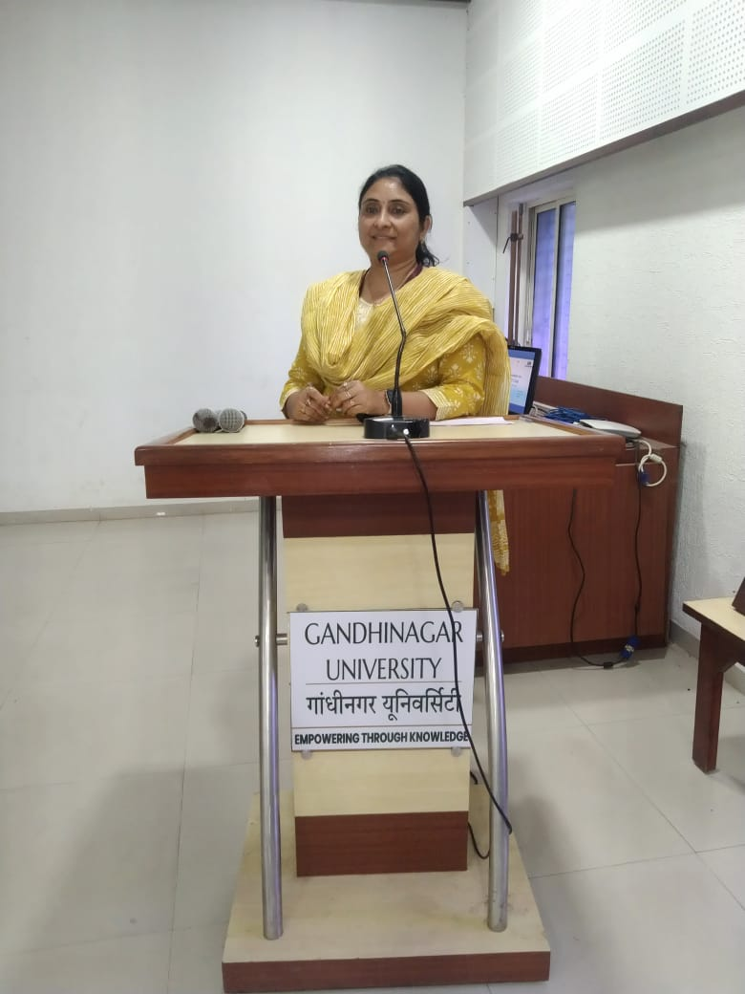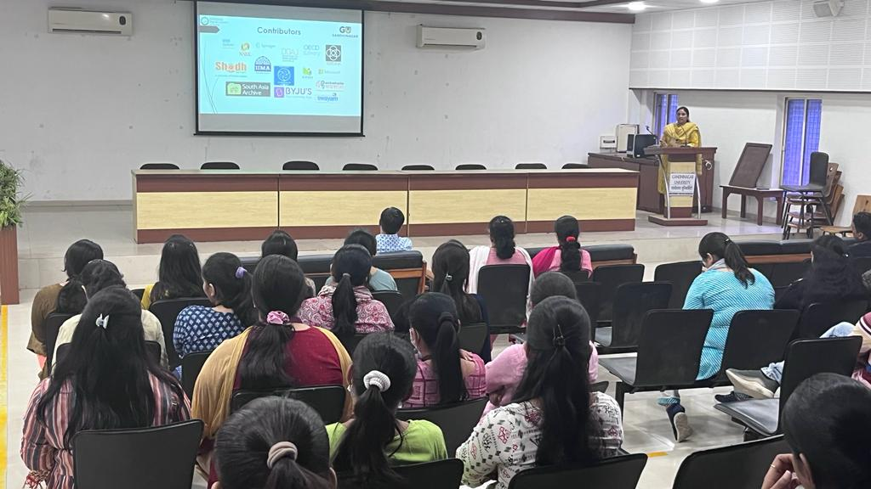

Presentation by Ms. Rupam Gupta

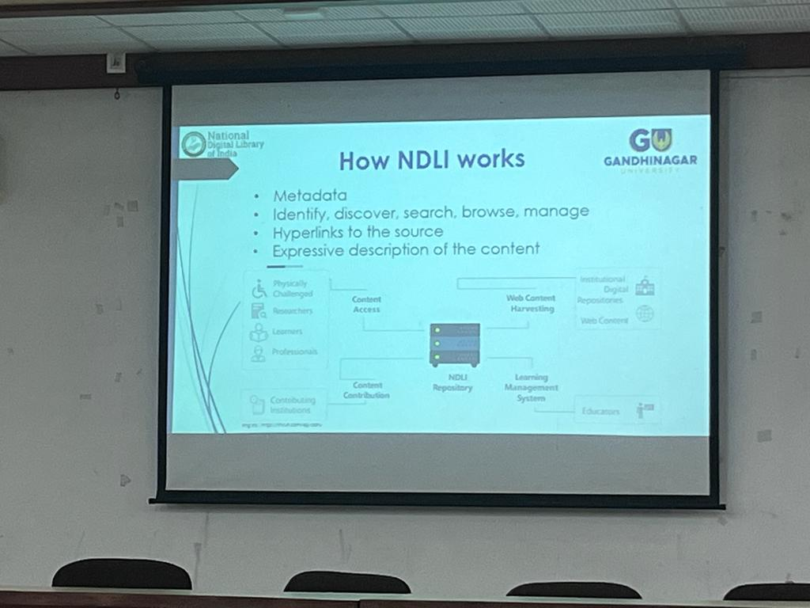

About NDLI & NDLI Club

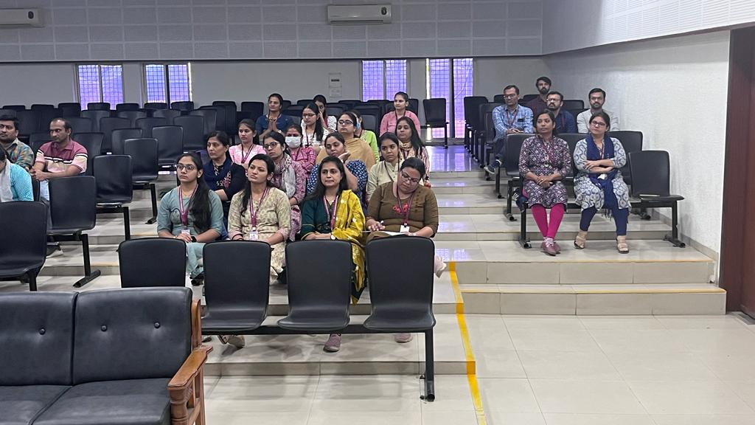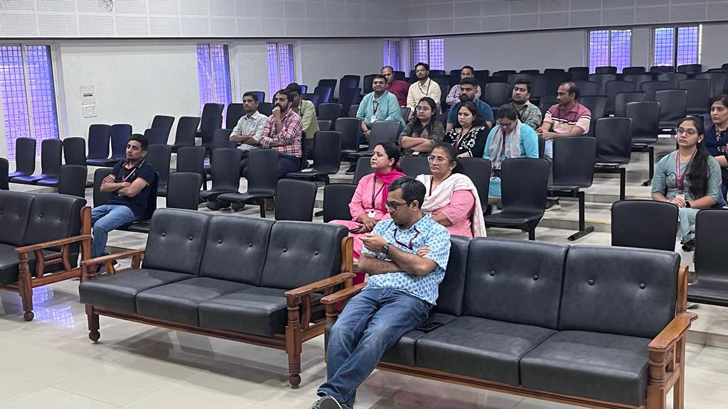

Participants attending the session
