A Report on
Holi Celebration 2023
7th March 2023, Tuesday

The spirit of Holi has different aspects. It is a carnival of colors, a celebration of the triumph of good over evil, a community festival and a tradition of ancient spring rites. It gives an opportunity to forget all differences and indulge in unadulterated fun with the colors of unity and brotherhood. India is a multi-cultural country and festivals celebrated in India symbolize the socio-cultural and religious diversity and aspirations. The festival of Holi was celebrated with great pomp and fervor at the Institute.

Holi gets us close to our religion and our mythology as it is essentially the celebration of various legends associated with the festival. Celebration of the various legends associated with Holi reassures the people of the power of the truth as the moral of all these legends is the ultimate victory of good over evil. Holi helps to bring the society together and strengthen the secular fabric of our country. For, the festival is celebrated by non-Hindus also as everybody like to be a part of such a colorful and joyous festival. It is interesting to note that the festival of Holi is significant for our lives and body in many other ways than providing joy and fun.

The institute organized Holi Festival 2023 on March 7, 2023 from 1:30 pm onwards at the Bus Parking Area. The event was scheduled just one day before Dhuleti hence the joy of festival flaunted everywhere. More than 250 students along with faculty members took part in this event.

Dr H.N.Shah, Director, Gandhinagar University greeted and wished the entire Gandhinagar University family and said that Holi is also a festival of love which is aimed at spreading the message of peace and happiness. Some of the faculty members motivate to the students for playing safe holy in the campus. The staff members put tilak and gathered to play “Holi”.

This event was celebrated with fun, fervor and togetherness by the students and employees of the institute.

.

Photo Gallery:
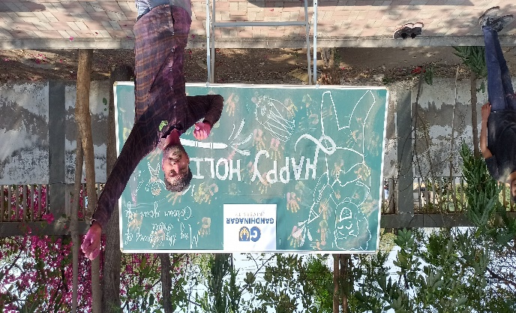 | 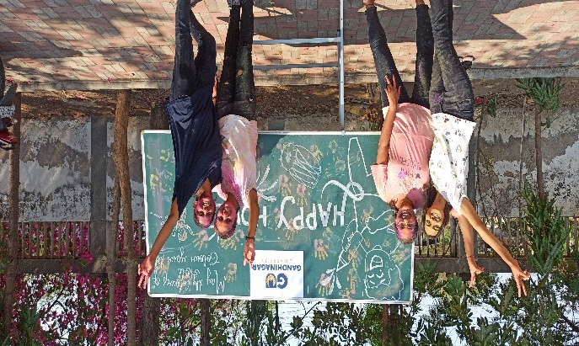
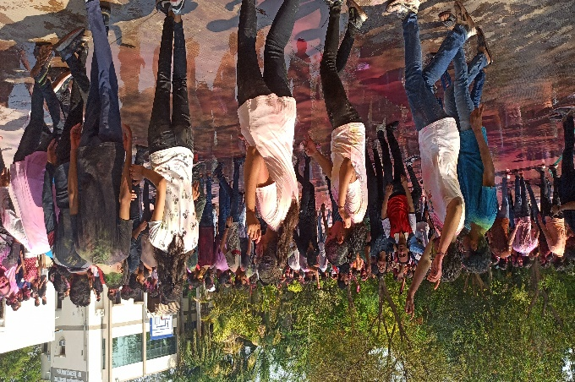 | 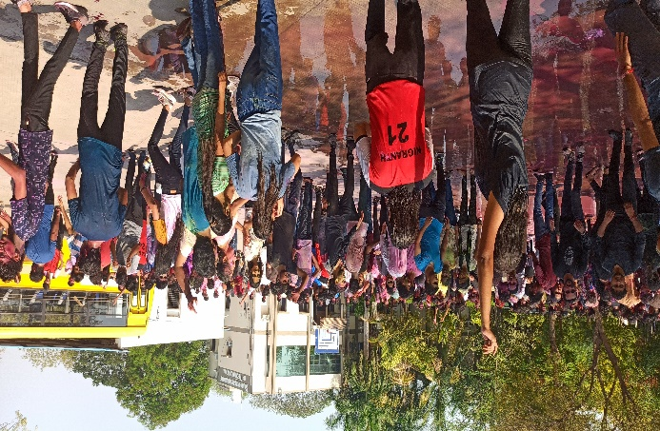
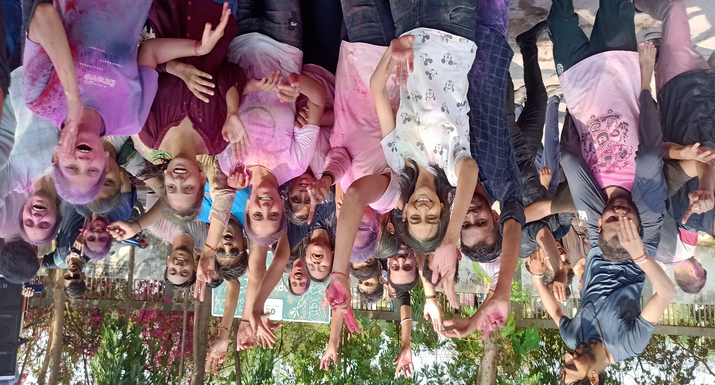
Students Celebrate Holi with colour

