Gandhinagar Institute of Technology
Computer Engineering & Information Technology Department
A Report on
“Visit to Nichetech Computer Solutions Pvt. Ltd.”
(10th March 2023)

Objective:
The objective of this visit was to make the students aware about the technologies used in software companies in the field of Ecommerce development, Mobile development and Web development.

About Visit:
This visit provided a valuable platform to both students as well as Nichetech Computer solutions Pvt. Ltd to exchange their information. Dr. Nisha Khurana organized this visit and Prof. Shreya Patel accompanied 76 students from Sem-6 of Computer Engineering and Information Technology Department, Gandhinagar Institute of Technology to the company.
Nichetech is an award-winning App developer in India. They provide the solutions to Ecommerce development, Web Development and Mobile Development. The mobile technologies they deal with are IOT, IOS, Android, Python, Flutter, React native, JAVA and Swift. AngularJS, PHP, ReactJS, Bootstrap are the front-end technologies they deal with. They work with many database technologies like MYSQL, PostgreSQL, MongoDB, SQLite, Oracle and many more. They also work with Content Management System Joomla, Drupal, WordPress and Wix.
Students were first introduced to the company profile like the kind of development they do in ecommerce, web and mobile development. Students interacted with the junior and senior developers. Developers explained the ongoing projects in the company. The company narrated its journey and explained how they work on the motto “Excellence is not a skill, it’s an attitude”. They also gave a brief about their ongoing client Collebra - which is honoured to have earned a spot-on Forbes list and is a promising client of nichetech.
They were also introduced to their mobile app MatruBharti. Matrubharti is a vernacular platform to read books and stories for free and writers can publish their books and stories to reach to millions of readers. It is an app which is developed to help the authors to publish digitally and reach globally. Matrubharti app also works in many regional languages. Students were also given valuable insights on how Designers, Developers and QA professionals work in a team.
The company works on the mantra “Lots of Kisses” which means Learn, Observe, Think and Speak and Keep it Simple Stupid. The students were entertained with a quiz too and two students from CE-IT respectively won a Nichetech Mug. At last the students had an interactive session with the developers and were explored with the opportunities available in the company. They were also served with refreshment.

A Few Glimpses of the Event:
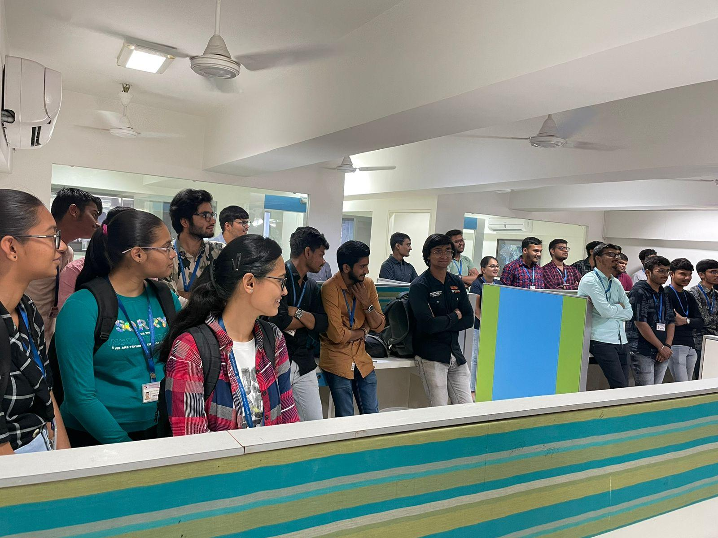
Students in an interaction
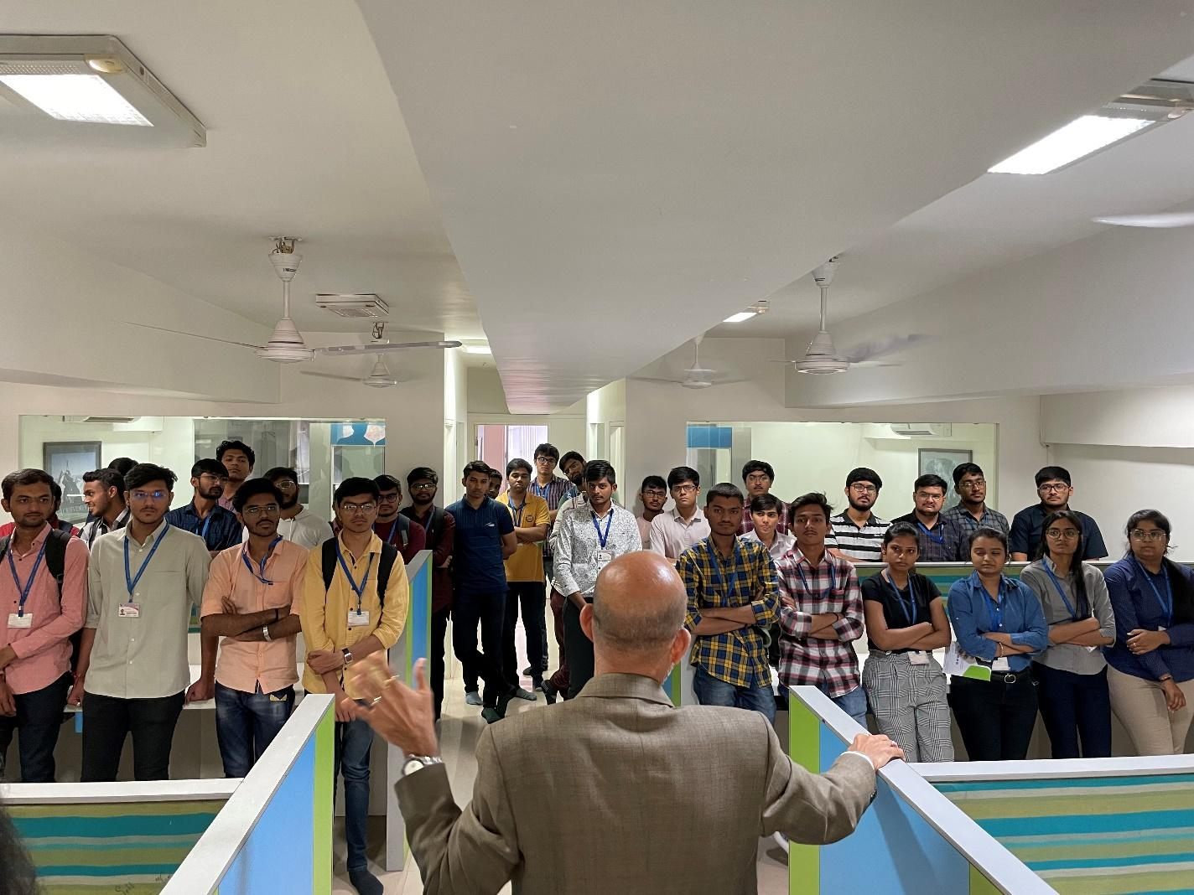
Interaction with the CEO of the company
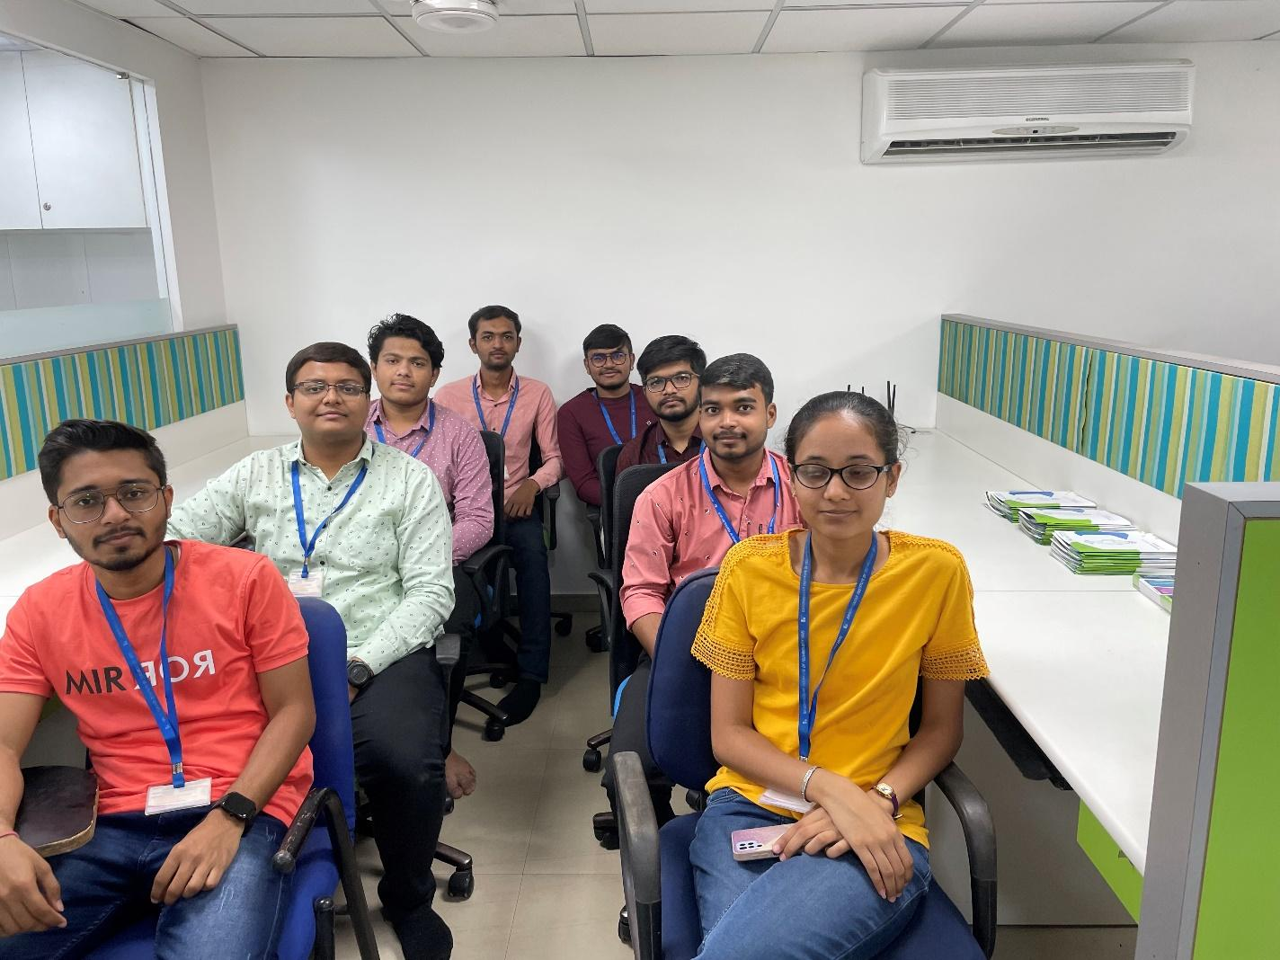
Students listening to instructions
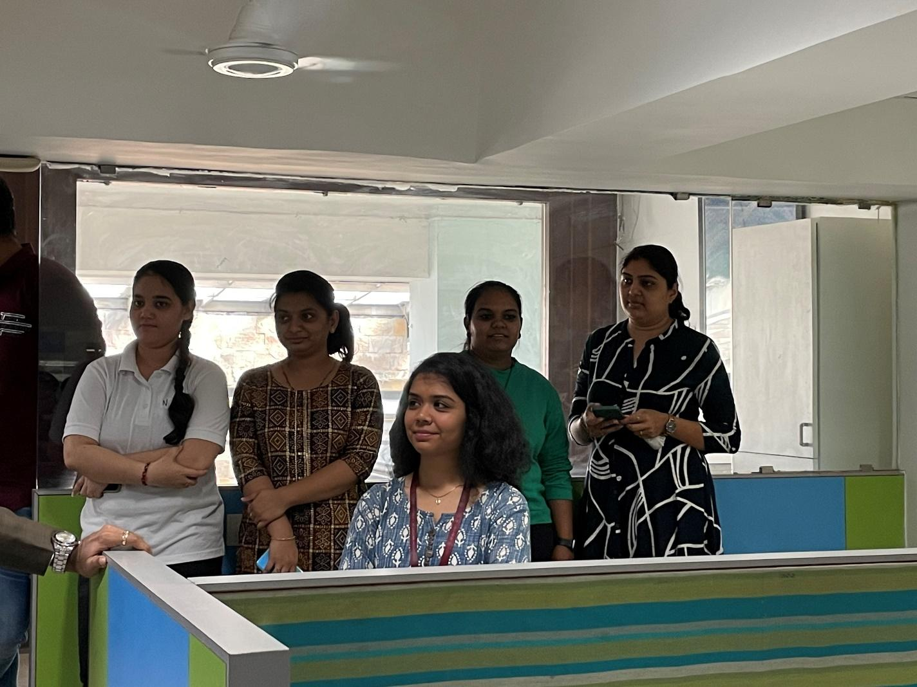
Company Professionals with Prof. Shreya Patel

