DOC NO: 1426

A Report on

Seminar
on

“Quality Assurance”

Organized by

GIT-CE/IT & GU-IQAC

on

04/03/2023

Gandhinagar University
2022-2023

Level: - University

Category: - Seminar

Date: - 04/03/2023
No. of Resource Person: - 01
Name of Resource Person: - Ms. Divya Sharma, Senior QA Engineer, Moon Technolabs Pvt. Ltd.

No. of Participants: - 53

Coordinator name: - Dr. Nisha Khurana

Mode: - Offline

Introduction:
Computer Engineering and Information Technology Department organizes various programs in the benefit of students in association with Internal Quality Assurance Cell (IQAC) from time to time. A Seminar on Quality Assurance was organized by CE & IT department on March 4, 2023, Saturday under the guidance of Dr. H N Shah, Director-GIT and Dr. Nimisha Patel, HOD, CE/IT. Expert Ms. Divya Sharma, Senior QA Engineer from Moon Technolabs Pvt. Ltd., Ahmedabad conducted the session. The event was coordinated by Dr. Nisha Khurana.

Objective:
The objective of the Seminar was to provide students a platform for gaining fundamental aspects in Software Quality Assurance. The goal of the workshop was to empower students with the concepts of testing, Software development life cycle and the importance of quality assurance in software products.

Program Overview:
A seminar on Quality Assurance was attended by the students of sem 6 of Computer Engineering, Information Technology, GIT and the students of sem 2 of B.Sc., GICSA. Around 55 students and faculty members attended the program. Session started with the introduction of expert by Dr. Nisha Khurana. Expert Ms. Divya Sharma covered the concepts of SDLC, and software testing. She also explained the importance of software testing and how it is carried out in practical. She explained the difference of Manual and automated testing. She also talked about the career aspects of quality assurance in industry. Students enjoyed and learnt a lot from the session. The session was concluded with vote of thanks by Dr. Nisha Khurana.

Outcome: - Students completely understood the concepts of Quality Assurance. How it is executed and what are the different tools that can be used for testing. Also, they were exposed with various career opportunities related to testing in industry.
A Few Glimpses of the Event:
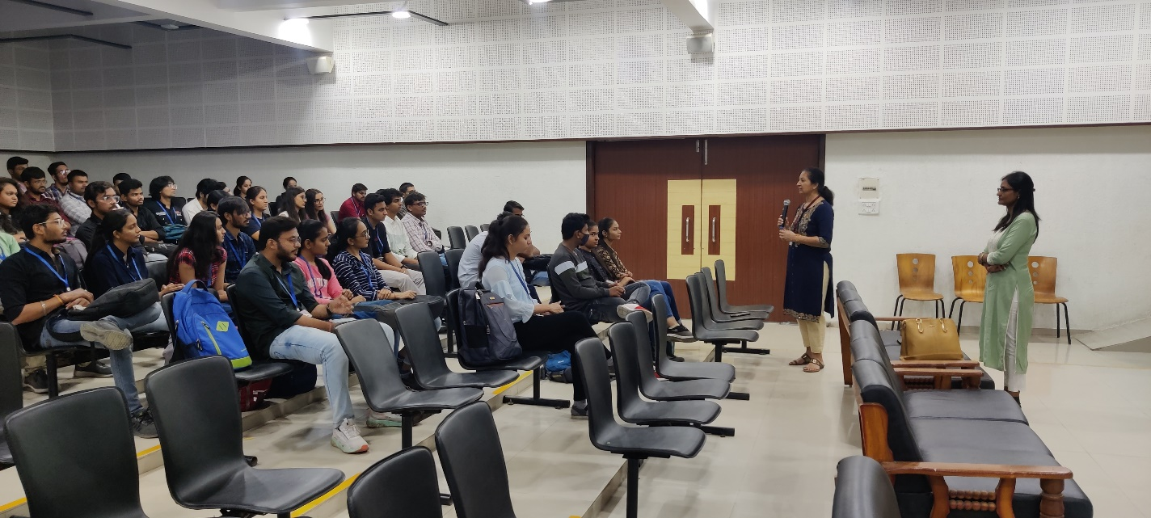
Introduction by Dr. Nisha Khurana
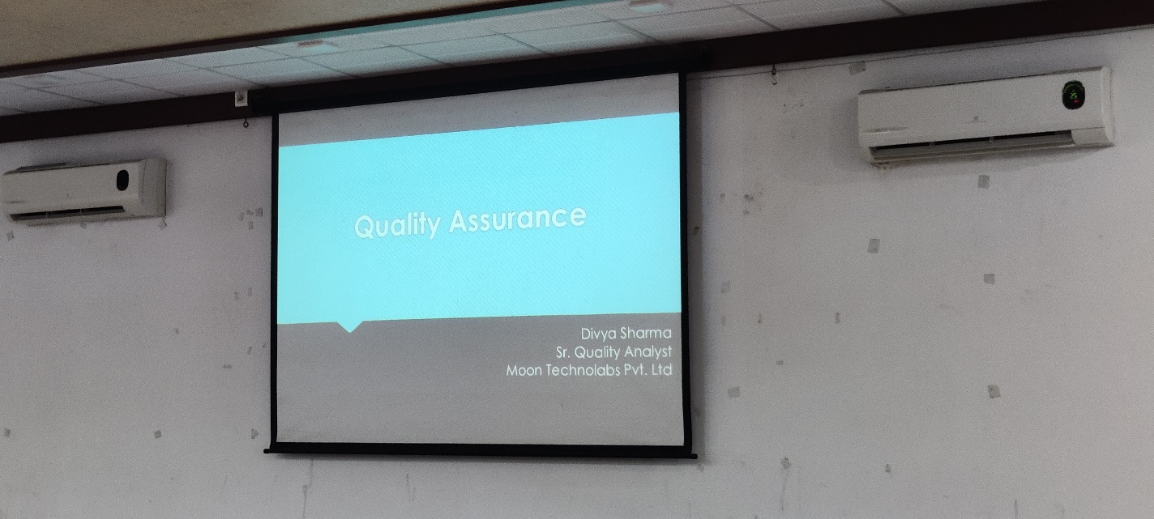
Title of the Session
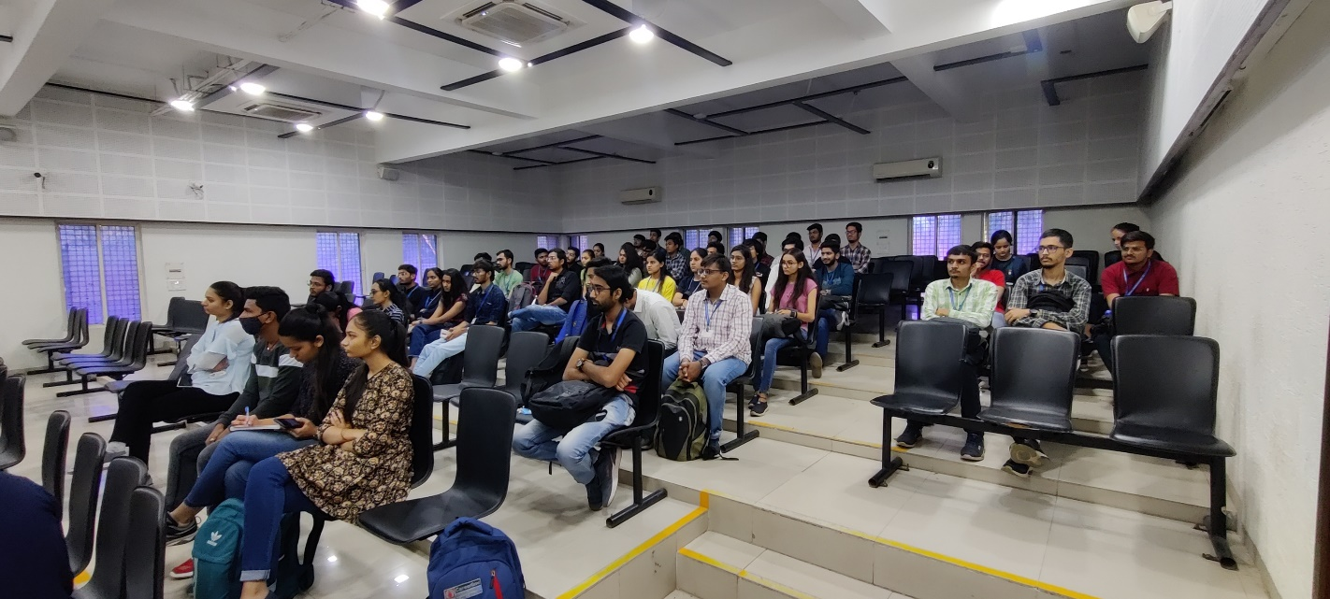
Participants
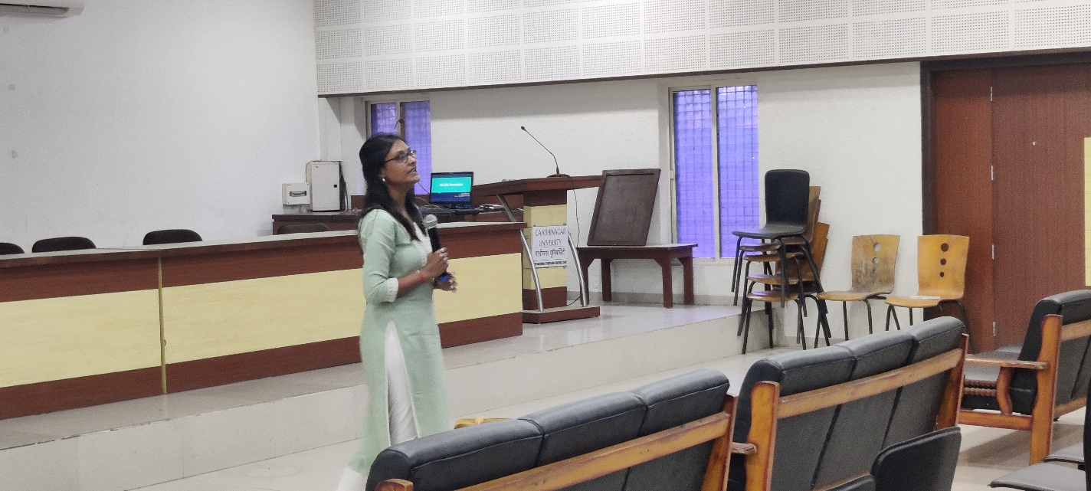
Expert Ms. Divya Sharma
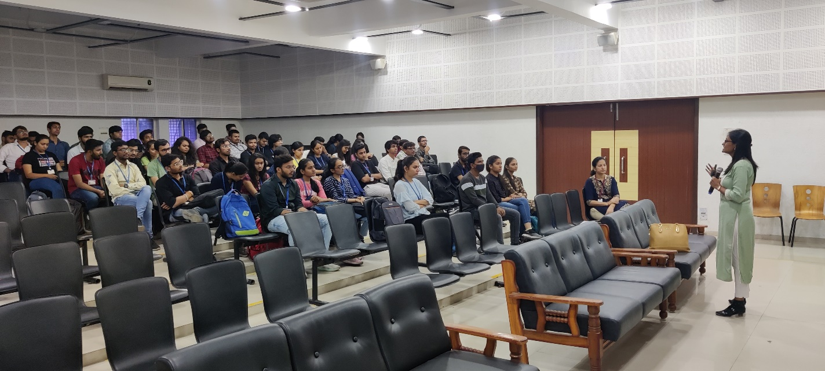
Concept explanation by the Expert
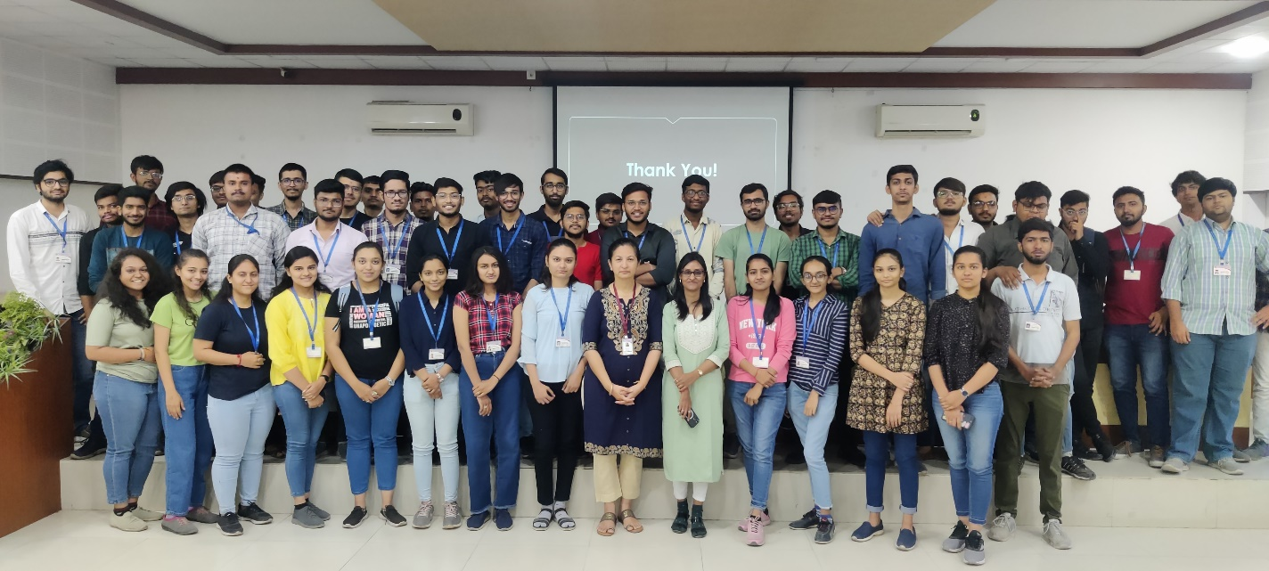
Group Photo

