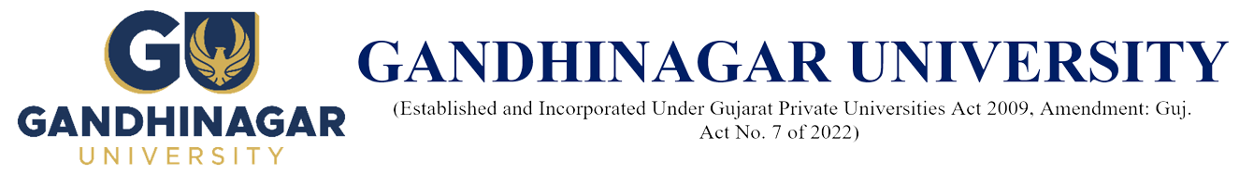A Report on
“Industrial Visit at Lancerfab Tech Pvt Ltd.” (5th April 2023)
Introduction:
Gandhinagar Institute of Technology a constituent institute of Gandhinagar University as a proud institute have been taking all care to ensure that the students are provided all necessary facilities and quality teaching with industry interaction. In order to impart practical training to the students. The institute has a desire that industrial visit is arranged for the students to sensitize them to the practical challenges that organizations face in the business world. It also gives greater clarity about various management concepts for students as they can practically see how these concepts are put into action.

Objective:
To enhance the practical knowledge about the various production and tooling facilities in industries, As Industrial visits are an integral part of Engineering and Management Education, and it is the experience that help students gain first-hand information regarding functioning of various industries. Also, to get guidance of various training session going in the recent trends of mechanical Industries.
Gandhinagar Institute of Technology has organized a one-day Industrial visit to Lancerfab Tech Pvt Ltd., Khatraj Chokdi on 5th April 2023 for 4th and 6th Sem Mechanical Engineering Students
The visit was organized with the prior permission and guidance of Honorable Director Dr. H N Shah and Prof. Nirav S. Joshi, Registrar (Administration) . It was supported by respected HOD Dr. Nimesh M. Gajjar.

Details of Industry:
LancerFab Tech Pvt Ltd, a complete sheet metal component & Contract manufacturing company offering Laser Cutting, CNC Bending, TIG, MIG, Arc Welding & Assembly services is an initiative of Visionary Industrialist Mr. Nitin Patel, after Promoting & writing success story of Gujarat biggest Laser Cutting Job Shop as Managing Director Since 1999, he felt the Gap in Delighting the customers, so in the year 2012 he promoted LancerFab Tech Pvt Ltd, to keep his commitment of “CUSTOMER FIRST”.
Since day one company’s top priority has remained delivering the right solution and the best quality service & committed to grow & institutionalized themselves by sticking to the principle that their customer’s successes equal our success.
Operating from modern 40,000 sq. ft factory and office complex near Indias most enterprising State Gujarat Capital Ahmedabad, sheet metal manufacturing facility combines state of the art machinery with a highly skilled workforce. LancerFab Tech Pvt Ltd is committed to become market leader for supplying precision sheet metal solutions, and will be going to build an unrivalled reputation for:

Supplying products ‘right first time’.
Products & Services:
At LancerFab Tech, they harness their industry experience and latest technology to create most accurate and precise drawings. They use the most advanced 3D CAD/CAM system for detailed laser cutting design and isometrics. This facilitates faster and accurate drawings, better revision control, and minimal development lead time, right from conceptualization to manufacturing. They have vast experience in all forms of Component Designing – from standard laser cutting to multi-process metal cut design and fabrication.
By using 3D Solid Modelling software in metal work design of assemblies and parts, they create “virtually” all the parts in three dimensions in our proprietary CAD workstations. This helps there to detect and fix any errors that may be present in the existing 2D sheet metal design process. Additionally, CAM software enables there to quickly transmit 3D data from the CAD system to the CAM, without any loss of intelligent attributes. This further helps to eliminate common errors that may arise during the process of translating data from CAD to CAM system.
LancerFab Tech offer comprehensive sheet metal design services that include:

All kinds of sheet cutting design, prototype development, component designing, and metal designing for parts and assemblies
Comprehensive CAD/CAM solutions
Metal cut design and technical support.
Project re-engineering and value engineering support
Estimation & costing
2D or 3D file import, download or upload engineering drawings and technical data on FTP.
In addition to unmatched sheet metal design capabilities, they also offer on-site technical consultancy and support. Their design team provides ingenious solution to meet any sheet metal designing problem.

Students Feedback
Through this visit the students got basic knowledge of Conventional Lathe, Milling, Grinding Machines, CNC machining center machine as well as machining processes like laser cutting machine, press break, turret drilling machine & inspection methods involved in the manufacturing of different jobs.
The visit helped familiarize students from the beginning of their course with real life working environment and made them understand about the working of various machines that are part of their curriculum.
From these industrial visits, student got knowledge of subjects like Manufacturing Process and Advanced Manufacturing Processes of 4th and 6th semester Mechanical Engineering respectively.

Photo Gallery:

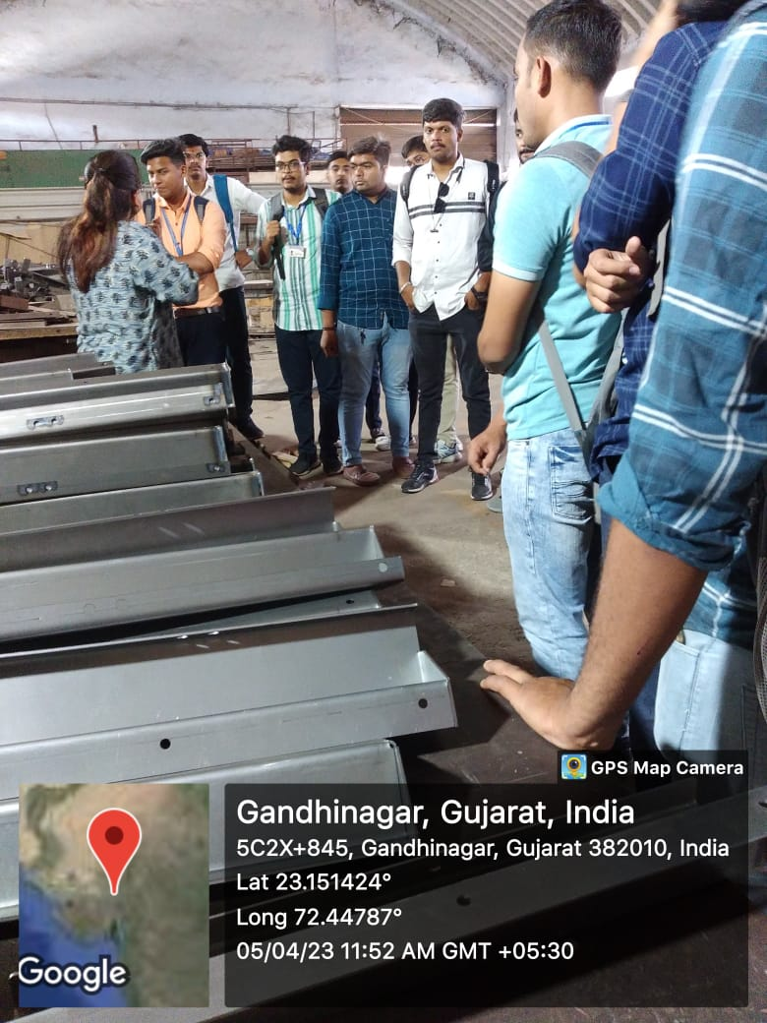
Students’ interaction with Miss. Dhara Shah, Technical Head, LancerFeb Tech
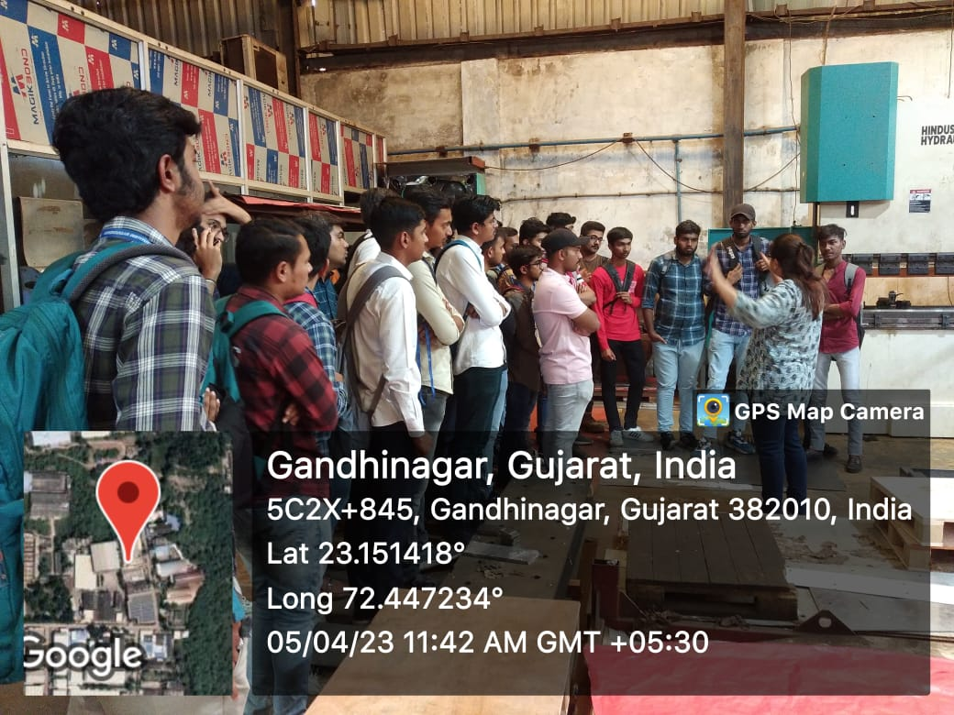
Student Interaction with the Ma’am
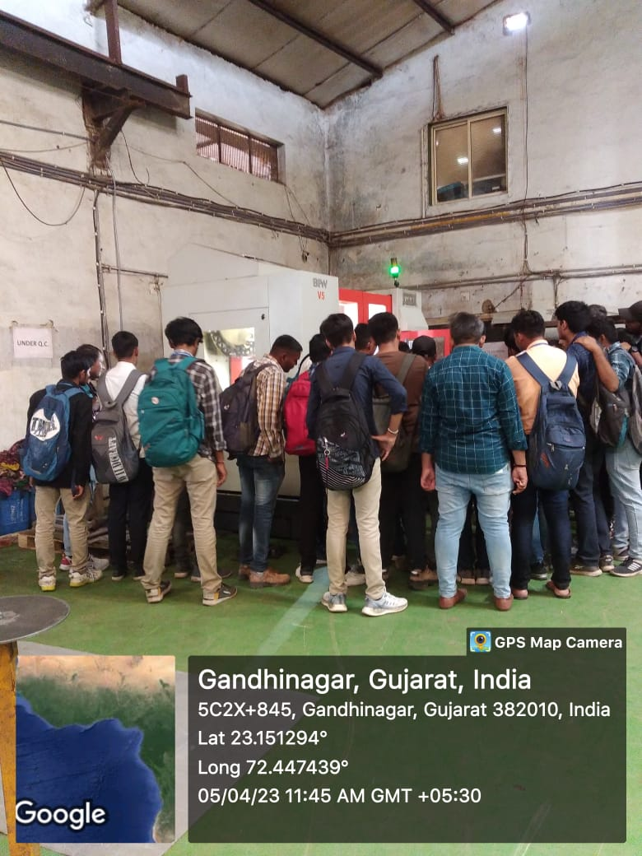
Student Interaction with operator
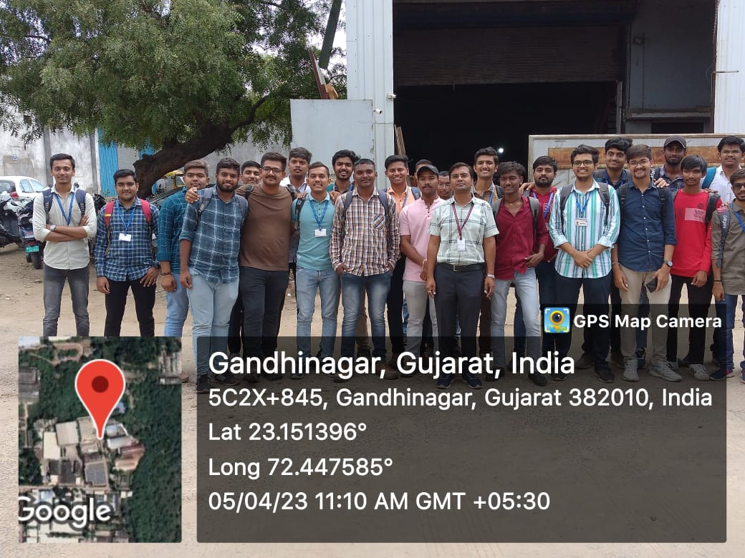
Group photographs with student and faculty

