A Report on Impulso 2023 20/03/2023 & 21/03/2023
Objective:
Gandhinagar University gives importance to students' fitness & other curriculum activities. Following the trend, Gandhinagar University organized its annual sports named “IMPULSO 2023” on 20th, 21th & 22nd March 2023 on college ground to provide a platform to the students to foster success in different sports. The students and faculties were at their harmony to organize panoramic activities related to sports activities. The objective behind keeping such sports events is to develop physical fitness by maintaining and increasing components like speed, flexibility, muscular strength, muscular endurance, aerobic capacity, and anaerobic capacity amongst the students. Participation in sport and other extra-curricular activities has an important role in ensuring that students’ educational experiences at Gandhinagar University are as good as they can be. Playing a sport is a great way for Students to take a break from academics and release pent-up energy. It also helps them lead fuller and happier lives as regular sports and fitness activities have proven to provide physical benefits and social and psychological benefits to students’. Along with this, it also enables them to provide the opportunity to be inventive and creative in sporting activities. It also prepares the students to be able to participate fully in the competitive, recreational, and leisure opportunities offered outside the college environment. The sports event assists the students to build self-esteem and self-confidence through positive sporting experiences. It also gives them a stage to do healthy competition through inter-branch and inter-semester matches. Thus, organizing such sports events ensures that every student can maximize their sporting potential and find a sport that they can enjoy and participate in with some success. It’s important to play sports because it’s a healthier lifestyle and it’s important for all of us to get rid of stress as well as enjoy what we’re doing.
Details of the Impulso 2k23:
Around 1150 students along with faculty members participated in various indoor and outdoor games. There were 16 sports in total which included 8 outdoor, 4 indoor sports & 4 Athletics. The number of participants varies in different sports. There were 270 players in cricket, 80 players in Volleyball, 65 players in Kabaddi, 44 players in Kho-Kho, 150players in Badminton, 68 players in Carom, 55 players in Table-Tennis and 60 players in Chess. From this year athletics were included there were 56 players in Long Jump, 190 in running, 40 in Shot-put & 40 in Disk Throw. There were individual as well as group matches depending on the availability of participants on time. Various students’ coordinators were appointed for the smooth coordination and functioning of all the events. The Annual sports days were a grand success in the wings of Gandhinagar University.

Gandhinagar University has Introduce the Inter College sports Impulso 2k23. There were 20 teams in cricket and 20 teams in Volleyball. The University and Institute like SAL, GLS, INDUS, KSV, KIRC, SAFFRONY, LDCE, PDEU, GEC BHARUCH, GEC VALSAD have participated in this Impulso-23. Around 300 players in cricket and 200 players in Volleyball have participated. Where PDEU were Champion and GLS became a Runners Up in Volleyball (Boys Category) & GLS were Champion and

Gandhinagar University became a Runners Up in Volleyball (Girls Category) this year Impulso 2k23 and KSV became a Champion and Gandhinagar University the host team became a runners up in Cricket
(Boys Category) & ACA were Champion and KIRC became a Runners Up in Cricket (Girls Category) for the year 2k23.
.
Glimpse of the various games:

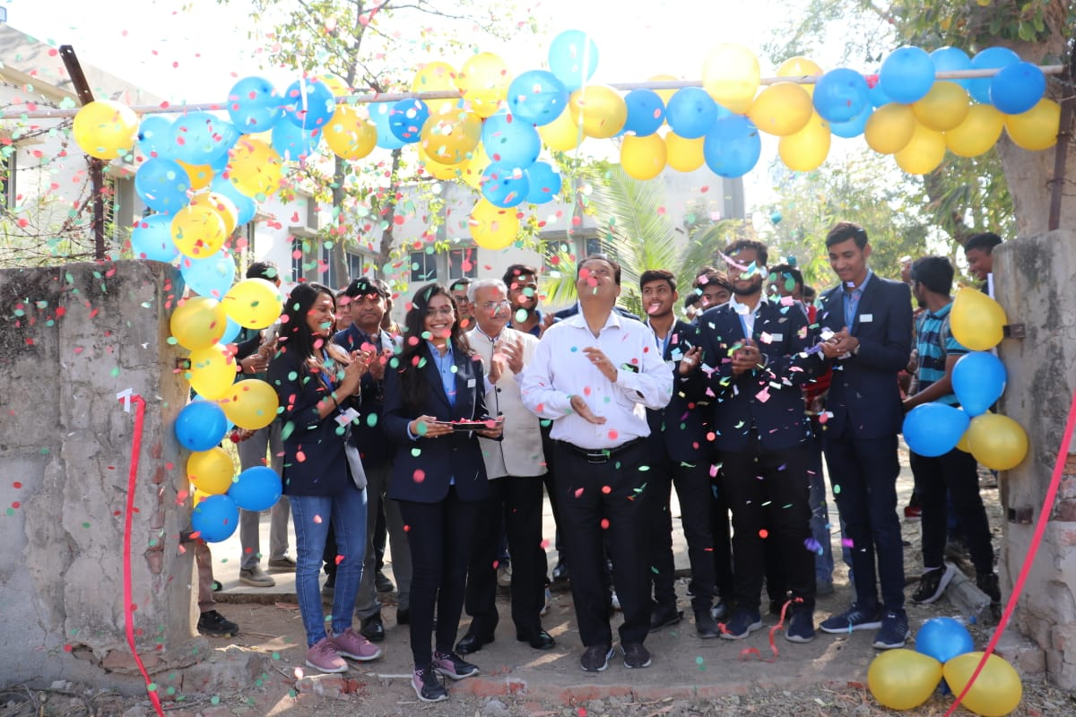Impulso-23 Inaugural Ceremony opening by President Sir | 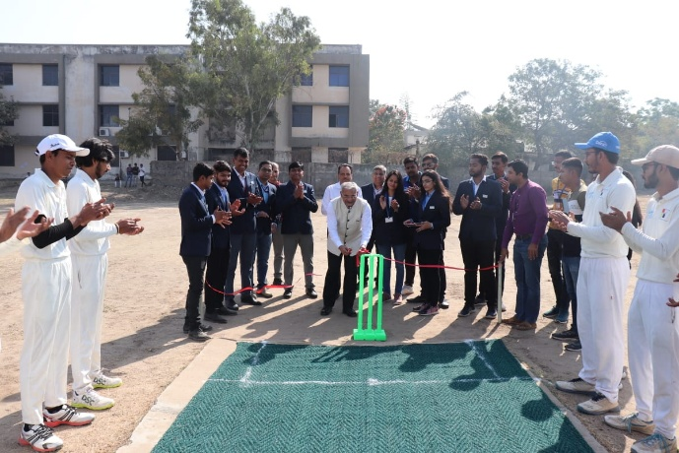Inaugural Ceremony by Director Sir of Matches Cricket
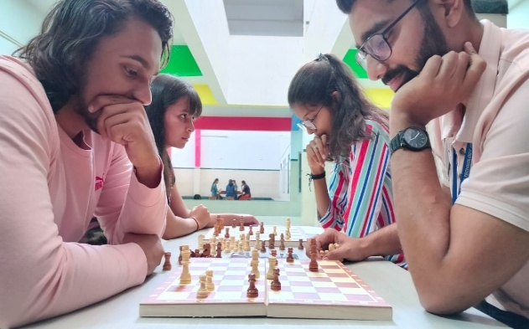Chess match between students | 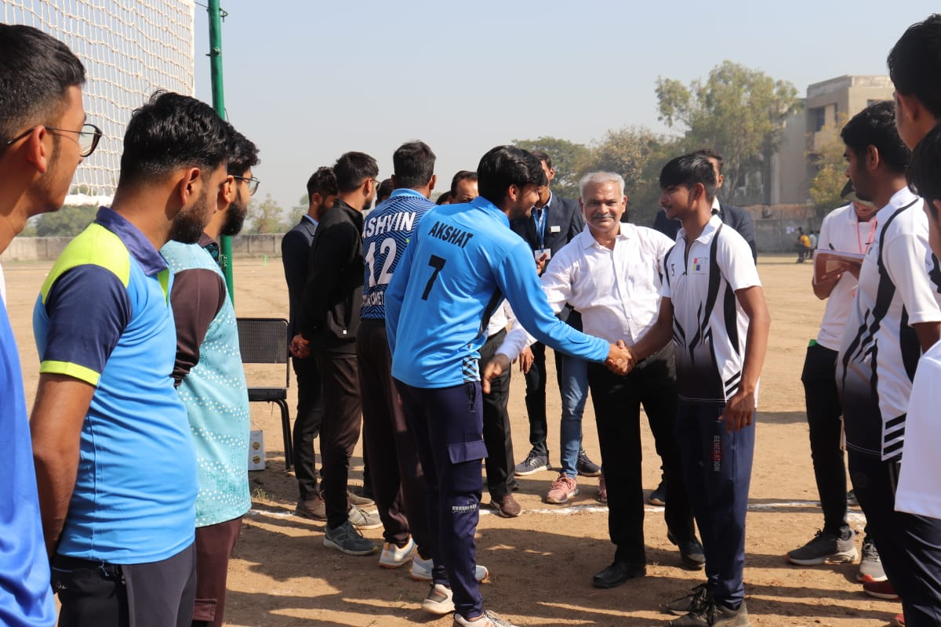Students ready for volley ball match
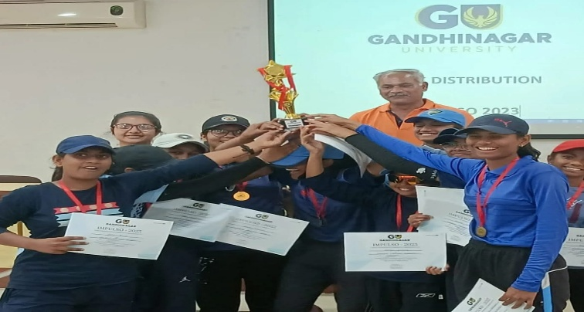  Open Girls Cricket Tournament  Champion team :- ACA | 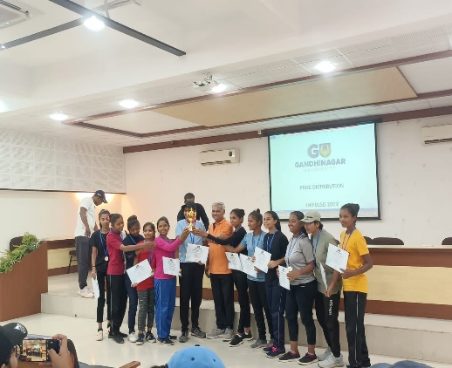  Open Girls Cricket Tournament  Runners up team :- KIRC
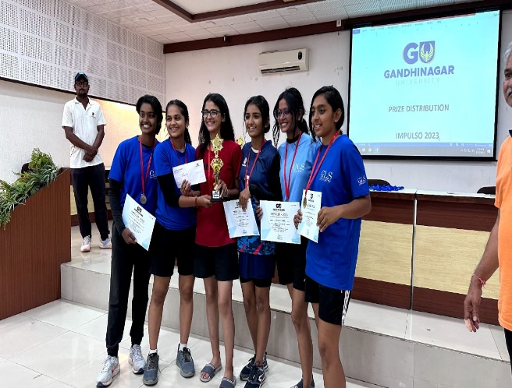  Inter college Girls Volleyball  Champion team :- GLS | 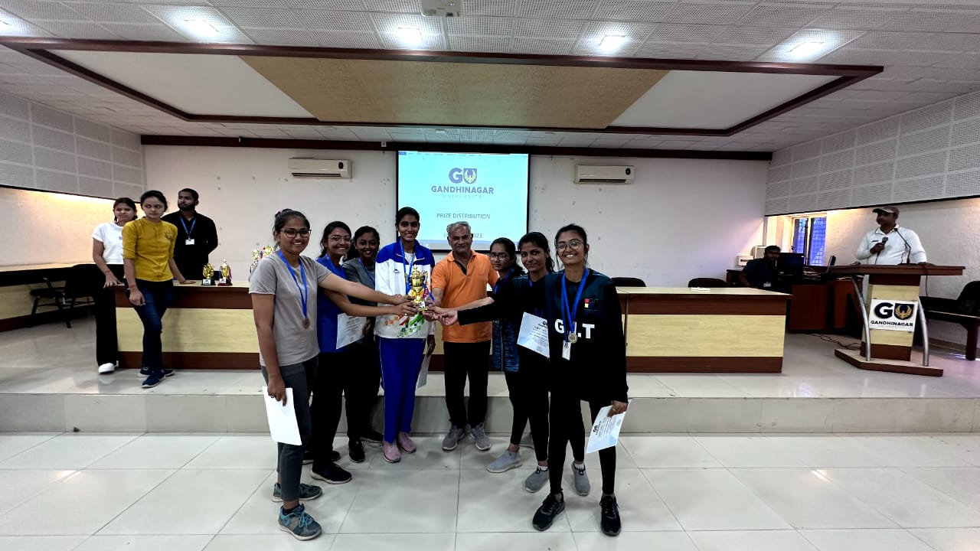  Inter college Girls Volleyball  Runners up :- Gandhinagar University
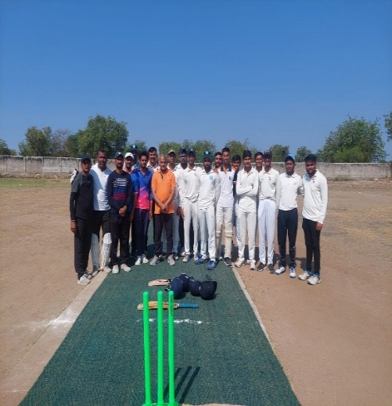Leather Ball Cricket Finale Staff v/s Students | 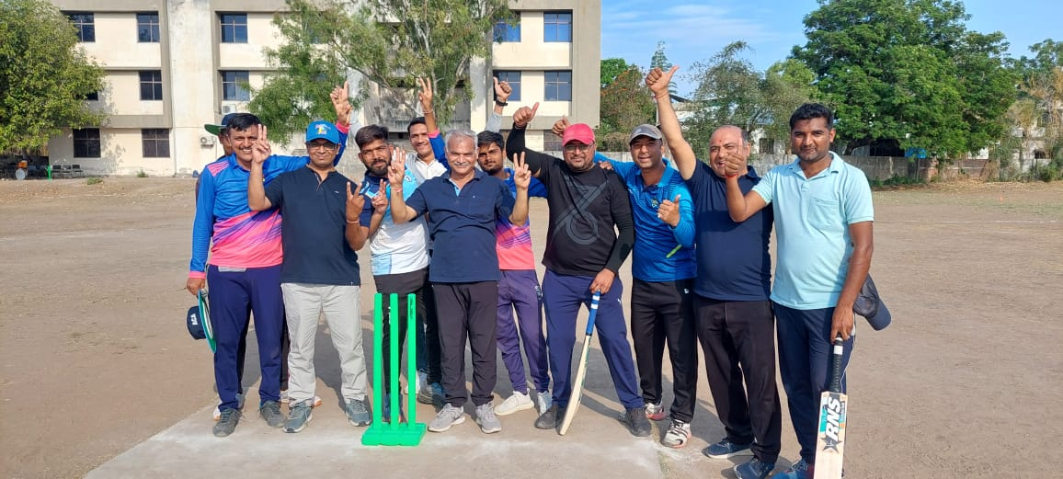Faculty winner’s Cricket team
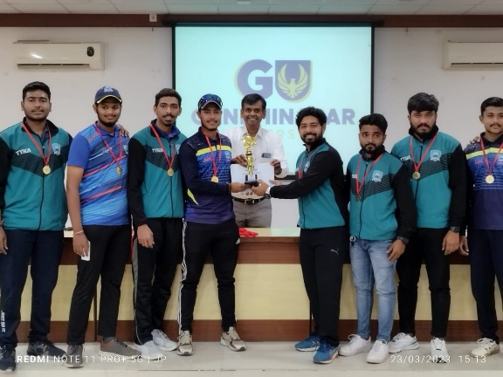  Inter college Cricket Tournament  Champion team :- KSV | 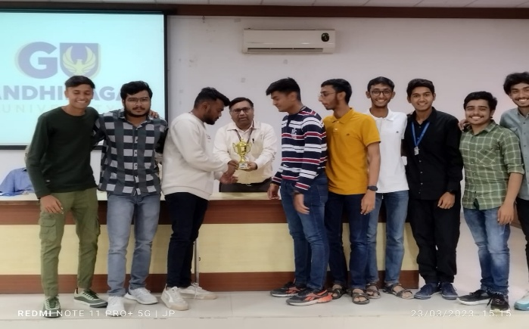  Inter college Cricket Tournament  Runners up team :- GIT
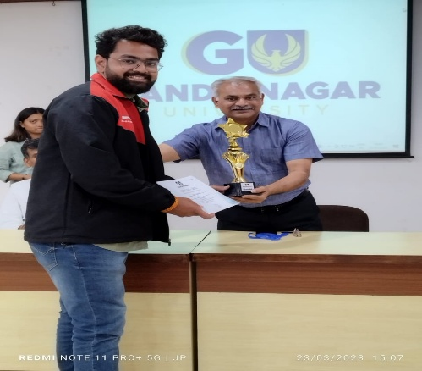  Inter college Boys Volleyball  Champion team :- PDEU | 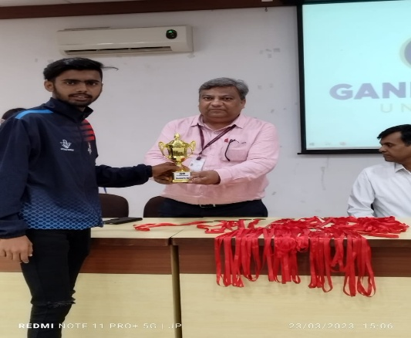  Inter college Boys Volleyball  Runners up team :- GLS

